Programme: Improving Urgent and Emergency Care

Project: To Develop Resuscitation Facilities, Improve Urgent Treatment Centre Accommodation and Reconfigure the Emergency Department at Pilgrim Hospital, Boston

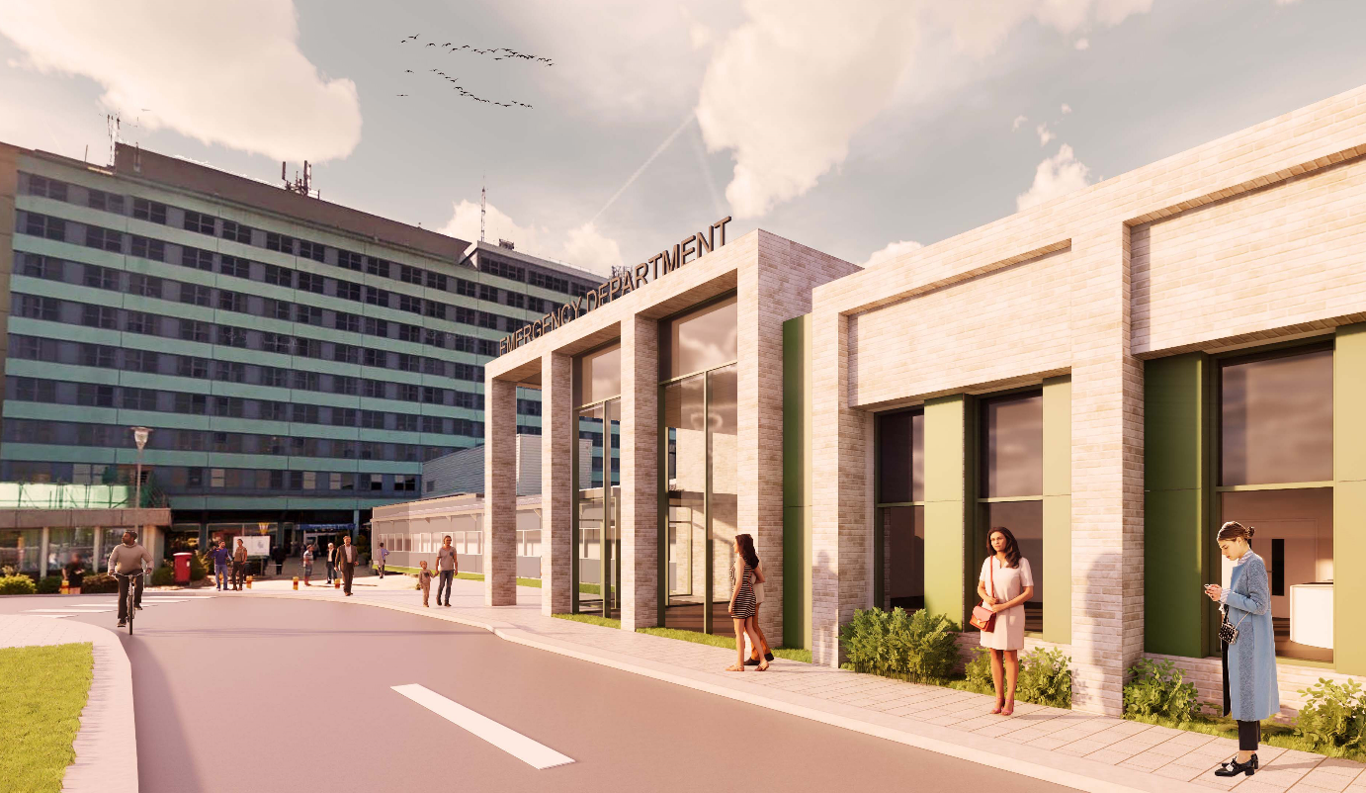

Full Business Case

Version history

Version | Date  Issued | Brief Summary of Change | Owner
V1 |  | First version
V2 | 22/04/2022 | Sensitivity Analysis added
V3 |  | Following Feedback from Regional and National NHSE, DHSC

1 Executive Summary 5
1.1 Introduction 5
1.2 The Strategic Case 9
1.3 The Economic Case 12
1.4 The Commercial case 19
1.5 The Financial Case 21
1.6 The Management case 22
1.7 Impact Assessments 24
1.8 Recommendation 30
2 The Strategic Case 31
2.1 Organisational Overview 31
2.2 The Area Served and its Needs 33
2.3 National and Local Strategies 34
2.4 Definitions 37
2.5 ULHT Performance 41
2.6 Investment Objectives 43
2.7 Business As Usual 45
2.8 Potential Business Scope and Key Service Requirements 51
2.9 Business Needs 52
2.10 Benefits 67
2.11 Risk 76
2.12 Constraints 85
2.13 Dependencies 86
2.14 Summary of the Strategic Case 87
3 The Economic Case 89
3.1 Introduction 89
3.2 Critical Success Factors 91
3.3 The Long List Options 92
3.4 Short Listed Options and Preferred Way Forwards 100
3.5 Sensitivity analysis of preferred option 106
4 The Commercial Case 108
4.1 The Commercial Case at OBC 108
4.2 Procurement Route 108
4.3 Rationale for Using the Pagabo Framework 112
4.4 Government Policy Objectives with Pagabo 116
4.5 Form of Contract 117
4.6 Legal Report and Accounting Treatment 117
4.7 Procurement Information 118
4.8 Management Plan 120
5 The Financial Case 121
5.1 Impact on the organisation’s income and expenditure account 121
5.2 Capital Investment required 124
5.3 Revenue Investment required 127
5.4 Cost Improvement / Benefits generated 127
5.5 Cost avoidance 128
5.6 Commercial Risks 129
5.7 Affordability 129
5.8 Payback Period 130
5.9 Opportunities 130
6 The Management Case 131
6.1 Stakeholders 131
6.2 Project Framework and Management Arrangements 132
6.3 Outline Project Plan 137
6.4 Use of specialist advisers 138
6.5 Change Management 139
6.6 Communications Plan 140
6.7 Benefits Realisation 142
6.8 Risk Management 143
6.9 Contract Management Arrangements and Plans 145
6.10 Project Assurance and Post Project Evaluation 146

Executive Summary

Introduction

The following full business case (FBC) seeks approval for a capital investment of £43.5m and a recurrent revenue impact of c. £0.8m (non-pay expenditure) for improvements to the Urgent Treatment Centre (UTC), an expanded resuscitation facility (Resus) and reconfiguration of the remaining Emergency Department at Pilgrim Hospital, Boston (PHB).

This investment is significantly higher than the original allocation of 21.3M. Funding sources to bridge the capital shortfall have been identified with NHSE&I allocating a further £13.1m and Lincolnshire ICS providing the £3.5m leaving a balance of £5.7m linked to inflationary pressures (£4.7m) and net-zero-carbon (£1.0m) – Lincolnshire ICS has agreed, through the capital envelope allocated to cover this additional increase in costs also. Details are provided in the ‘financial case’.

The project will support provision of modern urgent care facilities in line with the Lincolnshire Urgent and Emergency Care Strategy. Pilgrim Hospital’s Accident and Emergency Department was officially opened in 1977 with little expansion since.

This paper follows several previous strategic outline cases (SOC), which were unsupported due to a lack of capital. In June 2018 a Strategic Outline Case was submitted to ULHT’s Capital and Revenue Investment Group (CRIG) to expand the resuscitation facilities at Lincoln County Hospital (LCH) from 4 bays to 8, and at Pilgrim Hospital, Boston from 4 bays to 6.

The SOC presented 3 options for each site: business as usual, a separate build on the side of the existing majors department and an expansion of the resus department / new build to release existing accommodation.

Options 1 and 2 were discounted. Option 1 was ruled out – there are frequently more patients requiring resus facilities than the department has bays for, meaning clinicians have to make gatekeeping decisions based on levels of acuity. Option 2 would mean two separate resus areas with inefficient staffing models and poorer care for patients. Working with Oglesby and Limb architects, various outline designs for option 3 were developed. These options would need working up in more detail as part of the Outline Business Case (OBC).

The cost of each scheme was £7,448,780 at LCH and £7,196,925 at PHB. Designs followed HBN guidance at the time and included a trauma bay and a paediatric bay. The design at Pilgrim Hospital included some administrative space on the floor above resus.

Although the case was approved by the trust on 23rd July 2018, there was no capital to support either scheme.

Concurrently, Lincolnshire Sustainability and Transformation Partnership (STP) and CCG’s were working on business cases to develop Urgent Treatment Centres at various sites including the acute hospitals at Lincoln and Boston. Options were similar – business as usual, develop a stand-alone UTC or a co-located building. The project team selected the co-located option. For Pilgrim Hospital they produced outline drawings with a new, adjoining building coming forwards from the front of the hospital.

Both resus and UTC schemes at PHB had outline drawings that would involve moving roads on the site. The total cost of the UTC and resus cases was £21.3m. Although submitted in a joint bid for Wave 4 Estates Technology Transformation Funding (ETTF) this was not supported. However, on 5th August 2019, Prime Minister Boris Johnson announced funding for 20 health organisations to receive a share of £850m to improve services, which included an allocation of £21.3m to Pilgrim Hospital to carry out the above improvements to Urgent and Emergency Care.

After the trust received news of the initial funding an outline business case (OBC) was developed through workshops with the clinical teams, estates, finance and patient representatives. Representatives from ULHT, LCHS, LPFT, CCG, patient groups and regional NHSE estates teams were involved.

The working group established a clear principle from the outset – there needed to be a complete redesign of the whole ED rather than independent extensions outwards for resus and UTC as only doing this would:

- leave Majors, Minors and other areas still in poor condition;

- land lock the remaining department and prevent expansion in an area that was too small and had been rated inadequate by the CQC;

- cost a large amount of capital on road infrastructure.

The OBC was developed in accordance with the underlying principles of HM Treasuries Green Book; to develop clear spending objectives, benefits and risks and use these to develop the best value for money option to satisfy the spending criteria.

An up to date cost advisor report assessed the original plan (expanding resus and building the UTC) as costing c£33m (excluding VAT), not £21.3m. This was because:

- original plans were only at PID / SOC stage, had been developed independently and were not worked up in enough detail at the stage they were told to submit;

- inflation was not fully taken into account £1m;

- optimism bias of £3.1m and inflation adjustments totalling c£2m were excluded from the UTC PID for approval purposes;

- VAT for either scheme was not included in the WAVE 4 STTP bid (capital without VAT was 21.3M), excluding c£5m.

As owner of the site, ULHT was asked to develop and lead the project, working in close collaboration with partner organisations. Recognising early on in the project that both of these business cases were developed in isolation and, as the trust was developing its estates strategy that considers backlog maintenance issues with some of its buildings, there may have been other options to consider by amalgamating the projects and developing existing infrastructure. The project team also recognised that by developing options with both schemes as a single project there could be savings from fees and contractors. In order to be assured of best value for money it was decided that although a strategic outline case still stood the project would be taken back briefly to SOC stage to review:

- the scope of the project;

- the long list of options;

- the project aims.

The Lincolnshire Health System has a programme of work to improve urgent and emergency care (led by the Urgent Care Delivery Group). This project fits within that umbrella programme. Governance arrangements are described within the management case later, but a Project Oversight Group, chaired by the SRO (the then ULHT Chief Operating Officer), and a Project Working Group, chaired by the Project Director (the then ULHT Deputy Director of Operations), were established.

Both groups had membership from the relevant agencies including ULHT, LCHS, LPFT and commissioners. The working group developed a provisional schedule of workshops to take the project back to the SOC stage to review the scope, go through the options appraisal and develop the commercial and financial cases.

The OBC was approved at the Joint Investment Sub Committee (JISC – DHSC & NHSE&I) on 12th August 2021 (Appendix A).

For the most part the FBC dealt with procuring the contractor for the scheme and ensuring rigorous contractual arrangements are in place. However, the Trust utilised a “design and build” contract through the Pagabo framework to relook at the OBC design and develop the detailed drawings required.

Various workshops were again held with clinical teams to review the designs, IT solutions and extrapolate on the benefits. The full workshop program to develop the whole business case was:

In general the existing OBC design remains in place but the group felt that, as with the current situation, there remained a flaw in the design in that ambulant patients have to cross a busy road to enter the ED. Ambulance crews also offload non ambulant patients in this area making maintaining patients dignity difficult.

The team took the decision to “flip” the UTC side of the refurbished building. Whilst this leaves the layout of the UTC similar to the OBC design it provides an entrance close to the hospitals main entrance, improving the look of this area. It means ambulant patients can enter the building over a much quieter road with a pedestrian crossing. It also means that patients arriving by ambulance maintain much better dignity. The FBC also considered a revised strategy for the decant of staff within the “H Block” by bringing back into use an adjacent building – the Maternity Block. This building was closed due to asbestos and water issues, however work is ongoing to bring it back into use to support this scheme, eradicating some £6.7M of backlog maintenance (including VAT).

In terms of demonstrating best value for money a revised Comprehensive Investment Appraisal (CIA) was undertaken with this solution (option 4B) and the original OBC design (4A). The other options in the OBC were not appraised again as option 4A had already demonstrated best value for money. The benefits used within the model were also updated in line with the conditions of the JISC approval (Appendix A). The appraisal demonstrated that the new design offered far better value for money within the same cost envelope.

This FBC has considered and taken advice from HM Treasuries Green Book and supporting documents throughout and comprises the following sections:

- The Strategic Case. This section establishes the strategic context of the proposed investment, both in terms of national and local service drivers. It also sets out the case for change which summarises the business need for the investment, detailing the existing situation, and the need for service improvement;

- The Economic Case. This section identifies the long list of options and the process by which the short-listed options were then established and summarises the key findings of the economic appraisal taking into consideration the needs of the service and achieving value for money;

- The Commercial Case. This section summarises the procurement strategy and intended contractual arrangements;

- The Financial Case. This section confirms the funding arrangements and overall affordability of the scheme;

- The Management Case. This section demonstrates that the scheme is achievable and how the project team will successfully deliver the project to cost, time and quality.

The Strategic Case

    - The strategic context

This project is in line with national and local strategy and policy. Key to this are the consultation on Transformation of Urgent and Emergency Care: Models of Care and Measurement (December 2020) which is reviewing how performance metrics are taken and looking at how appointments systems could be introduced into urgent care, the NHS Long Term Plan (January 2019) which is aligned to the new ED integrating the different organisations in Lincolnshire, the NHS 5 year forward view (March 2017) setting out the priority to improve urgent care performance and access to primary care services and Urgent Treatment Centres – Principles and Standards (July 2017) setting out a national requirement for acute hospitals to develop UTC’s.

The ULHT estates strategy has identified areas of the estate that are in poor condition and this includes buildings adjacent to the area where the SOC’s had planned to expand. It became very clear during the first of the project working group’s workshops that there was an opportunity to develop the estate to cut infrastructure costs and change the original plans, which had included costs for moving two of the roads that ran nearby.

ULHT’s performance against the 4-hour target has been poor. There have been growing attendances to the Emergency Department (ED), staffing difficulties and a long length of stay for our inpatients, which causes backlogs into the “front door”. Plans have been developed to improve the position but it was recognised that the aging infrastructure in our ED’s had not kept pace with demand and modern medicine, and this was a significant contributing factor to performance.

    - The case for change

Capacity and demand modelling showed that, for our most ill patients requiring resus, we do not meet the demand and doctors have to make difficult decisions on which patients can go into the resus area. There is frequently a requirement for 6 cubicles, not the current 4, and often demand peaks at up to 8.

This business case deals with the issues around poor and inappropriate estate for our patients. It does not request additional staffing. Staffing is reviewed by the medicine division constantly and separate cases to increase staffing go to the Trusts Capital and Revenue Group for internal approval. More detail around the increases in staffing WTE (especially medical and nursing) over recent years is given in section 2.9.5, and the medicine divisions recruitment plan aligned to the expansion of the ED is given in Appendix M.

The majors and minors areas of the ED are similarly compromised and the patient feedback we receive demonstrates clearly a need to improve the dignity and quality of clinical space. The CQC continued to rate the department “inadequate”. In its unannounced, focussed inspection in January 2020 they noted that:

- the department was too small for the number of patients arriving. This impacted on how patient flow could be managed. It also resulted in patients being treated in corridors or the central space of the department and having their dignity compromised;

- a shortage of hospital in-patient capacity was preventing admissions and these patients were being cared for in the central area of majors, as well as being located in the plaster room, along the main ambulance arrival corridor (three patients), and also nine patients receiving care in chairs located throughout the emergency department;

- the resuscitation and major’s areas were both operating at full capacity, as was the integrated assessment centre (IAC). This meant there was extremely limited capacity for patients who required resuscitation, or those patients who required management in an appropriately equipped clinical bed space;

- patients were being managed continually in this (central) area during the inspection. We had previously found up to six patients were being nursed in this area. Despite the reduction in trolleys, the area did not lend itself to protecting patients privacy and dignity. Patients remained in close proximity to one-another, therefore impacting on the ability for patients to be sufficiently spaced for infection control purposes;

- the resuscitation area operated at full capacity for the duration of the inspection. Department staff worked tirelessly to try and stabilise patients as quickly as possible in order further resuscitation space could be created to meet demand;

- a patient remained on an ambulance despite having chest pain and having a complex medical history. There was no appropriate monitored bed space for the patient to be relocated to and so hospital staff had been required to commence an assessment of the patient whilst they remained on the ambulance.

The trust receives many comments through patient feedback regarding the quality of the accommodation, an example of just one:

ULHT|A&E|PILGRIM A+E DEPT | 18/01/2020 07:58 | Left sat on a chair over night for approx 10 hours waiting to be seen by a doctor. Another patient in the same waiting area was asleep on the floor in front of me whilst receiving IV fluids as there was nowhere suitable to sleep or lay as she stated several times to care staff that sitting in a chair was uncomfortable and too painful for her. This was uncomfortable to watch.

An Urgent Treatment Centre is in place within the ED but is based on the previous “Primary Care Streaming” accommodation. It is felt this could be developed to provide better accommodation, take the minors patients out of the main department and improve the flow within urgent care.

Diagnostic performance is also a big problem in the ED affecting the time taken for blood results to come back and for imaging investigations (notably CT scanning) to be completed. A single in-house CT scanner was in place in the hospital, which is quite a distance from the ED and, when not functioning, causes major diversions across the county and beyond for very ill patients, which affects their chances of recovery as well as causing logistical problems for our ambulance provider, EMAS. As of March 2021, an additional modular scanner is available but again is a distance from the ED and separate from the main hospital (meaning ED patients would be transferred by ambulance if it was used to scan them).

The working group reviewed the original scope of the two strategic cases but made the decision that in order to address the issues facing urgent care in Boston then new spending objectives were agreed:

- To improve accommodation within the Urgent Treatment Centre, bring the “minors” service into the UTC and improve patient flow;
- To improve access to care for our most seriously ill patients;
- To improve flow and quality within the remaining ED;
- To improve the turnaround of diagnostic and pathology services within the emergency department.

The working group held a workshop to take these spending objectives forward to develop critical success factors and a range of core, desirable and optional requirements within the new service.

The Economic Case

    - The long list
This project is not just about building new facilities; it is about changing the way the service works, with an intent to work towards integrating staff from different organisations into a single urgent care team able to provide seamless care for all patients. In addition, the original strategic cases had been developed independently by different organisations and the trusts estates strategy indicated there would be advantages in looking at different location options.

A large range of options were considered in three different workshops. Firstly, a list of possible design locations were presented - from the original plan of two separate extensions to the existing building, through to refurbishing or rebuilding adjacent structures.

The preferred option from the first of these workshops was to consider a building referred to colloquially as the “H-Block” – block OX or CSS building. This is located between the current ED and the main Out Patient department. Within the OBC plan it was felt it would be possible to decant staff within this building to space thought being made available towards the back of the site (no longer the case). In reviewing this as part of the FBC a decision was made to refurbish the maternity block – a building which had been closed due to asbestos and clean water issues. This plan removes £6.7m of backlog maintenance and creates more than enough space for the decant. The existing H Block building could then be refurbished or demolished to remove backlog maintenance issues

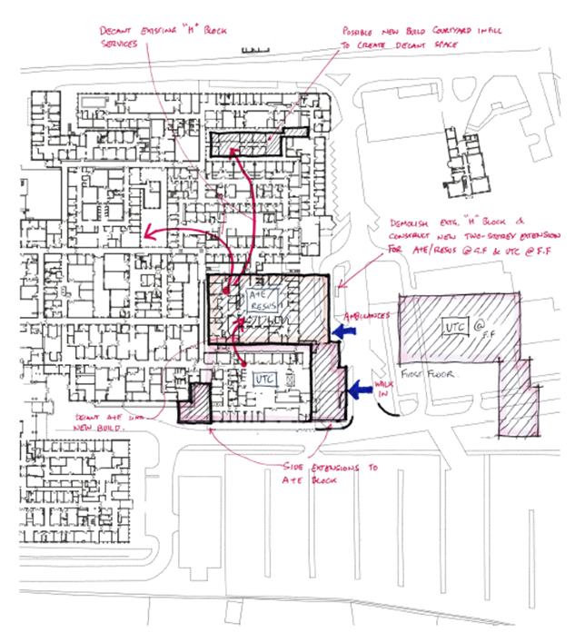

All 12 design location options were taken forwards in the OBC to the full long list options appraisal.

Another workshop considered the clinical model. Discussions focussed on three different plans; business as usual with divisions between the services, an intermediate option with some shared areas such as reception, or a completely new model whereby all agencies work from a central navigation hub to discuss cases and pull patients to the correct area. The 3rd option was preferred, after some debate between the working group and the oversight group – there is an intent to work towards integrated staffing and the design should reflect this.

The clinical model was important to inform the design process and the services that are considered as essential, desirable and optional. The location workshop options were split into do minimum, intermediate and do maximum options for further debate within the full options appraisal. The outcome of the options appraisal, using HM Treasuries Green Book Options Framework is given below:

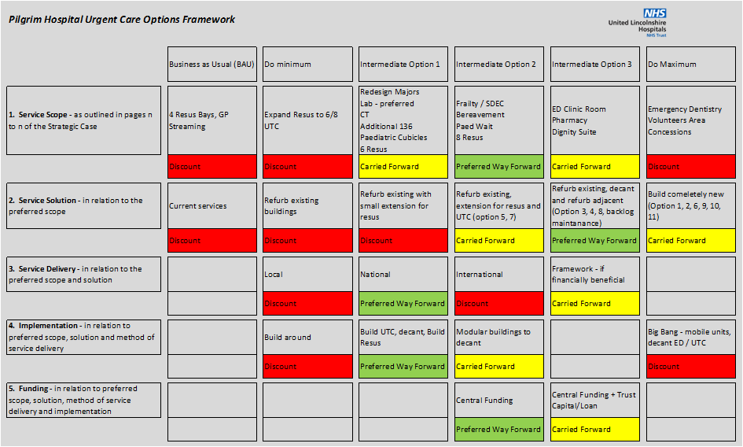
    - The Shortlist and Preferred Way Forwards
These options provided a short list of 4 for further economic analysis. The preferred way forwards was:

PWF 4A | Rationale
Description | With demolition of the adjacent “H Building” and a new build ED, the ED would be relocated and the former building refurbished / extended. This would provide an 8 bay resus and UTC, new majors area and additional services such as CT scanner, section 136 suites, paediatric area, frailty / SDEC and bereavement facility. The trust would prefer to use own known national contractors but would look at framework options. A phased approach to build new buildings, decant into them and refurbish / extend former locations. The project has an agreement to fund centrally
Strengths | - Provides sufficient capacity to contain existing demand and future proof services  - Financially realistic in view of less building work and no road moves  - No disruption to existing services during construction  - Preferred decant option beings dormant property back into use
Weaknesses | - Capacity is constrained compared to the do maximum option  - Does not allow future expansion without road diversion  - Constrained by shoe-horning new build into the space left from the “H Block”
Opportunities | - Does provide increased capacity and would improve patient outcomes  - Removes backlog maintenance issues from H Block (offsets the cost to demolish and build new)  - Good connectivity between ED and UTC would promote staff integration and new ways of working
Threats | - Requires decant of existing services within the H Block
Conclusion | This option was felt to be the preferred way forwards in terms of providing most of the core and desirable requirements and satisfies the spending objectives. It was felt to be achievable by decanting some services out of the H block and would mean the work could be phased to minimise any disruption

This main issue to address was the gap between ring fenced funding and the actual cost. The preferred way forward “do minimum” would come in almost on budget but the economic analysis showed that this would provide far less value for money.

The preferred way forward “do maximum” option would involve major new building work, road diversions with significant infrastructure costs. Whilst this would support the core, desirable and optional elements the cost of this would be prohibitive in the economic appraisal.

    - Indicative Costs
The indicative costs for the different options considered at OBC were as follows:

Note, these costs are indicative, a higher level (24%) of optimism bias was built in to the financial summary

Following meetings with NHSE&I on 19th October 2020 the indicative costs were reviewed again and a further economic analysis of options to bring costs closer to the original £21.3m was requested. Further cost advice was taken on the design after meetings with NHSE&I estates teams focussed on ensuring rooms were HBN compliant, circulation spaces were more accurate and more information on BREEAM and Modern Methods of Construction were taken into account.

The options subjected to further cost advice and financial appraisal (see financial case – CIA modelling) were:

Option 4: the designs were re-appraised after the clinical team requested more space on the 1st floor and plant was moved into the ceiling space. This considerably increased costs at £48,822,997.

Option 4a: the original option 4 was reviewed and included the above detail such as HBN compliant rooms. The cost for the option increased slightly to £36,767,551.

Option 5: the original option to refurbish the H Block and build out to the rear of the building for resus. This option was re-costed at £33,897,258.

Option 8: a refurbished H block without the large extension for resus. Whilst this would significantly limit the accommodation costs were much closer at £27,931,892.

The economic appraisal however did not support option 8 as the best value for money option. Neither did it support the clinicians preferred model – the revised option 4 with additional space on the first floor. Option 4a – the original plan to demolish the H block and rebuild for ED, with plant located on the first floor – remained the best value for money option.

In developing the FBC the design was reviewed with different architects. The brief was to maximise the potential use of space by reducing the amount of corridor space and ensure rooms were more HBN compliant. Whilst the design (termed option 4B) remained essentially the same as in the OBC the walk in entrance / UTC side was essentially flipped. This created an added advantage of an entrance near to the main entrance of the hospital – improving the look of this area as well as separating walk in patients from ambulance patients, providing improved dignity and safety.

Option 4B would essentially cost the same as option 4A but increased costs for the decant plus increased inflation and offsetting carbon pushed the cost to £43.5m. This new preferred way forwards was:

PWF 4B | Rationale
Description | With demolition of the adjacent “H Building” and a new build ED, the ED would be relocated and the former building refurbished / extended. This would provide an 8 bay resus and UTC, new majors area and additional services such as CT scanner, section 136 suites, paediatric area, frailty / SDEC and bereavement facility. The trust would prefer to use own known national contractors but would look at framework options. A phased approach to build new buildings, decant into them and refurbish / extend former locations. The project has an agreement to fund centrally
Strengths | - Provides increased capacity to future proof services  - Financially realistic with only moderately increased costs  - No disruption to existing services during construction  - Preferred decant option significantly reducing backlog maintenance  - Refreshed the appearance of the main entrance to the hospital  - Provides entrances that are safer and more dignified
Weaknesses | - Capacity is constrained compared to the do maximum option  - Does not allow future expansion without road diversion  - Constrained by shoe-horning new build into the space left from the “H Block”
Opportunities | - Does provide increased capacity and would improve patient outcomes  - Removes backlog maintenance issues from H Block (offsets the cost to demolish and build new) and maternity block  - Good connectivity between ED and UTC would promote staff integration and new ways of working  - By bringing the maternity block back into use and decanting some staff from the H Block and OP department into there, the space within OP can also be used for additional clinical accommodation
Threats | - Requires decant of existing services within the H Block
Conclusion | This option was felt to be the preferred way forwards in terms of providing additional clinical accommodation, more than satisfying the spending objectives. It was felt to be achievable by decanting services out of the H block and OP’s and would mean the work could be phased to minimise any disruption

In line with the conditions within the approval of the OBC the benefits register for the project was reviewed to consider wider societal benefits. The CIA model was again used to compare the options using the refreshed benefits register. Options were limited to (as the others had already been discounted) BAU, 4A and 4B. Option 4B demonstrated a significantly higher benefit to cost ratio.

The Commercial case

The Trust chose the PAGABO framework to achieve four good, strong commercial bids to demonstrate good value for money.

Following a meet the buyer event, the tender package was sent out via the Pagabo framework to all suppliers on the appropriate lot. The Trust asked each of the bidders to prepare a presentation to be held virtually and all team members, including the QS team, would evaluate this. Each of the team members gave scores and this was fed into the evaluation matrix. The bidder’s scores were as follows:

Element | Total Score Available | XXX | John Graham | XXXX | XXXX
Capacity and Case Studies | 10% | 8% | 8% | 6% | 8%
Project Team + Skill Set | 10% | 8% | 10% | 8% | 10%
Contractors Proposals - Fully worked detailed feasible programme | 10% | 6% | 8% | 8% | 8%
Contractors Approach and management of design process | 5% | 4% | 4% | 4% | 5%
Contractors Proposals – Project Delivery | 5% | 4% | 4% | 4% | 5%
Contractors Proposal – BREEAM | 5% | 4% | 4% | 4% | 4%
Contractors Proposal – Social Value | 5% | 4% | 4% | 4% | 5%
Cost Plan | FOR INFORMATION ONLY NOT WEIGHTED
Presentation/ Q&A’s | 10% | 8% | 8% | 6% | 8%
Total Quality | 60% | 46% | 50% | 44% | 53%
Total Price | 40% | 33.30% | 40% | 28.10% | 30.63%
TOTAL | 100% | 79.30% | 90% | 72.10% | 83.63%

Following the outcome of the tender and the evaluation process, the recommendation of the project team was to award the contract to John Graham.

After the Board Approval, procurement actively worked with our QS team at Turner and Townsend, and our legal support at Browne Jacobsen to develop the NEC contract, along with the appropriate X and Z clauses.

Once Grahams had been appointed, they worked on the design elements of the project. Once designs were finalised, bids were sent out by Grahams for the various build packages to enable them to get to a guaranteed maximum price (GMP) for the build. GMP was submitted to schedule and details of the GMP amounts can be found in the financial section of this report. If this FBC is approved, commercially the Trust will need to get the NEC contract signed and issue out the tender award notice to the market.

Additionally, pre-work has been carried out on Social Value with the Graham’s Social Value Manager XXX. XXX holds monthly meetings with the procurement team and a Social Value plan has been drawn up, ready to be put into action if FBC is approved.

The Trust has also drawn up a risk allocation figure to show where various risks from this project sit commercially. Some risks sit with JGraham, some with ULHT and some risks are shared between the two parties.

Risk Category | Potential Allocation
Risk Category | Public | Private | Shared
- Design Risk
- Construction and Build Risk
- Operating Risk
- Variability of Revenue risk
- Legislative risk
- Financing risk
- Control risk
- Availability and Performance Risk
- Transition and Implementation risk
- Termination risk
- Technology and obsolescence risk
- Social Value risk

The Financial Case

    - Summary of financial appraisal
This case requires total capital investment of £43.5m with recurrent revenue costs of £0.8m for non-pay expenditure including depreciation/PDC impacts. Capital funding will be supported in the main by PDC funding allocated/requested totalling c£34.4m with Lincolnshire ICS agreeing to support the capital shortfall of £9.1m and this is outlined in the letter of support for both capital and revenue implications.

There are no pay costs associated with this case as the department has adequate staffing for the current demand and any increase will be dealt with internally.

There are also no income changes due to the same activity level being provided and the long-term impacts of the pandemic unknown however the right-sizing of the facility will ensure there is future proofing for increased activity levels and the income opportunity that presents.

Revenue costs will be included within annual planning to ensure affordability and will allow for options to manage any shortfall in years 2023/24 and 2024/25. In terms of affordability, income allocations through commissioners and increased CIP programmes would both be avenues with which to support the increased revenue implications of this build, however with the scheme being one of the highest priorities within Lincolnshire and an enabler to delivering more cost effective and safe services, this would be supported financially. From 2025/26 onwards, there is an annual contribution of £0.7m to the Lincolnshire ICS financial position – in essence the payback period is 2 years and 11 months.

Finally full year savings anticipated amount to £1.5m (including VAT) per annum deliverable. There are further non-cash releasing benefits of c£6.6m (excluding VAT) and Societal benefits of c£4.7m (excluding VAT) per annum.

The Management case

    - Project Management Arrangements
The scheme is an integral part of the Urgent and Emergence Care Improvement Programme, which comprises a portfolio of projects for the delivery of improvements in Urgent and Emergency Care. This project is being managed under PRINCE2 methodology and has a Project Oversight Group (POG) chaired by the SRO and a Project Working Group (PWG) chaired by the project director. Reporting lines and governance arrangements are:

The project working group was rationalised to produce the FBC. At OBC stage this included many more clinicians and partner organisations. To complete the commercial and financial cases it was more efficient to streamline the project team to relevant staff within ULHT (detailed within the management case). A number of workstreams were set up to develop the FBC, one of which was a design review which did still include many of the original clinical teams and partner organisations from the OBC.

A number of additional meetings with advisors and contractors have also been established including project update and strategy meetings and risk reviews.

Key milestones are:

Milestone activity | Date
FBC Complete, Internal Approvals Complete | 11/04/22
External Approvals Complete (NHSE&I, HMT) | 18/07/22
Maternity build and H Block decant complete | 31/10/22
New build ED | 08/07/24
Refurbish old ED for UTC | 28/02/25
Handover | 28/02/25

Impact Assessments

Rapid Service or Workforce Change Equality Impact Assessment Tool
This tool has been developed in response to the COVID-19 pandemic and the need for the NHS to respond by rapidly changing delivery of services or to the workforce by Silver / Gold commands whilst also maintaining our public sector equality duty under the Equality Act 2010 to show due regard for equality in decision making.
- Rapid Service or Workforce Change Details
- Description of change | Project to develop resuscitation facilities, improve urgent treatment centre accommodation and reconfigure the emergency department at Pilgrim Hospital, Boston
- Type of change | Build new & refurbish existing
- Form completed by | XXXX Associate Director of Strategic Projects
- Date decision discussed & agreed
- Equality Impact Assessment
Complete the following to show equality impact assessment considerations of the decision making to ensure equity of access and to eliminate harm or discrimination for any of the Protected characteristics: age, disability, gender reassignment, marriage and civil partnership, pregnancy and maternity, race, religion or belief, sex, sexual orientation ?
Or other groups which can include, but not be limited to, people who are; carers, homeless, living in poverty, asylum seekers/refugees, in stigmatised occupations (e.g. sex workers), use substances, geographically isolated (e.g. rural) and surviving abuse

- How does this decision impact on protected or vulnerable groups? eg. their ability to access services and understand any changes? | This project, following funding announced by the Prime Minister Boris Johnson in August 2019 has been developed as a response to the following CQC Issues:  CQC:  - The department was too small for the number of patients it dealt with and this impacted on how patient flow could be implemented. It also resulted in patients being treated in corridors or the central space of the department and having their dignity compromised. The department was not compliant with several standards. However, managers had thought carefully about how to best use the space and staff worked hard to minimise the effects on patients;  - As a result of pressures in the department and ongoing staffing issues, care was not provided in a way that staff wanted;  - The service did not always plan and provide care in a way that met the needs of local people and the communities served. The department was constrained by its size and the premises were not suitable for the number of patients who attended;  - In its actions the trust should take to improve services it stated “The trust must ensure premises across all services are suitable for the purpose for which they are being used and properly maintained. Regulation 15(1)”;  - a shortage of hospital in-patient capacity was preventing admissions and these patients were being cared for in the central area of majors, as well as being located in the plaster room, along the main ambulance arrival corridor (three patients), and also nine patients receiving care in chairs located throughout the emergency department;  - the resuscitation and major’s areas were both operating at full capacity, as was the integrated assessment centre (IAC). This meant there was extremely limited capacity for patients who required resuscitation, or those patients who required management in an appropriately equipped clinical bed space;  - patients were being managed continually in this (central) area during the inspection. We had previously found up to six patients were being nursed in this area. Despite the reduction in trolleys, the area did not lend itself to protecting patients privacy and dignity. Patients remained in close proximity to one-another, therefore impacting on the ability for patients to be sufficiently spaced for infection control purposes;  - the resuscitation area operated at full capacity for the duration of the inspection. Department staff worked tirelessly to try and stabilise patients as quickly as possible in order further resuscitation space could be created to meet demand;  - a patient remained on an ambulance despite having chest pain and having a complex medical history. There was no appropriate monitored bed space for the patient to be relocated too and so hospital staff had been required to commence an assessment of the patient whilst they remained on the ambulance.  In addition the department receives regular feedback from service users, via the Friends and Family Test:  FFT:  The clinical teams and patient representatives, in direct discussion with the architect and other construction consultants, have developed designs for a new ED and Urgent Treatment Centre (UTC). This “working group” visited other departments to observe best practise designs and took advice from resources such as current HBN documents.  There were many design options available, some of which involved expansion to the front and side of the ED, although these were expensive as they involved moving roads. At the same time the Trusts estates strategy was published and included information on the quality of the estate and backlog maintenance. The building next to the ED was identified as in the worst level of condition.  The best value for money design was to demolish this adjacent block and build a new ED. The old ED would be refurbished and joined to the new building to create one large, seamless Emergency Zone:  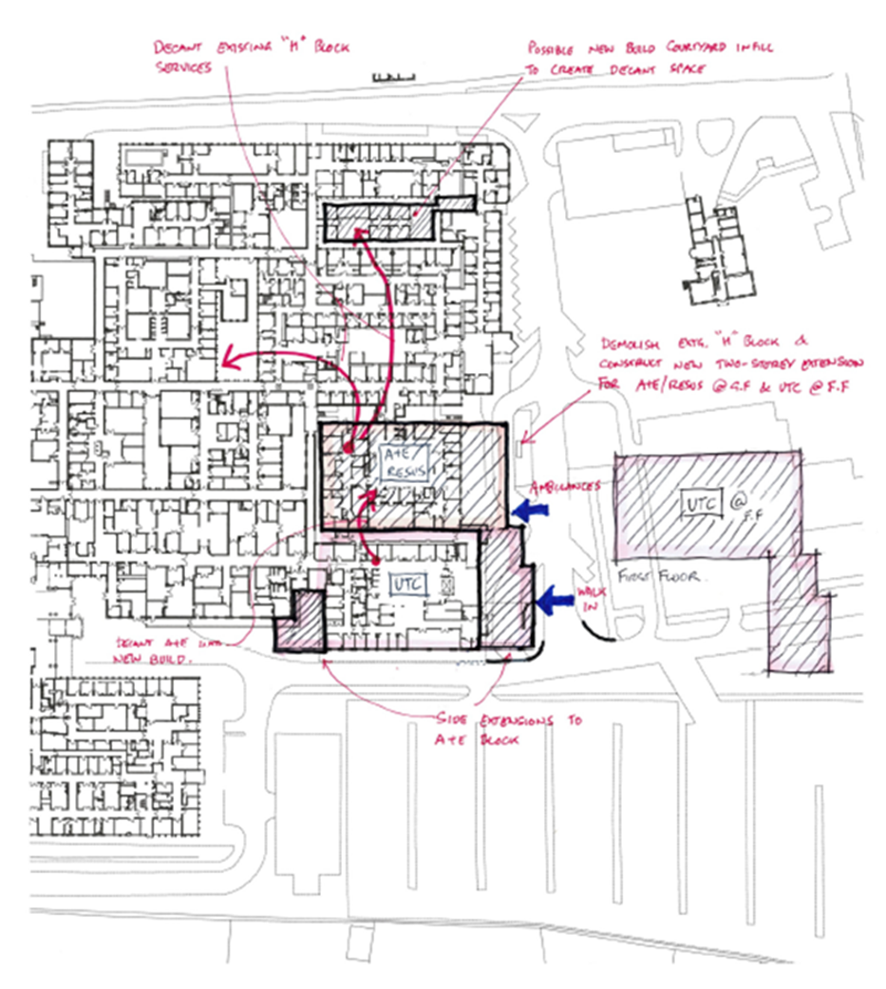  Throughout the design process the needs of all patients were taken into account, including those with protected characteristics, homeless, asylum seekers/refugees, substances users and so on. Existing services will be maintained with no change of location, however, the size of the department will be much bigger. In particular, the accommodation will be improved with:  - inclusion of dignity suite / changing places;  - eradication of the central area or any other space where patients on trolleys can be “parked”, off set with the increase in cubicles;  - cubicles will be single occupancy, with tinted glass fronted doors to improve infection control and afford more privacy;  - DDA compliant designs produced by the contracted architect;  - Increase of facilities for those with mental health problems;  - Dedicated paediatric area away from the noise of the main ED;  - Bereavement facility with relatives room for private viewing.
  Location | Discharge Date | Patient Comments
  ULHT|A&E|PILGRIM A+E DEPT | 02/01/2020 19:30 | The excessive wait time including 3 1/2 hrs for blood test results and then no room for the doctor to examine me which was then done in the corridor and a store room
  ULHT|A&E|PILGRIM A+E DEPT | 06/01/2020 13:00 | Waiting in hallways. No sensitivity.
  ULHT|A&E|PILGRIM A+E DEPT | 10/01/2020 02:13 | The ambulance service is in a bad way. Then to cap it all there were 12 ambulances queuing at a and e .A holding bay. The wards were full. The examination rooms were all full. The corridors were used as holding bays. Otherwise looked after well. But felt that so many hours passed after me falling unconscious etc...6 hours...plus...that I was sent home by 3am. My heart beat settled and blood pressure. But was told to go home and return if it happened again.
  ULHT|A&E|PILGRIM A+E DEPT | 18/01/2020 07:58 | Left sat on a chair over night for approx 10 hours waiting to be seen by a doctor. Another patient in the same waiting area was asleep on the floor in front of me whilst receiving IV fluids as there was nowhere suitable to sleep or lay as she stated several times to care staff that sitting in a chair was uncomfortable and too painful for her. This was uncomfortable to watch.
  ULHT|A&E|PILGRIM A+E DEPT | 11/02/2020 22:00 | No one recommends an emergency service, I would like to point out if you have long waiting periods, having plastic chairs is unacceptable! Everyone was amazing and jolly and awesome but those chairs! Five hours in an uncomfortable unfit for human resting chair is not cool
- Risks and Mitigations
- What actions can be taken to reduce/mitigate any negative impacts? (If none please state so) | No negative impacts have been identified with the project, in fact, most changes are positive for all patients and their carers.  Due diligence will be given to all features of the department to promote equality, for example, taking account of the various common local languages.
- What data/ information do you have to monitor the impact of the decision? | No specific needs have been identified due to the positive nature of the change, although the trust can still monitor a raft of data associated with urgent care, as well as external assessments from CQC and FFT results.

Recommendation

We recommend approval of this Full Business Case for a capital investment of £43.5m, annual revenue consequences of £0.8m together with annual cost improvements of £1.5m.

Signed:

Date:

Director of Finance and Digital, People & OD - Senior Responsible Officer
United Lincolnshire Hospitals NHS Trust

The Strategic Case

Organisational Overview

Lincolnshire has a population of over 1.1M across a diverse demographic spread. The county is the fourth largest in England, with a large coastline to the east. It borders Norfolk and Cambridgeshire in the south, Leicestershire and Nottinghamshire to the west and Yorkshire to the north. It is one of the country’s largest agricultural areas and has long established engineering industries. The county town is the City of Lincoln with the towns of Boston in the south east, Grantham in the south west, Spalding and Stamford in the south and Louth and Grimsby in the north. The resort town of Skegness is on the south east coast, close to Boston.

Key healthcare organisations within the county and involved in the project are:

    - Lincolnshire CCG
Lincolnshire CCG is the CCG responsible for planning, commissioning and developing healthcare services for the population of Lincolnshire. The CCG has a budget of 1.2bn and covers the 790,000 people registered with GP’s living in the county. Management within the CCG is divided into 4 localities – East, South, South West and West. The East locality is responsible for a population of around 240,000. The locality works together with its constituent 26 GP practices to improve the quality and delivery of health services for patients.

    - Lincolnshire Community Health Services NHS Trust (LCHS)
LCHS is the primary provider of community healthcare services across Lincolnshire. LCHS has an annual turnover of c102M and employs 1,800 staff. It delivers care in community settings across a range of services including community nursing, therapy, end of life care, urgent care, public health, children’s health and social care services. It is the provider of Urgent Treatment Centres within both the Pilgrim and Lincoln Emergency Departments and also at Louth and Skegness Community Hospitals. The organisation delivered a surplus of 4.8M in 18/19.

    - Lincolnshire Partnership NHS Foundation Trust (LPFT)
LPFT are the primary provider of specialist health services for people with learning disabilities and mental health problems in Lincolnshire.

    - United Lincolnshire NHS Trust (ULHT)
As lead for the project ULHT are generally referred to in this document as “the Trust”. ULHT are the provider of acute and planned care hospital based services throughout most of Lincolnshire and neighbouring counties. The Trust provides its main services from three acute hospitals – Lincoln County Hospital (536 beds), Pilgrim Hospital, Boston (347 beds) and Grantham and District Hospital (80 beds). Pilgrim Hospital is in Boston is the second largest site. Some outpatient, day case and IP services are provided from 4 smaller sites at Louth, Gainsborough, Spalding and Skegness.

The Trust has an annual income of £643m (20/21) and sees more than 145,000 emergency patients, over 600,000 outpatients and over 180,000 inpatients per year.

The Trust is organised into 4 organisation wide divisions for Surgery, Medicine, Family Health and Support Services. These divisions are led by a Clinical Director, Divisional Managing Director and Lead Nurse / Clinician and performance is reported to the trust board via a performance review structure.

Some of the largest risks in the Trust relate to its workforce. Ability to recruit and levels of staff engagement and morale impact on both financial instability and fragility of services. The Emergency Department at Grantham and District Hospital (the smallest of the main sites) closed overnight due to a shortage of staff in August 2016. Paediatric services at Pilgrim Hospital have previously also been reduced as a result of the poor staffing problems.

The Trust’s emergency services continue to operate under pressure with high attendances and acute admissions. Historically, Pilgrim Hospitals ED struggled to recruit substantive staff, both medical and nursing. More recently there has been significant investment combined with target recruitment programmes which have allowed the department to recruit, retain and develop a substantive workforce. Annual establishment reviews are undertaken, led by the Director of Nursing, based on real time demand and capacity work. A full Medical Workforce Management Project is ongoing to ensure our medical workforce is able to deliver the care we need now, and in the future.

The capacity and demand planning for the physical environment uses current data and planned increases in the population aligned with the ONS estimates. The staffing models have been built along similar lines, noting that the demand will be lower at commencement of the service. Increases in the workforce will therefore need to be staggered in line with demand rather than a big bang approach which may over provide. It is anticipated that, to begin with, some areas of the department may only be utilised for surge capacity, increasing utilisation and staffing in the years ahead.

A full workforce plan, signed off by the division and triangulated with current demand and capacity requirements, is available in Appendix M. The plan focusses on three key areas:

- Growing a multidisciplinary workforce, including creating a resilient senior decision-maker layer of Emergency Medicine staff;
- Reducing attrition in the ED;
- Improving retention of staff working in ED.

The Area Served and its Needs

The Boston catchment area consists of three localities - Boston Area, East Lindsey, Skegness and Coast, all with very different challenges.

Significant health challenges for the locality include:

- A larger population - more people are expected to be living longer and the number of people aged 75 and over, is expected to more than double in size. 23% of Lincolnshire’s population currently are aged over 65 whereas nationally this figure is just 18.6%;

- Heart disease - despite a 40% fall in the number of deaths from coronary heart disease in Lincolnshire in the last 15 years, heart disease continues to be a key cause of premature deaths. 4.1% of Lincolnshire’s population have coronary heart disease compared to a national median of 3.2%;;

- Stroke – 2.3% of Lincolnshire’s population live with the consequences of stroke (national median 1.8%), and older people are more at risk of strokes;

- Cancer - causes one in four deaths in Lincolnshire, yet two thirds of cancers are potentially preventable;

- Diabetes - there are more people living with diabetes in Lincolnshire than the national average (7.9% vs 7.0%), with many more undiagnosed. Age and living in a poorer area are two key factors. People with diabetes are also at an increased risk of having a stroke and dying from heart disease.

National and Local Strategies

There are a great number of national policies and strategies which relate to urgent and emergency care.

Appendix G – National and Local Strategies - provides much more detail of the key documents. The following is a more condensed list of the national and local policies and strategies and how they relate to this project.

Policies and Strategies | Impact on Project
Transformation of Urgent and Emergency Care: Models of Care and Measurement (December 2020) | Describes the consultation on new performance metrics. Introduces booked appointments into ED’s and UTC’s to manage demand and capital to increase capacity within ED’s and 111 services.
Health Infrastructure Plan (HIP) (October 2019) | Provides investment for the NHS to develop capital projects
NHS Long Term Plan (January 2019), plus Updated Planning Guidance (2022) | Improvements in technology and out of hospital care drive the integration of different organisations. The Pilgrim Hospital ED Project will incorporate the acute trust, the community trust and the mental health trust all within one single department. The planning priorities and guidance, 2022, sets out the need to improve responsiveness or Urgent and Emergency Care, supported by creating c.5,000 additional beds (including virtual ward expansion) and eliminating 12-hour waits and reducing ambulance delays.
Five Year Forward View (October 2014) | Acute care systems where a range of primary, community, mental health and hospital services work together to provide a single service
Next Steps on the NHS Five Year Forward View (March 2017) | Prioritised improving ED performance and access to GP and primary care services, including extended access out of hours which will be provided within the UTC element of the project
General Practice: Forward View (April 2016) | Additional funding to support primary care services. A five year STP package of funding for GP practices but also steps to develop workforce and modernise infrastructure and technology
Urgent Treatment Centre’s – Principles and Standards (July 2017) | Sets out the agenda for developing UTC’s on acute hospital sites such as Boston. Patient would be able to access urgent treatment centre’s a minimum of 12 hours a day, staffed by primary care, access to diagnostics such as X-ray. Urgent appointments booked through 111 as well as walk in access. Routine and same-day appointments, out of hours general practice. This would be part of a locally integrated urgent and emergency care service working with ambulance services, NHS111, GPs and the acute hospital ED. This standardisation was part of a drive to simplify urgent care models and use the same nomenclature
The Carter Report (interim June 2015 and final February 2016) | Ensures trusts have a strategic estates plan to reduce estates costs and invest in and reconfigure the estate. Maximises the clinical space planned within the new ED at Pilgrim Hospital and supports the development of a new, more cost effective building
NHS Property and Estates: Why the Estate Matters for Patients (March 2017) | Presented STP processes to redevelop hospital infrastructure to modern standards.
Local Estates Strategies (DoH June 2015) | Established Local Estates Forums between trusts, commissioners and stakeholders. Developed understanding of available estate, aligned to commissioning intentions. Ensures commissioners and providers are aligned in developing new capital projects
Estates and Technology Transformation Fund (ETTF) | Initially as part of the General Practice Forward View and to support developing GP practices but also now invests in technology and modernising workforce
Lincolnshire STP Estates Strategy (draft) | Describes the previous Wave 4 capital bids to develop resuscitation improvements and develop UTC’s at Lincoln and Boston. Describes the “Integrated Urgent and Emergency reconfiguration of estate at Pilgrim and Lincoln County Hospitals” as a key STP service strategy to alleviate the extreme issues at the two sites.
ULHT Estates Strategy | The ULHT estates strategy identified areas of the estate that were in poor condition and considers the backlog maintenance issues and costs to modernise buildings.  The development control plan for Pilgrim Hospital identified the “H Block” as an area for demolition due to the state of the building. The revised plan at FBC also redevelops the maternity block, another area with very significant backlog maintenance issues.
ULHT Clinical Strategy | Considers all elements of the trusts work but in particular looks at where services need to be integrated and more sustainable. This project is aligned with the strategy by providing a more robust service with combined providers and a more cost effective model of care. This is further enforced by the Trusts new Integrated Improvement Plan 2020-2025.  The Acute Services Review is a system level transformation of fragile services. Whilst acute medicine is considered within the proposals there are no actions that will impact Pilgrim Hospitals’ ED. Changes to other clinical services leaving or coming to the site may impact on the number of transfers to or from other hospitals but would not impact the overall demand for the ED.

Definitions

    - Emergency Medicine

Emergency Medicine is the specialist field of medicine that deals with patients presenting to an Emergency Department with the most acute and severe illness and trauma from all age groups and with an undifferentiated spectrum of physical and behavioural disorders.

The specialism has grown from the Casualty Departments of the 1960’s and 70’s initially treating trauma to now encompass critical and acute care for a much wider range of conditions.

Historically, Casualty Departments became known as Accident and Emergency Departments as the speciality developed. Today, the Royal College of Emergency Medicine (RCEM) describes the term Emergency Departments (ED) as most reflective of current practise.

The undifferentiated nature of attendances means that the ED physicians must be trained in a wide range of areas and the ED itself must be divided into areas to treat the varying acuity that presents.

    - Emergency Departments
In England Emergency Departments are divided into three types:

- Type 1: major ED providing 24 hour consultant led services with resus facilities
- Type 2: single speciality ED service such as ophthalmology
- Type 3: other units such as minor injuries and walk in centres

Pilgrim Hospital has a Type 1 ED.

To cope with the undifferentiated range of presentations the ED is usually divided into four distinct areas:

- Triage: Once patients are booked in, they undergo a quick assessment process to determine which area of the department is best suited to meet their condition. Triage is usually undertaken by senior nursing staff and is done at the front door following reception for walking patients or within a Rapid Assessment and Treatment (RAT) area for patients coming in by ambulance;

- Minors: those patients deemed as having minor injuries such as sprains, minor fractures, low level illness – some of these patients are simply offered treatment advice or referred to primary care;

- Majors: for seriously unwell patients a number of cubicles are designated “Majors”. Many of these patients will be admitted or referred on to tertiary centres;

- Resus: for patients who are critically ill, usually brought in by ambulance. These are the acutely unwell patients with undifferentiated presentations as well as those patients within the department at risk of deterioration and who will require enhanced care or continuous monitoring.

In 2017 NHS England, by recognising that ED attendances were increasing and many complaints could be dealt with by other services, funded every acute trust to implement one of three solutions to support ED’s with the lower acuity patients. These were:

- Where there was already an Urgent Treatment Centre on site protocols needed to be adapted to comply with best practise;

- Where there was some kind of Primary Care Streaming in place the service needed to be adapted to comply with best practise;

- Where there was no service in place organisations had to implement a Primary Care Streaming service in line with published best practise by September 2017.

This therefore put an onus on trusts with the available funding to implement a co-located 5th area to an ED for streaming out patients who could be seen in primary care services. Pilgrim Hospital did not, at the time, have a Primary Care Streaming Service so the trust, working with Lincolnshire Community Health Services implemented a new model of care with GP’s and Acute Care Practitioners working out of 4 clinical rooms adjacent to the minors area. Since the OBC was submitted an adjacent area to the ED (formerly OP’s) has been developed to provide a limited UTC service.

Pilgrim Hospital, Boston has a reception with triage, resus area, and majors area within the ED and a co-located UTC.

    - Urgent Treatment Centres

As referenced in section 3.3 there is a specification for a UTC already published and an expectation that all organisations with an ED would be providing this by December 2019.

The core set of standards includes:

- Being able to access urgent treatment centres that are open at least 12 hours a day, GP-led, staffed by GPs, nurses and other clinicians, with access to simple diagnostics, e.g. urinalysis, ECG and in some cases X-ray;

- Have a consistent route to access urgent appointments offered within 4hrs and booked through NHS 111, ambulance services and general practice. A walk-in access option would also be retained;

- Increasingly be able to access routine and same-day appointments, and out-of-hours general practice, for both urgent and routine appointments, at the same facility, where geographically appropriate;

- Know that the urgent treatment centre is part of locally integrated urgent and emergency care services working in conjunction with the ambulance service, NHS111, local GPs, hospital ED services and other local providers.

Pilgrim Hospital, Boston, has an Urgent Treatment Centre but the accommodation is constrained within the building adjacent to the ED. This meets the criteria for UTC but does not provide sufficient capacity or HBN complaint accommodation. There are 6 consultation rooms.

    - Minors

Minors areas are used to treat simple injuries and illness. Increasingly commonly patients are now treated within a UTC or Same Day Emergency Care (SDEC) area and minors areas are being removed.

PHB ED had three small cubicles designated as “minors” although this is not in a separate area to majors. Since the introduction of the UTC these cubicles have now been removed and used for a sluice and quick assessment spaces.

    - Majors
The main “epicentre” of the ED is the majors area where patients with life-threatening emergencies are seen. Majors cubicles are used to assess patients who often require admission to IP beds and in many hospitals is the area that sees the largest delays. “Fit to Sit” areas are designed to take patients who, whilst seriously unwell, do not necessarily need to be recumbent in a cubicle for a protracted period of time. These patients will be seated in an area where they can be treated with dignity and moved to a treatment room if required.

PHB ED has just eight majors cubicles and a fit to sit area created within a further cubicle.

    - Resus
An ED should always aim to maintain an empty resuscitation bay so that there is the capacity to deal with any unplanned emergencies. Emergency Departments take great efforts to continually assess the acuity of patients within the resuscitation bays, stepping them down if necessary to create an empty bay. Current demand means that this is often not possible. Running an ED with all resuscitation bays full creates a serious risk of harm through delayed access to an appropriate resuscitation facility.

The Health Building Note 15-01: Accident and Emergency Departments (April 2013) recommends standardisation of room-handling. That is, each room should have equipment located in the same position, as should communication points, electrical switches and services etc. To develop new resuscitation areas alongside the existing would compromise this and this has been shown to increase medical errors.

The same guidance defines key components of a resuscitation area such as:

- Easy, unimpeded access from the ambulance entrance;
- Space for staff to have 360 degree access to the patient;
- Space for all the necessary equipment within each bay;
- Ceiling mounted twin armed pendants to accommodate equipment, medical gasses and electrical and data connectivity.

The resus area at Pilgrim Hospital, Boston does not meet these standards. The main resus area, an open plan, 4 bay space, is insufficient to get clear access to patients, with all necessary equipment and there are no ceiling mounted pedestals. Gases are provided from ceiling based pipes, hanging down, although oxygen and suction are wall mounted. Monitoring equipment, IT, power is all wall mounted around the bay, inevitably leading to cables tracing across the floor to the patient. There is a great deal of clutter on the floor and on surrounding workspaces. Since the OBC was submitted the department has had to convert a separate area of the department for 2 additional escalation cubicles. This directly contravenes HBN guidance as the areas are geographically and functionally separate. Staff find that each work area is different and describe occasions when asked for equipment they do not know where it is. There are no “grab boards” for commonly used items, and they are often mislaid. Medicines such as antibiotics often require the nursing staff to leave the area to retrieve them from the main ED.

ULHT Performance

The current Emergency Department at Pilgrim Hospital was completed in October 1999. At the time demand and subsequent planning was based on attendances of 130 patients per day. Primary Care Streaming opened in October 2017 providing an additional 3 clinical rooms to see minor injury and ailments. The department now sees an average of 205 patients per day.

The trust is often one of the worse performing trusts in the county achieving just 62.1% of patients seen, treated, discharged or admitted within 4 hours in September 2021 (ED 50.2%, UTC 86.4%), against an average of all trusts of 75.2%.

Admitted and Non-Admitted Performance Against the 4 Hour Target (PHB, 70 days to 7th November 2021, excludes UTC)
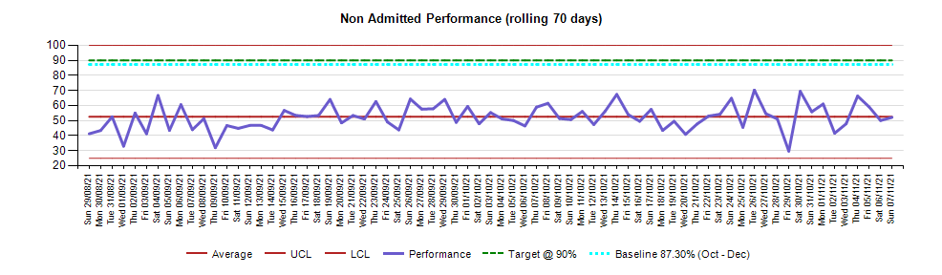
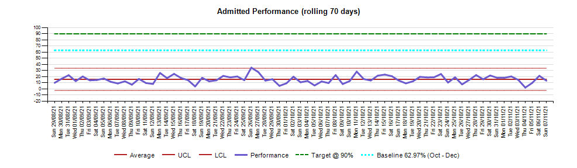

The key drivers for this poor performance include:

- Increased attendances to ED, far in excess of the capacity of the department (as noted by CQC, see later);

- Inability to reduce further the number of ambulance conveyances to each department;

- Ongoing staffing difficulties across urgent care and particularly within Lincoln and Pilgrim ED’s;

- More urgent medical admissions than planned increasing the demand upon the already constrained bed base;

- Inability to reduce further our top quartile length of stay for emergency patients;

- Inability to reduce the number of delayed transfers of care to 3%.

As a result of the above drivers, bed occupancy within the hospital sites remained above 92% during the year, regularly peaking in excess of 100% during winter. This caused delays to admit patients into hospital beds resulting in often overcrowded emergency departments causing delays in ambulance handovers.

Key actions were taken during 2018/19 and 2019/20 which included:

- Redesign of the ambulance handover process;

- Increase to the number of cubicles at Lincoln to support minors;

- Introduction of primary care streaming at Lincoln and Pilgrim with subsequent development into UTC’s;

- Investment in the nursing and medical rotas to right size the staffing to meet demand (recruitment continues);

- Re-invigoration of the SAFER flow bundle, which are a series of good practice initiatives to reduce waiting for patients. This also included ‘Red2Green’, ‘end PJ paralysis’, ‘perfect weeks’ and ‘multi agency discharge events (MADE)’;

- Reconfiguration of the Trusts bed base, and focused work at PHB including a redesign of how patients flow through the hospital.

Key actions for 20/21 included:

- Standardisation of triage processes across the trust;

- Implementation of Same Day Emergency Care (SDEC) facilities and processes;

- Further improvements to ambulance processes such as the use of pre-hospital practitioners within the Rapid Assessment and Treatment (RAT) area, small reconfiguration within the PHB department to improve ambulance flows and the Emergency Physician in Charge (EPIC) having contact with crews via mobile phone;

- Senior leadership assurance groups with membership including partners and CQC.

Investment Objectives

The spending objectives for this project are designed to address the need to improve the quality of public services at Pilgrim Hospital, in terms of the delivery of new policy changes (developing Urgent Treatment Centres) and an improvement on constitutional standards. Reducing waits should increase throughput and reduce costs. The environment for staff and patient safety will be brought up to standards as set out in Health Building Note 15-01 “Planning and Designing Accident and Emergency Departments”, or derogated where further improvements can be made.

To develop the spending objectives a workshop was held with all service commissioners, providers and users to agree a single, unified vision for the service.

This workshop confirmed that the joint providers of healthcare in Lincolnshire are seeking to provide:

Investment Objective SO1: to develop the accommodation for the Urgent Treatment Centre, addressing compliance
Specific | A co-located building (new build or refurbished existing infrastructure) that conforms to “Urgent Treatment Centres – Principles and Standards” (NHS England, July 2017)
Measurable | The service will be designed to provide the correct number of HBN compliant facilities in line with the business needs and will be reviewed from the design and schedule of accommodation
Achievable | Within new premises or existing, redeveloped buildings from the capital allocation received
Relevant | Fits within local and national strategies at a time where demands on the ED exceed the capacity of the existing infrastructure
Time Constrained | To be completed at the outset of the new building going live, in line with the project programme

Investment Objective SO2: to improve access to care for our most seriously ill patients, addressing effectiveness
Specific | A co-located building (new build or refurbished existing infrastructure) that provides capacity to cope with highest demands of patients requiring resuscitation facilities
Measurable | The service will be designed to provide the correct number of HBN compliant facilities (or agreed derogations) in line with the business needs and will be reviewed from the design and schedule of accommodation
Achievable | Within new premises or existing, redeveloped buildings from the capital allocation received
Relevant | The demand analysis demonstrates a lack of provision (which correlates with what our senior doctors have told us) for our most unwell patients who require treatment within a “resuscitation department” or resus
Time Constrained | To be completed at the outset of the new building going live, in line with the project programme
Investment Objective SO3: to improve flow and quality within the remaining ED, addressing effectiveness
Specific | By moving minor injury and illness to the UTC we will reconfigure the remaining Emergency Department to improve outcomes and quality for major illness and injury attendances (majors) and paediatrics
Measurable | The service will be designed to provide the correct number of HBN compliant facilities (or agreed derogations) in line with the business needs and will be reviewed from the design and schedule of accommodation
Achievable | Within the existing footprint of the ED, within the capital allocation received
Relevant | The demand analysis demonstrates a lack of provision for our “majors” category of patients
Time Constrained | To be completed at the outset of the new building going live, in line with the project programme

Investment Objective SO4: to improve the turnaround of diagnostic and pathology services within the Emergency Department, addressing effectiveness
Specific | Reduce delays from poor quality of samples and out of date technology.
Measurable | Turnaround times of pathology samples (current contract is 90% within 1 hour for ED tests  Performance for pathology is just over 90% for all tests except Cardiac Troponin at 89%, this objective will improve all results to over 90% (expected 92%)  For CT the current number of patients scanned within an hour of requesting is less than 50%. This is expected to rise to over 90% with the scanner in the department
Achievable | Options are around improving access by having services closer to patients or improving the infrastructure such as air tubes that deliver services
Relevant | To help improve performance against standards and improve patient care
Time Constrained | To be completed at the outset of the new building going live, in line with the project programme

The workshop agreed a single project to develop each of the spending objectives within what is likely to be a phased plan over 2-3 years. These spending objectives would underlie the ethos behind the project and has been reviewed during writing of the FBC to ensure the scope has not crept in light of any policy or service changes.

Business As Usual

    - Pilgrim Hospital, Boston

Pilgrim Hospital is a district general hospital located to the north of Boston, officially opened in 1977. It has 347 beds and provides all major specialities with a 24 hour Type 1 ED.

The hospital sits to the west of the main entrance from Sibsey Road. The ED is situated at the front of the site, along with the majority of OP services. A 10-floor tower block behind it contains the majority of the wards and IP services:

    - PHB Emergency Department

The gross internal area of the current ED (including circulation areas) is approximately 1200m². The area of the department used for the UTC is 150m². If the current ED treatment areas were “sized up” to meet current HBN requirements their overall footprint would increase from 241m² to 395m². The department is approximately 61% smaller than it should be before considering the need to meet demand.

Just over 15% of space is used for non-clinical reasons, well in line with the Carter Report, 2016, which recommends no more than 35%. That said, the project will consider further options for increased efficiency, adopting Agile Working principles for shared office space and the plan to merge clinical teams with single reception and triage areas will also help to reduce the footprint and overall build costs.

The current service provides a type 1 Emergency Department (a consultant led 24 hour service with full resuscitation facilities and designated accommodation for the reception of emergency patients) for Boston and the surrounding area. The service is divided into two workstreams – “traditional” ED patients are seen by ULHT staff and patients deemed suitable for the UTC (a type 3 ED service) are taken out of the main ED at point of entry by LCHS staff. Annual exercises are performed to review the current capacity and demand situation within ED. These are centred on reviews of staffing, but for the SOC’s for this project physical capacity was considered for both the required resus capacity and UTC capacity. More recent work was completed to look at cubicle utilisation in each of the ED areas and the amount of space that would be required. This was extrapolated for future ONS population predictions.

Patients can attend the ED by one of two routes – walk in or ambulance. Ambulance patients go straight to a Rapid Access and Treatment (RAT) area where they are assessed, or if acutely unwell into resus. Some ambulance patients, although a very limited number, can be referred to the UTC if deemed safe to do so. Most patients will then be moved to a “majors” cubicle where they will await results of investigations, start treatment and then go on to be admitted or discharged.

Walk in patients all now attend the UTC reception. A large number are taken in to this service, led by LCHS. Those deemed requiring the ED are then referred around a short corridor to the ED reception where they are booked in, triaged and taken into majors or minors areas.

The table below shows the Service Line Reporting position of Pilgrim ED for the financial year 2019/20.

Originally the UTC was contained within the footprint of the ED (named the GP streaming service) but due to the need to increase capacity in areas such as resus it was moved into one leg of the adjacent “H Block”. By doing this the trust were able to create an additional 3 consultation rooms for the UTC service. The drawings below show the current layout of ED and the UTC location within the “H Block” which is the building to the North of the ED.

PHB ED Existing Lay out

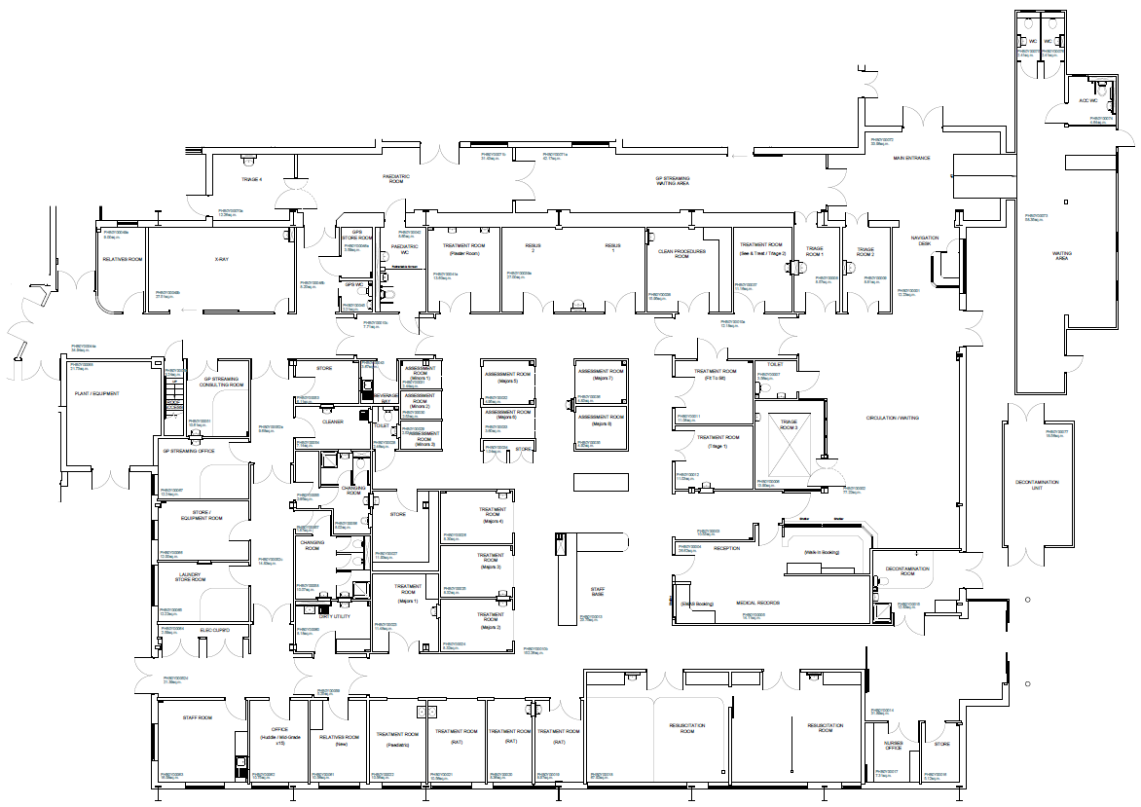

UTC within the “H Block”
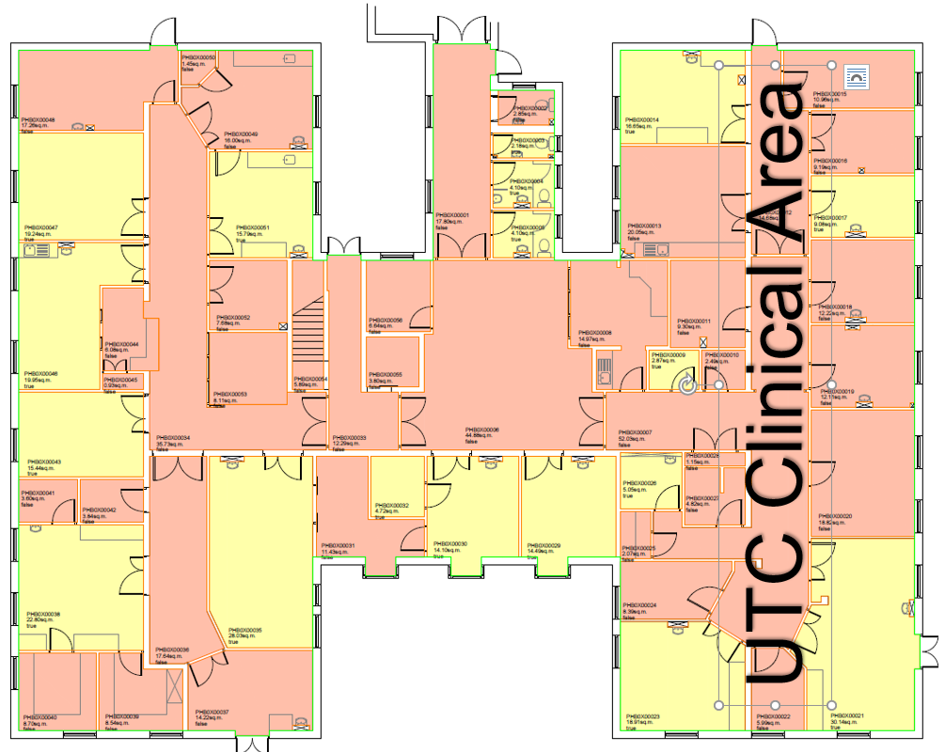

Potential Business Scope and Key Service Requirements

A workshop was held on 13th November 2019 (Workshop 1) to discuss the scope of the project, key service requirements and benefits, risks, constraints and dependencies. This group defined the scheme as a “Project to Develop Resus Facilities, Improve the Urgent Treatment Centre Accommodation and reconfigure the Emergency Department, at Pilgrim Hospital, Boston”. The potential business scope has been split into core, desirable and optional requirements.

The core model would be a simplistic design that fits the scope of increasing resus capacity, building a UTC and redeveloping the space left behind for majors cases. However, more desirable options would improve throughput, have the potential to bring patients back faster to clinic and improve facilities for children. Some of these ideas would need to be carried forward, although some could be left out depending on cost. Some optional ideas were considered, of which few would be taken forward, although one – zoning of the waiting room – was observed in other departments and seemed to work well at little extra cost.

The table below shows the output of the workshop split into Core, Desirable and Optional requirements.

There has been some debate regarding the inclusion of “places of safety” suites. The county’s mental health provider, LPFT, have commenced work to develop a disused site in Boston. The plan was to remove the need for ED to have Places of Safety. Within the OBC it was decided to retain 2 cubicles but not to follow current advice to install en suite rooms. During the design refresh the working group looked again at the potential to create a full place of safety suite in addition to the 2 general cubicles as the LPFT scheme is now delayed with questions over affordability. This is now included in the design, see Estates Annex.

Business Needs

    - Summary of UTC & ED Capacity Requirements
The following analysis uses:

- ULHT/LCHS UTC/ED data from December 2019 (the introduction of the UTC) to August 2021.
- ULHT ED data from January 2019 to September 2021.
- The Office for National Statistics (ONS) growth forecast for the area of 6%.

In order to set out a chain of reason from the data through analysis to insight that, with the addition of context, illustrates a forecast requirement for:

- A minimum of 9 UTC rooms in total (i.e. a further 3 in addition to the existing 6).
- Sufficient capacity to see up to 50 ED patients at a given time, including 8 Resus patients within resus cubicles (i.e. a further 2 Resus cubicles in addition to the existing 6).

The above being strongly in alignment with prior modelling and narrative within the OBC.

The work entailed a top-down approach from monthly averages, and then bottom-up from patient level data to take into account divergence from the mean at the 65%-tile to 85%-tile for low to high variability.

    - UTC Demand and Capacity Modelling (streaming and Minors)
The chart below illustrates the monthly demand for the UTC/ED (type 1 and 3 attends); the current mean value is 6,124 attends per month.

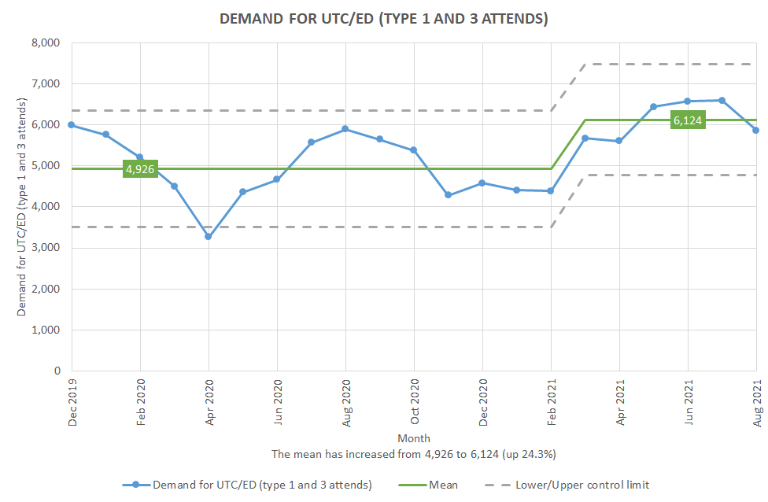

The chart below illustrates the % of the monthly demand for the UTC/ED that is streamed away from the ED, and completed by the UTC; the current mean value is 34.6%.

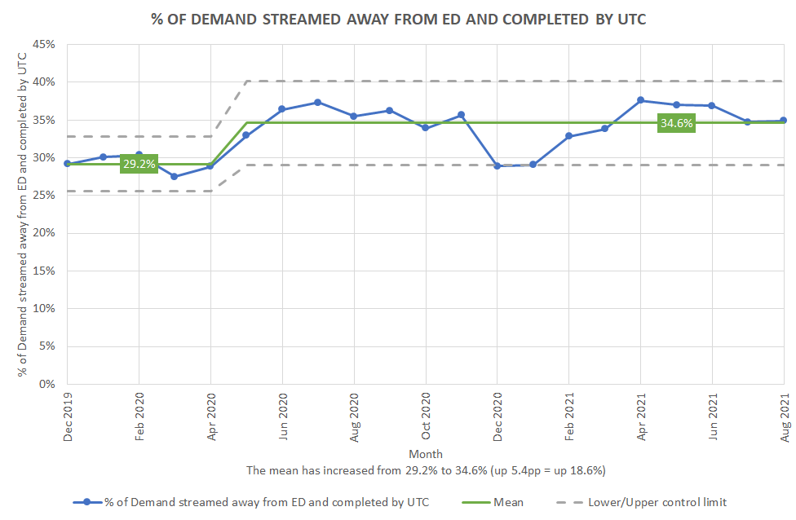

The chart below illustrates the weighted mean total presentation time (mins) per attend. This accounts for the case mix between patients presenting with an injury or an illness, making the assumptions that,

- Illness presentations require on average one 15 to 20 mins consultation.
- Injury presentations require on average two 15 to 20 mins consultations.

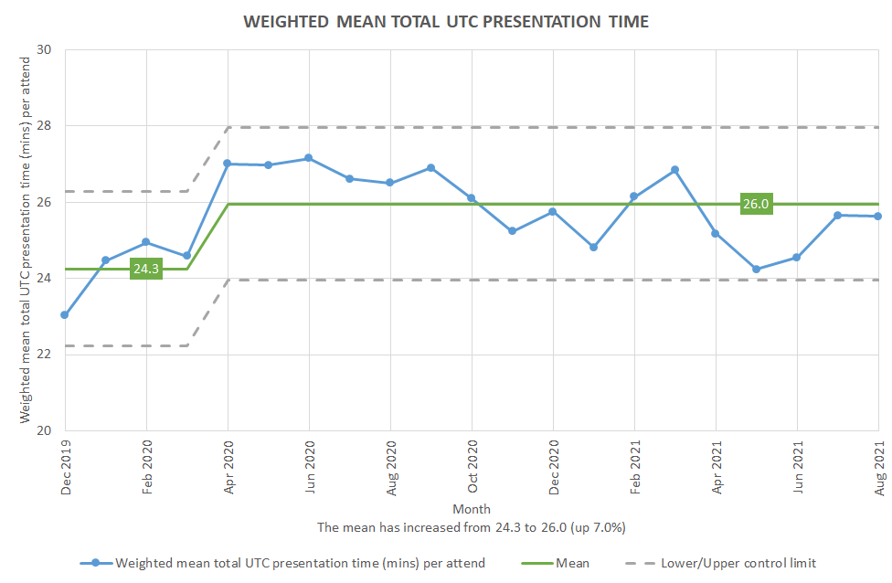

The current weighted mean total presentation time is 26.0 mins per attend.

Multiplying the demand for the UTC/ED, by the % of that demand which is completed by the UTC, by the weighted total presentation time per attend, gives a forecast mean number of mins of demand per month. This mean forecast then needs to be scaled up to take into account of the highly significant divergence from the mean activity that the UTC undertakes throughout the day (see the chart below, for the last three months of the data period).

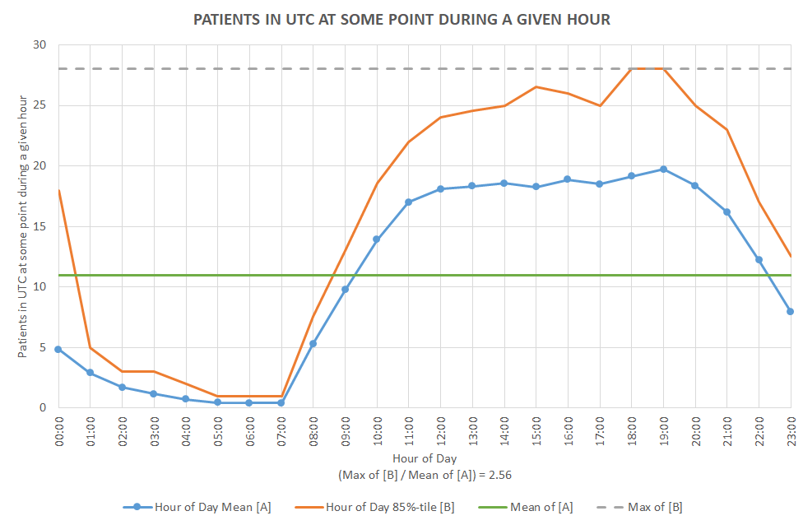

This equates to:

- a 3.5 room requirement to meet current demand (including 2 mins of non-patient facing time after each patient is seen, but excluding any additional time required to move patients to/from other locations necessary to their UTC stay e.g. to/from x-ray);
- a further 2 room requirement for health care support, specialty review, and to allow better patient flow;
- a further 1 room requirement for the initial clinical assessment; giving a total of 6.5 rooms.

In addition to the (much reduced) volume of Minors still currently being streamed to the ED, there are cases when a different skill-mix at streaming would have meant that patients streamed to the ED as a Major would have instead been streamed to the UTC as a Minor. Further to this there is likely to be additional UTC demand in the desired future state as a result of offering phlebotomy services within the UTC.

Given the above, and the observation that other UTC/ED co-located organisations stream at or above 75% of their demand to their UTC; our aim is to increase the volume of demand streamed by at least 15pp, thus streaming at or above the equivalent to 50%; which would require a further 1.5 rooms.

Adjusting the above (6.5 + 1.5 rooms) for the ONS growth forecast for the area results in a forecast requirement for a minimum of 9 UTC rooms in total (i.e. a further 3 UTC rooms in addition to the existing 6).

The above being strongly in alignment with prior modelling and narrative.

    - ED Demand and Capacity Modelling (Majors and Resus)

Demand

The chart below illustrates the monthly demand for the ED; the current mean value is 4,113 patients per month, flat versus pre COVID-19 volumes.

The three charts below illustrate that while the (total) demand for the ED is flat versus pre COVID-19 volumes, there has been a significant increase in complexity. This is due to the volume of Minor demand reducing in a highly significantly manner as a result of streaming Minors from the ED to the UTC, with a comparable volume of Major and Resus demand replacing it.

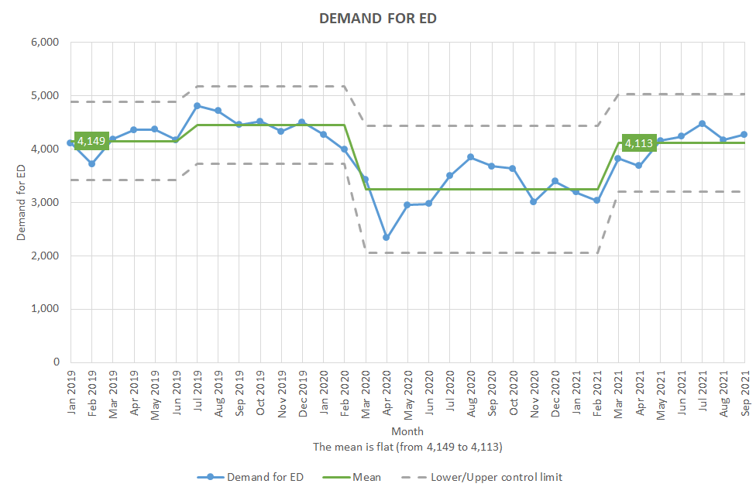

The chart below illustrates the monthly Minor demand for the ED. The current mean value is 207 patients per month, and illustrates the impact of streaming Minors from the ED to the UTC. In the desired future state a highly significant proportion of these patients would be streamed to the UTC.

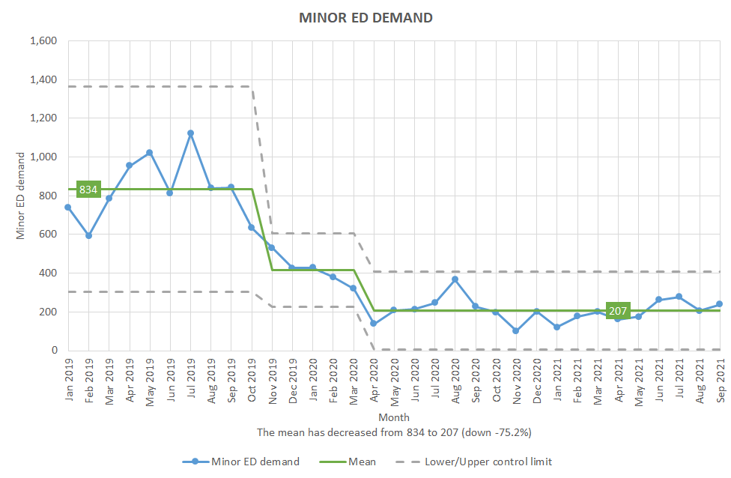

The chart below illustrates the monthly Major demand for the ED. The current mean value is 3,488 patients per month, significantly higher than pre COVID-19 volumes.

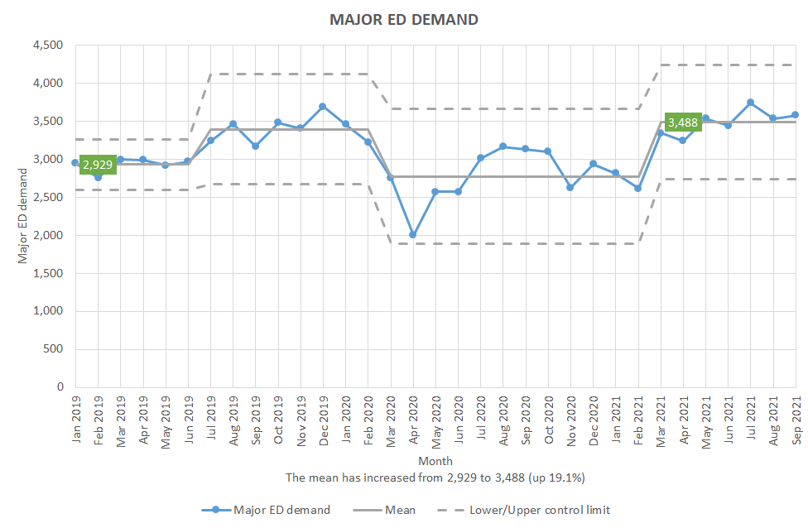

The chart below illustrates the monthly Resus demand for the ED; where the patient was triaged as resus, moved to a resus cubicle (1 to 4, or CED 1 or 2) during their ED stay, and/or was discharged from / transferred out of a resus cubicle (1 to 4, or CED 1 or 2). The current mean value is 461 patients per month, significantly higher than pre COVID-19 volumes.

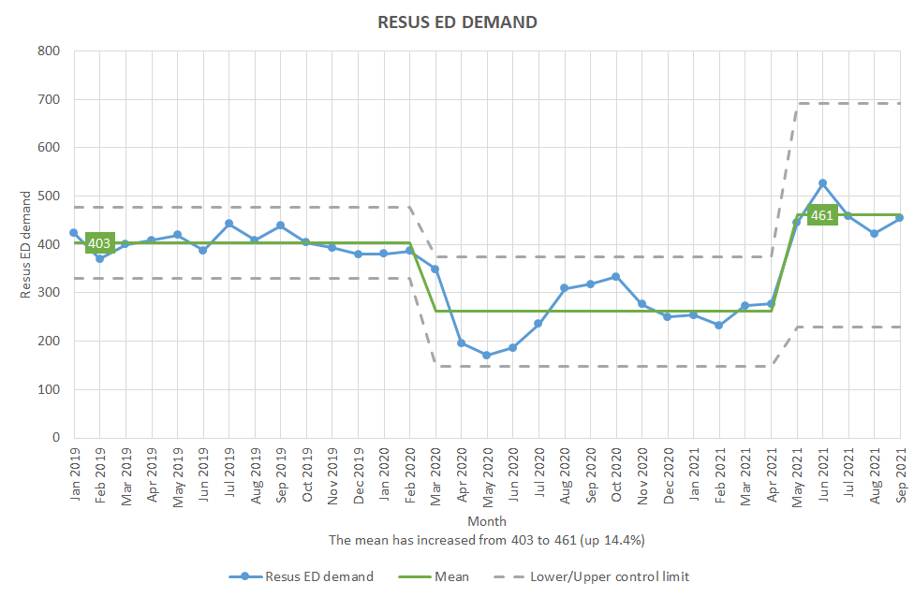

Presentation time

The chart below illustrates the Majors mean total ED presentation time (mins) per attend. The current value of the mean is 367 mins per patient, significantly higher than pre COVID-19 times.

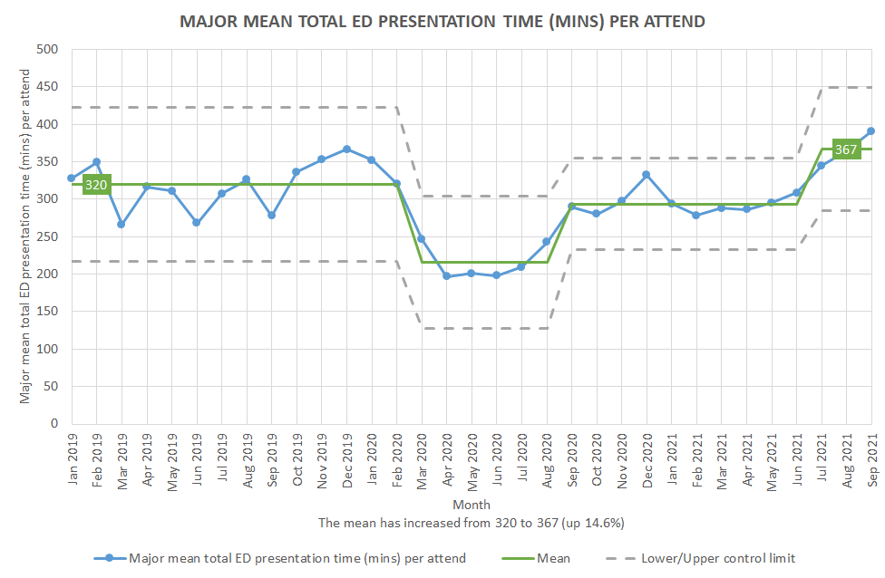

The chart below illustrates the Resus mean total ED presentation time (mins) per attend. The current value of the mean is 493 mins per patient, significantly higher than pre COVID-19 times.

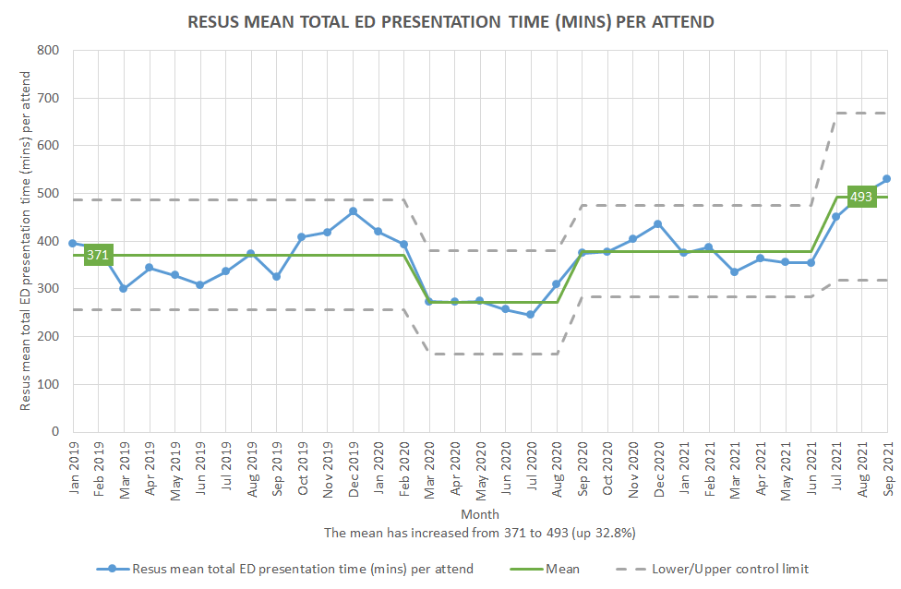

Required capacity

Equivalent to the calculation performed above for the UTC, multiplying the Major and Resus demand for the ED, by the respective total presentation time per attend, gives us a forecast mean number of the respective mins of demand per month. Again, this mean forecast then needs to be scaled up to take into account the significant divergence from the mean activity that the ED undertakes throughout the day (see the two charts below, for the last three months of the data period).

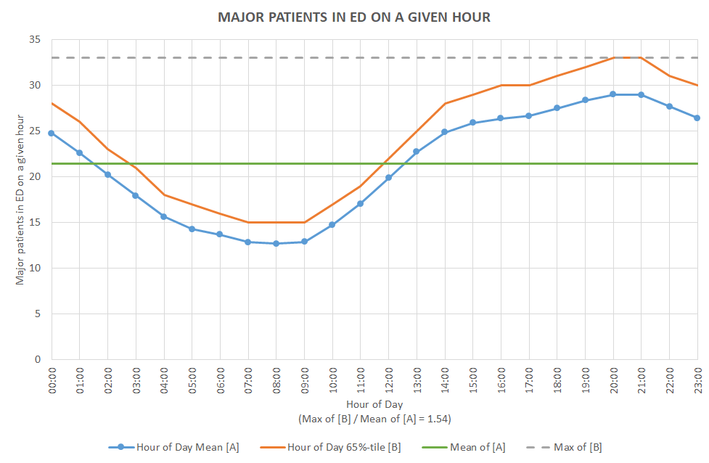
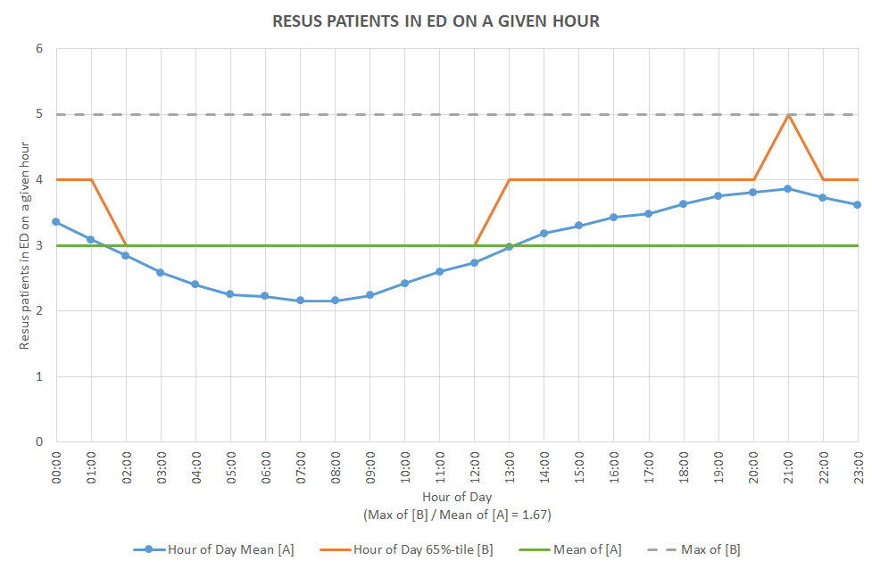

This equates to a requirement for capacity to see 45 Major patients and 9 Resus patients at a given time. This would be the requirement if the two capacities are mutually exclusive (“carved-out”), but this is not the case.

Instead these values must be further scaled down to fit within the scaled up combined Major and Resus footprint (see the first chart below, which is applied to the product of the combined Major and Resus demand and the weighted mean total presentation time (mins) per combined Major or Resus attend), subject to the Resus distribution (see the second chart below, given that the Resus capacity is of primary importance).

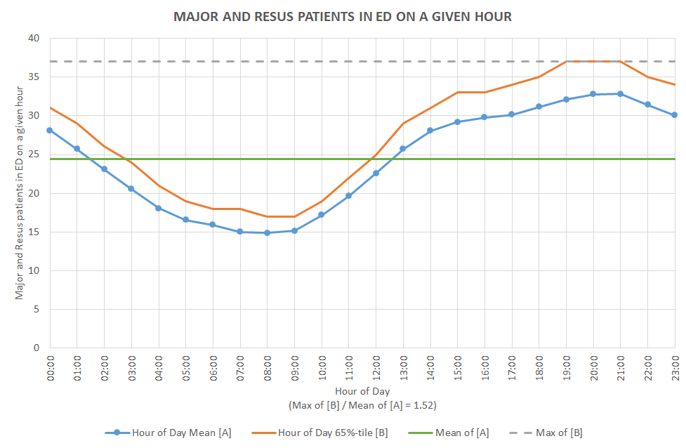

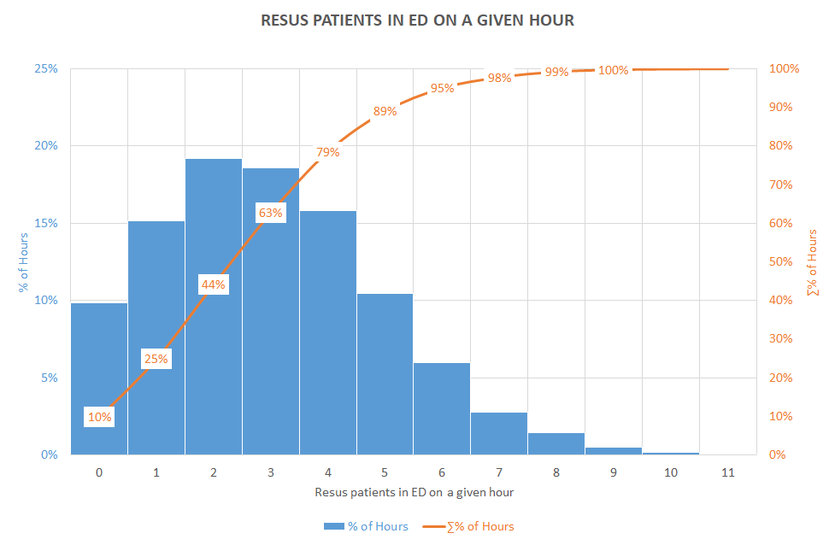

This equates to the requirement for the capacity to see 52 ED (Major and Resus) patients at a given time, including 7 Resus patients in resus cubicles.

Adjusting the above (52 inc. 7) for the ONS growth forecast for the area, given the context that there would have been cases in the past where a less experienced skill-mix at streaming would have meant that patients would have inappropriately been streamed to the ED as a Major rather than appropriately streamed to the UTC as a Minor. The above results in a forecast requirement for sufficient capacity to see up to 50 ED patients at a peak given time, including 8 Resus patients within resus cubicles (i.e. a further 2 resus cubicles in addition to the existing 6). The ability to “see” 42 majors patients does not correlate directly to cubicle numbers in the same way as resus does – some patients are seen within “fit to sit” areas, others in dedicated speciality cubicles, all whilst others are being assessed in the RAIT bays (see below).

The above being strongly in alignment with prior modelling and narrative.

    - Summary of Capacity Requirements
The table below pulls together the above information into one chart demonstrating the demand and capacity requirement for the PHB ED. This excludes additional requirements that add extra value to the scheme such as CT, bereavement and frailty services and is the core requirements for cubicle spaces the department will need.

 | Current Cubicles | Required Spaces / Cubicles
Resus | 4 + 2 temp | 8
Majors | 8 | 43 spaces (includes cubicles, fit to sit, speciality specific rooms etc.)
UTC (inc minors) | 6 | 9 spaces (includes consult rooms, step up rooms etc.)
Paediatrics | 1 | 3

    - Staffing

The Trust uses the Baseline Emergency Staffing Tool (BEST) tool that was developed by the RCN Emergency Care Association and Faculty of Emergency Nursing in 2013 to evaluate staffing requirements. This monitoring is done regularly to ensure staffing is correct for the number of patients attending at any time. There have been significant increases in medical and nurse staffing over recent years:

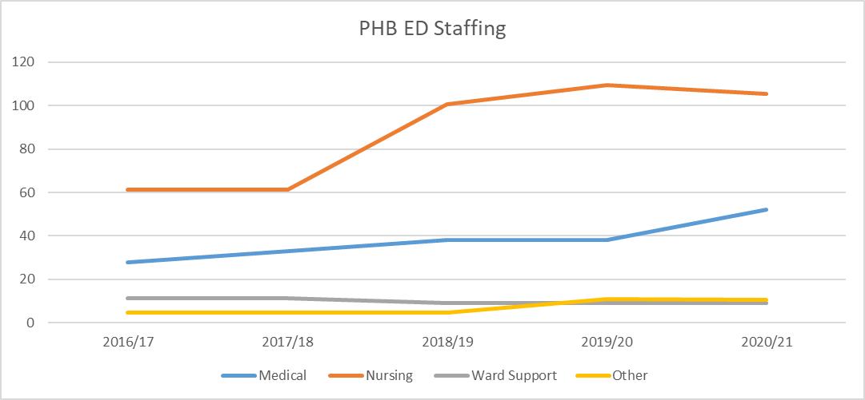

The business case presented is regarding the need to provide a right sized, fit for purpose building. Revenue consequences do not include staffing as this will be dealt with by the Trust / Region as a separate case or cases. The following demonstrates the increase in establishment that will be required as the demand continues to grow over the coming years, this is based on the capacity and demand data within this business case. CCG have been appraised of, and are supportive of the data. The full staffing plan, produced and approved by the Medicine Division is given in Appendix M.

Medical workforce requirements will require an increase as follows with the numbers including a dedicated paediatric middle grade doctor, a resus middle grade and a dedicated “Fit 2 Sit” middle grade:

 | Current | Proposed
Jr | 12 WTE | 24 WTE
Middle Grades | 25 WTE | 38 WTE
Consultant | 12 WTE | 15 WTE

Nursing workforce requirements, based on the BEST tool and as with medical staffing reviewed annually will, in a phased manner, require:

Current Estate | Current Template | Future Estate | Proposed Template
Nurse in Charge | 1 | Nurse in Charge | 1
Pre Hospital Practitioner | 1 | Pre Hospital Practitioner | 1
Fit 2 Sit (16 spaces) | 2 x RN  1 x HCSW | Fit 2 Sit (23 spaces) | 3 x RN  1 x HCSW
Majors & RAT (15 spaces) | 5 x RN  3 x HCSW | Majors & RAT (23 spaces) | 6 x RN  3 x HCSW
Paeds (1 cubicle) | 1 x RN  1 x HCSW | Paeds (4 cubicles) | 2 x RN  1 x HCSW
Resus (6 spaces) | 3 x RN  1 x HCSW | Resus (8 Spaces) | 4 x RN  2 x HCSW
Triage 2 streams | 2 x RN  1 x HCSW | Triage 3 streams | 3 x RN  2 x HCSW
TOTAL | 15 x RN  7 x HCSW |  | 20 x RN  9 x HCSW

In addition, the department benefits from extended roles with advanced practitioners working alongside our medical staff. The new department and supporting Same Day Emergency Care (SDEC) Unit which share ACP staff, will see an increase in Advanced Clinical Practitioners (ACP’s) from the current 10 to 14 WTE.

The plan also discusses the vision to see more types of new roles into the department including Physician Associates and Pharmacist Clinicians.

The recruitment campaign was established at the same time as the Trust agreed to the increase in Medical Staff described above. This targeted campaign has been very successful and there are, at time of submitting the case, no medical vacancies in the department.

Further recruitment initiatives will be undertaken to ensure a stable and growing establishment by:

- Developing CBU recruitment plans as part of the wider workforce planning process;
- Supporting the recruitment and retention of new roles such as Physicians Associates / Pharmacist Clinicians;
- Continuing to focus and develop great employee experiences throughout the recruitment, on-boarding and induction process;
- Providing staff with the right opportunities to develop and build careers within their specialty of choice ensuring staff feel valued in their role;
- Continuing to support our in house CESR training and rotation programme.

    - Diagnostics
Urgent care is served by radiology and pathology for its diagnostics. There is an X-ray room in the ED department and pathology tests are sent to the labs via an air tube system. The site has 2 CT scanners both approximately 1 year old. However, one of the scanners is located outside of the building. To save on costs of the scheme this scanner will be moved into the ED was completed. Downtime of these scanners is low – they are both fairly new – but will increase as they age. Currently, any downtime (planned or unplanned) on the scanner inside radiology means that ED patients have to be taken to the mobile scanner – a significantly increased distance part of which is outdoors. The alternative if the downtime is know is to divert EMAS crews where the crew feel that CT scanning might be necessary which places pressure on other departments. Having 2 scanners reduces the risk of unplanned downtime and is a much better situation than previously but planned downtime remains an issue which would be alleviated by moving the mobile scanner into the ED.

Currently to get a scan, patients have to be taken out of ED to radiology even when both scanners are operational, presenting its own risks and staffing implications – a nurse usually accompanies the patient. The ED refers, on average, 790 patients for CT scans a month – 25 to 30 patients per day. The department is 175m from the ED taking approximately 3 minutes transfer, 10 minutes to scan (average scan time) and 3 minutes transfer back as a minimum. If there are no other delays this means a nurse is absent from the ED for 6-7 hours every day, more than the equivalent of one full time member of staff!

By placing the mobile scanner and X-ray room in a position in ED accessible to both ED and the wider hospital through a separate entrance an out of hours service can operate from just this area, avoiding any additional staffing costs.

Laboratory tests are sent to the labs through an air tube system. The project looked at different options (Appendix L Pathology Paper) to improve results turnaround times as these often exceed the agreed hour. The air tube system is also subject to breakdowns and when this happens specimens are taken to the labs by hand, incurring additional delay. Whilst the project team considered a facility for point of care testing the preferred option was to look at improving the existing laboratory services with improved staffing (separate internal business case) and a dedicated air tube just shared between the ED and pathology. This would be the primary system for the department with the resilience of a fall back to the existing system if the dedicated one fails.

    - Additional Needs
To support performance in the ED the Trust established frailty services across its sites. However, they remain underdeveloped and to create a reduced length of stay for patients a small facility is required close to the ED. This will consist of just a few cubicles and related facilities which can support Same Day Emergency Care, frailty and the potential for some AEC services. In the FBC the plan to decant staff to the maternity block allows us to release some services from the OP building next to the ED. This accommodation will be utilised by the UTC during construction. Once the UTC refurbishment is complete this area will become vacant and the plan is to use part for SDEC / frailty services.

Existing arrangements for patient relatives where patients pass away are inadequate with body viewing often having to take place within the open bay resus area. The plan is to create a separate viewing facility with its own entrance supported by a relatives room.

A Changing Places facility close to the waiting room will provide dignified toilets and cleaning facilities for those patients with severe learning and physical disabilities. This will include also include a changing bench with hoist.

Uncertainty over XXXXXXXXXXXX development has led to a rethink from OBC to FBC on the accommodation for patients requiring places of safety. The two organisation continue to discuss future options but this is likely to take years to resolve. To protect these vulnerable patients the design for FBC incorporates a Safe Assessment room with en-suite and 2 further Places of Safety rooms with their own access within the vacated OP area.

    - Quality of Care
No hard and fast quantifiable data exists to support additional business needs such as changing places. However, the clinical team placed particular emphasis on ensuring the facilities above were included. The team want to provide the best care they can.

Previous comments from patients and CQC make difficult reading but are included here as this gives a clear understanding of the current issues within the department.

Many public comments show that patients are lying in corridors for long periods of time or sat in chairs whilst in pain. There are also comments from patients who have been treated in corridors or store cupboards. These are a few taken over a short period from the “Friends and Family Test”:

Location | Discharge Date | Patient Comments
ULHT|A&E|PILGRIM A+E DEPT | 02/01/2020 19:30 | The excessive wait time including 3 1/2 hrs for blood test results and then no room for the doctor to examine me which was then done in the corridor and a store room
ULHT|A&E|PILGRIM A+E DEPT | 06/01/2020 13:00 | Waiting in hallways. No sensitivity.
ULHT|A&E|PILGRIM A+E DEPT | 10/01/2020 02:13 | The ambulance service is in a bad way. Then to cap it all there were 12 ambulances queuing at a and e .A holding bay. The wards were full. The examination rooms were all full. The corridors were used as holding bays. Otherwise looked after well. But felt that so many hours passed after me falling unconscious etc...6 hours...plus...that I was sent home by 3am. My heart beat settled and blood pressure. But was told to go home and return if it happened again.
ULHT|A&E|PILGRIM A+E DEPT | 18/01/2020 07:58 | Left sat on a chair over night for approx 10 hours waiting to be seen by a doctor. Another patient in the same waiting area was asleep on the floor in front of me whilst receiving IV fluids as there was nowhere suitable to sleep or lay as she stated several times to care staff that sitting in a chair was uncomfortable and too painful for her. This was uncomfortable to watch.
ULHT|A&E|PILGRIM A+E DEPT | 11/02/2020 22:00 | No one recommends an emergency service, I would like to point out if you have long waiting periods, having plastic chairs is unacceptable! Everyone was amazing and jolly and awesome but those chairs! Five hours in an uncomfortable unfit for human resting chair is not cool

In their inspection of June 2019 the CQC rated Urgent and Emergency Services at PHB as inadequate (no change from previous inspection). Whilst the main reason for this was the inability to adequately staff the department with substantive employees the CQC also noted:

- The department was too small for the number of patients it dealt with and this impacted on how patient flow could be implemented. It also resulted in patients being treated in corridors or the central space of the department and having their dignity compromised. The department was not compliant with several standards. However, managers had thought carefully about how to best use the space and staff worked hard to minimise the effects on patients;

- As a result of pressures in the department and ongoing staffing issues, care was not provided in a way that staff wanted;

- The service did not always plan and provide care in a way that met the needs of local people and the communities served. The department was constrained by its size and the premises were not suitable for the number of patients who attended;

- In its actions the trust should take to improve services it stated “The trust must ensure premises across all services are suitable for the purpose for which they are being used and properly maintained. Regulation 15(1)”.

A focused unannounced CQC inspection, specifically for the PHB ED, took place in January 2020, in response to concerning information they had received about the care of patients in the department. They again noted that the department was too small for the number of patients attending, in particular that:

- a shortage of hospital in-patient capacity was preventing admissions and these patients were being cared for in the central area of majors, as well as being located in the plaster room, along the main ambulance arrival corridor (three patients), and also nine patients receiving care in chairs located throughout the emergency department;

- the resuscitation and major’s areas were both operating at full capacity, as was the integrated assessment centre (IAC). This meant there was extremely limited capacity for patients who required resuscitation, or those patients who required management in an appropriately equipped clinical bed space;

- patients were being managed continually in this (central) area during the inspection. We had previously found up to six patients were being nursed in this area. Despite the reduction in trolleys, the area did not lend itself to protecting patients privacy and dignity. Patients remained in close proximity to one-another, therefore impacting on the ability for patients to be sufficiently spaced for infection control purposes;

- the resuscitation area operated at full capacity for the duration of the inspection. Department staff worked tirelessly to try and stabilise patients as quickly as possible in order further resuscitation space could be created to meet demand;

- a patient remained on an ambulance despite having chest pain and having a complex medical history. There was no appropriate monitored bed space for the patient to be relocated to and so hospital staff had been required to commence an assessment of the patient whilst they remained on the ambulance.

In November 2021, the latest inspection, it was again noted that the design, maintenance and use of facilities, premises and equipment did not always keep people safe. However, since the inspection in January 2020 they noted that the department had been reconfigured with a new X-ray room, additional triage room, a modular waiting room, fit to sit area and paediatric area. An additional resus room with 2 bays had been created across the department but at the time of the inspection these were being used as majors bays as the department was at capacity. They also noted that patients were being held on ambulances. Patients presenting with acute mental health concerns did not have access to a dedicated room, they were being placed in an observable majors bay with access to rooms containing hazardous equipment. A lack of storage meant trolleys were blocking corridors, there were no facilities to meet the needs of patients’ families

Benefits

In developing the OBC a series of workshops were held with key stakeholders. The first workshop on 13th November 2019 considered the strategic dimensions to the case including benefits. The list generated was refined throughout the project, including a detailed appraisal of costs. A benefits plan and register was also completed to assist with post project evaluation. Benefits were divided into Direct Public Sector, Indirect Public Sector and Wider Societal Benefits as below. Cash releasing benefits were treated as such if the benefit released costs to the main partner organisations LCHS and ULHT. Non cash releasing benefits were identified as those bringing additional income into the two trusts, but still a cost to the NHS to fund, if they were quantifiable and had improved outcomes. Qualitative, unquantifiable benefits were still evaluated for their impact. In terms of the comprehensive investment appraisal, societal benefits were also considered where some of the benefits could be considered in this category.

A further workshop, with stakeholders, staff and patient representatives, was held on 26th November 2021. This session was used to review the existing register in the OBC to make sure it was still relevant and accurate. The group also considered any additional benefits the options may bring to help strengthen the cost benefit ratio. The full, revised plan and register is given in Appendix O.

As part of the approvals process for the OBC the Trust was asked to review the benefits as part of the FBC to improve cost benefit ratio and comply better with the Public Services (Social Value) Act, 2012. To assist the Trust has been grateful to have support from the PAGABO framework in identifying social benefits and also from the Social Value Engine jointly developed by Rose Regeneration and East Riding of Yorkshire Council. This software assists in calculating what may have been unquantifiable social benefits by using financial proxies from reliable sources.

In a financial appraisal, definite cash releasing benefits may be included to support any spending proposal. Removing WTE staffing from a budget to support revenue for equipment or drugs for example. In an economic appraisal a wide range of benefits should be considered to support with identifying the preferred way forwards from a range of options. These include benefits that may not be either cash releasing or non-cash releasing but more societal in nature. In order to quantify these benefits the Social Value Engine was used to find evidence from a range of sources which most closely matched the benefit identified (proxies). This was then modified for the quantities involved in the PHB project (patients, staff etc) and deflators applied:
- deadweight – how much of the benefit might have been achieved without the intervention;
- leakage – how much of the benefit might have delivered an impact outside of the area intended;
- attribution – the proportion of a benefit which might be claimed by others because they claim their activity also contributed to the benefit;
- drop off – the proportion of the outcome that will diminish / deflate over time;
- displacement – the amount of the benefit that may have been moved or displaced from somewhere else.

The result was a long list of anticipated benefits tempered to what should be achievable and scrutinised to make sure they were relevant at the correct impact. As these benefits were all now largely quantified the cost benefit ratio was strengthened to demonstrate the best solution within the CIA. The benefits register is given below.

Benefit Number | Title | Description | Measure / Baseline / Method | Calculation of Benefit (exc VAT) | Data Source | Collection Interval /  Frequency | Responsible Organisation | Responsible Officer
CRB1 | Lower staff costs due to less reliance on agency staffing | A new clinical model, with shared workforce between acute and community services, based within a new, purpose build department will improve resilience and recruitment, leading to reduced agency costs | Agency spend within ED | £944,195 | Finance | Monthly | ULHT | Medicine Divisional Managing Director
CRB2 | Improved running costs- reduction in ongoing maintenance | Reduction in ongoing maintenance post implementation due to newer accommodation | Estates & Facilities budget | £41,667 | Estates | Quarterly | ULHT | Director of Estates & Facilities
CRB3 | Improved running costs of a new build | New build or refurbished accommodation will reduce the costs of energy by using modern building methods and zero carbon standards | Estates & Facilities budget | £41,667 | Estates | Quarterly | ULHT | Director of Estates & Facilities
CRB4 | Partner organisations reduction in staffing costs due to less reliance on agency staffing | There will be a reduction is agency costs for LCHS, ULHT's community partner organisation A new clinical model, with shared workforce between acute and community services, based within a new, purpose build department will improve resilience and recruitment, leading to reduced agency costs | LCHS agency spend within UTC | £102,500 | Finance, LCHS Finance | Monthly | LCHS | Director of Finance, LCHS
CRB5 | Reduced absenteeism | An improved working environment with reduced stress will reduce staff sickness levels | Absenteeism rates pre pandemic vs post handover rates (5.43% of 132 staff. Assumes a 1% decrease for 1.32 WTE | £80,000 | Workforce Informatics Team | Quarterly | ULHT | Medicine Divisional Managing Director
NCRB1 | Reduced conversion rate | The new department will have sufficient capacity and improved diagnostic turnaround times to enable clinicians time to properly evaluate a patients condition without the pressure to admit to create capacity | PHB converstion rate pre Covid at 20%. | £121,667 | Informatics | Annually | ULHT | Medicine Divisional Managing Director
NCRB2 | Reduce backlog maintenance | New build and refurbished accommodation for the ED will significantly reduce the outstanding backlog maintenance issues within the existing infrastructure | Trust estates strategy | £827,500 | Estates | Annually | ULHT | Director of Estates & Facilities
NCRB3 | Reduce backlog maintenance | Asbestos and improved water supply to the maternity block for the decant will reduce the outstanding backlog maintenance issues within this building | Trust estates strategy | £5,589,445 | Estates | Annually | ULHT | Director of Estates & Facilities
NCRB4 | Improved patient outcomes | There will be a reduction in clinical errors through working in a state of the art department with improved design, ventilation, lighting etc. | 25 incidents in ULHT ED from moderate harm to death in 20/21. NHS Litigation Authority - average NHS Negligency payout c.50k Based on avoiding just 1 | £50,000 | Datix | Annually | ULHT | Medicine Divisional Managing Director
SB1 | Incremental health gains | Improved health for the Lincolnshire population through spending less time in hospital | 100 ED pts x 0.1 QALY @£246 / pt / day * 365 | £748,250 | CCG | 24 Months | ULHT | Strategic Projects team
SB2 | CO2 savings | By achieving better performance against zero carbon standards, emissions will be reduced, | Total CO2e Emmissions per occupied floor area | £8,333 | Estates | 24 Months | ULHT | Director of Estates & Facilities
SB3 | Reduction in handover delays | Reducing handover delays will free up time for EMAS to see more patients | Based on 50% reduction in lost hours per day. | £55,509 | Informatics | 24 Months | ULHT | Medicine Divisional Managing Director
SB4 | Improved patient outcomes | Treatment in a modern ED / UTC, with a faster diagnostic turnaround due to additional CT scanner and laboratory resilience, will give patients higher quality care | Based on 50 pts benefit in 0.1 QALY @426/pt/day*365 | £374,125 | Informatics | 24 Months | ULHT | CSS Divisional Managing Director
SB5 | Improved patient outcomes | The increase in capacity within the ED and UTC will allow patients to be seen faster, improving outcomes | Proxy - reduced cost of treating people with long term conditions | £282,685 | https://publications.parliament.uk/pa/cm201415/cmselect/cmhealth/401/401.pdf | 24 Months | ULHT | Strategic Projects team
SB6 | Improved access | A new design will facilitate safer access to the building, reducing risk | Proxy - collaboration savings | £58,463 | http://social-value-engine.co.uk/calculator/CCVG_SROI_report_fv_120214.pdf | 24 Months | ULHT | Strategic Projects team
SB7 | Improved access | A new design will facilitate improved dignity for patients arriving by ambulance | Proxy - average spend on health per person | £638,051 | http://social-value-engine.co.uk/calculator/public-health-interventions-sep-2014.pdf | 24 Months | ULHT | Strategic Projects team
SB8 | Improved patient outcomes | The department will be better placed to deal with mass casualty events through having greater capacity, which will improve outcomes | Proxy - Average spend on health per person - specifying the number of people we feel will not need the depth of service current users have to provide | £161,545 | https://www.ons.gov.uk/peoplepopulationandcommunity/healthandsocialcare/healthcaresystem/bulletins/ukhealthaccounts/2019 | 24 Months | ULHT | Strategic Projects team
SB9 | Improved patient outcomes | Specialist treatment rooms will improve outcomes for those specific patients by having speciality specific equipment and staff on hand | Proxy - Saving from home treatment alongside inpatient care in an integrated care pathway | £449,473 | https://www.networks.nhs.uk/nhs-networks/regional-mental-health-workshop-mids-east/documents/supporting-materials/nmhdu-factfile-3.pdf` | 24 Months | ULHT | Strategic Projects team
SB10 | Improved patient outcomes | A dedicated paediatric zone will be less stressful and frightening for children and with dedicated equipment and staff on hand will improve outcomes for children | Proxy - Cost of Family Therapy, 6,837 paed attendances at PHB ED in 2021 | £647,694 | https://www.thebritishcbtcounsellingservice.com/fees/ | 24 Months | ULHT | Strategic Projects team
SB11 | Better experience for patients and carers | Improved patient confidence in our services (may also indirectly impact on patient outcomes) due to more professional looking department. A high quality area will improve all round experience of care and improve confidence | Proxy - Improved emotional wellbeing as a result of self-esteem and confidence based on 1% of patients. | £8,332 | SROI Report FINAL - DIGITAL.pdf (wildlifetrusts.org) | 24 Months | ULHT | Strategic Projects team
SB12 | Improved reputation | A state of the art department with better patient outcomes and staff retention will improve the organisations reputation | Proxy - Cost of Family Therapy | £417,302 | https://ella-foundation.org/stage-2-predictive-sroi-report-study/ | 24 Months | ULHT | Strategic Projects team
SB13 | Improved staff satisfaction, morale and wellbeing | Reduced pressure and improved relationships with EMAS will support staff in both teams to have better job satisfaction, mental health and wellbeing | Proxy - Better career development opportunities | £416,291 | https://www.wildlifetrusts.org/sites/default/files/2019-09/SROI%20Report%20FINAL%20-%20DIGITAL.pdf | 24 Months | ULHT | Strategic Projects team
SB14 | Improved staff satisfaction, morale and wellbeing | The department will be better placed to deal with mass casualty events through having greater capacity, which will improve staff job satisfaction, mental health and wellbeing | Proxy - Improved emotional well-being as a result of self esteem and confidence | £49,182 | http://social-value-engine.co.uk/calculator/Value%20for%20Money%20Statement%20%E2%80%93%202014.pdf | 24 Months | ULHT | Strategic Projects team
SB15 | Improved patient outcomes | The creation of negative pressure areas in resus will improve IPC and ability to cope with pandemics | Proxy - Enhanced Feelings of Residential Satisfaction | £421,702 | http://social-value-engine.co.uk/calculator/Value%20for%20Money%20Statement%20%E2%80%93%202014.pdf | 24 Months | ULHT | Strategic Projects team
SB16 | Improved patient outcomes | The creation of donning and doffing areas in resus will improve IPC and ability to cope with pandemics | Proxy - Enhanced Feelings of Residential Satisfaction | £421,702 | http://social-value-engine.co.uk/calculator/Value%20for%20Money%20Statement%20%E2%80%93%202014.pdf | 24 Months | ULHT | Strategic Projects team
SB17 | Improved staff satisfaction, morale and wellbeing | An improved design, more calming with better performance times, will reduce incidents of violence and aggression towards staff | Proxy - Crime against the person | £317,470 | https://assets.publishing.service.gov.uk/government/uploads/system/uploads/attachment_data/file/732110/the-economic-and-social-costs-of-crime-horr99.pdf | 24 Months | ULHT | Strategic Projects team
SB18 | Improved staff satisfaction, morale and wellbeing | Improved staff morale through better CQC inspection reports | Proxy - Improved organisational culture leading to more motivated staff | £654,985 | https://www.accountsandlegal.co.uk/small-business-advice/average-employee-cost-smes-12-000-to-replace | 24 Months | ULHT | Strategic Projects team
SB19 | Improved training facilities | Staff will have facilities on site for training including a resus simulation area. This will improve the knowledge, skills and confidence of staff. | Proxy - Average cost of a personal development course | £169,964 | http://social-value-engine.co.uk/calculator/Two%20Day%20Personal%20Development%20Training%20Course.pdf | 24 Months | ULHT | Strategic Projects team
UB1 | Improved constitutional standards | The increased capacity and new designed operational model will improve performance against the 4 hour standard | Data produced internally from informatics but cannot be confined to just this project | N/A | Informatics | 24 Months | ULHT | Medicine Divisional Managing Director
UB2 | Improved contractual performance for pathology | Improving the infrastructure to pathology (provided by Pathlinks, Northern Lincolnshire and Goole Hospitals) will improve their ability to meet contractual obligations  IO4 - To improve the turnaround of diagnostic and pathology services within the ED | As per the Pathlinks contract | N/A | Pathlinks / informatics | 24 Months | Pathlinks | Pathlinks Service Manager
UB3 | Improved paediatric services | Current service has no division between adult and paediatric patents. A separate waiting area will improve safety | CQC Reports | N/A | CQC Reports | 24 Months | ULHT | Medicine Divisional Managing Director
UB4 | Improved staff satisfaction, morale and wellbeing | Staff will have better job satisfaction, mental health and wellbeing through working in a modern facility that allows them to provide better care for patients | Staff Survey | N/A | Staff survey | 24 Months | ULHT | Medicine Divisional Managing Director
UB5 | Improved bereavement services | Families will be able to spend time with recently deceased patients in a private area with separate access so they do not need to walk through the ED, or view within the resus area as per current arrangements | FFT / CQC | N/A | FFT / CQC | 24 Months | ULHT | Medicine Divisional Managing Director

Risk

This section of the FBC describes the path the register has taken to get from the early stages of the project through OBC to its current live status.

Since OBC stage the risk register has been developed and refined to much greater levels of detail. Many individual risks are now costed out fully. The register has been developed from the original Cabinet Office Risk Potential Assessment (RPA, Appendix I), through to additional risks identified at initial stakeholder workshops and to detailed design and construction risks identified by the design and project teams whilst developing the detailed plans for the FBC. The risk register is, and will continue to be until the end of the project, a live document. Some initial risks have now been discounted or closed. The register currently lists over 100 individual risks and is given in Appendix P.

For financial evaluations within the FBC only key risks are considered. These are risks that are generic to any option, risks that may vary between options, or risks that are specific to individual options. For the financial case within the FBC a contingency sum based on costed risks has been applied as a percentage within the capital ask.

The development of the risk register is identified below.

    - Risks Developed within the RPA

Highest rated risks within the RPA related to political interest, trust priorities to improve urgent care and the need to move the project at pace. There were 4 risks rated very high:

Strategic Impact Area |  | Very Low | Low |  | Med |  | High | Very High
A1. Political | None, or unlikely to have any political interest. |  |  |  |  |  |  | X | As a prerequisite for major policy initiative or manifesto commitment, a high level of on-going Ministerial or political interest. Likelihood of PAC, or equivalent strategic body, interest.
Explanatory Notes
(Completion mandatory)
Scored VH due to a high level of on-going Ministerial or political interest. Announcement for funding for organisations was made by the Prime Minister in person at Pilgrim Hospital.
A4. Operational business and commercial change | Low priority, limited impact on the organisation’s administration, operations or staff.  No impact on third party organisations. No changes to regulatory requirements. |  |  |  |  |  |  | X | Departmental priority, addressing high profile business issue. Essential to fulfil legislative/legal requirements. Significant impact or additional burden on business or staff, on external commercial markets, regulations or trade. The change is novel or contentious.
Explanatory Notes
(Completion mandatory)
The project is critical to delivery of urgent care on the site and thus an extremely high priority. It will cause a significant impact and burden on staff during the building work and will represent a completely different way of working with integration of 2 separate trusts.
B1.3. Business performance | No significant change to the organisation’s business. No change to the operation of external bodies. |  |  |  |  |  |  | X | Very high business performance profile. Changing demands or expectations of performance or staff or behaviours. Significant changes to consumer or business operations.
Explanatory Notes
Complex contractual changes to staff working in the delivery of urgent care. New patient pathways significantly changing the way A&E works. Careful consideration of how these changes will be implemented without any change in expectation from patients.
B4.1 Time | Timescales not challenging, no external drivers. No imposed changes expected to the agreed schedules. Contingency available and tested business continuity plans. |  |  |  |  |  |  | X | Schedules very challenging. Immovable deadlines. Major changes to deadlines or imposed deadlines likely to occur. Very limited or no contingency or contingency options available.
Explanatory Notes
High pressure to deliver quickly due to political pressure and the need to reform urgent care may lead to significant constraints and unknown issues throughout the project.

The Cabinet Office Risk Potential Assessment is included in Error! Reference source not found. but scores overall as high risk due to the key risks of high value and political interest captured above. The Risk Potential Assessment was completed early in the project and is held by the SRO.

Excerpt from the Cabinet Office Risk Potential Assessment
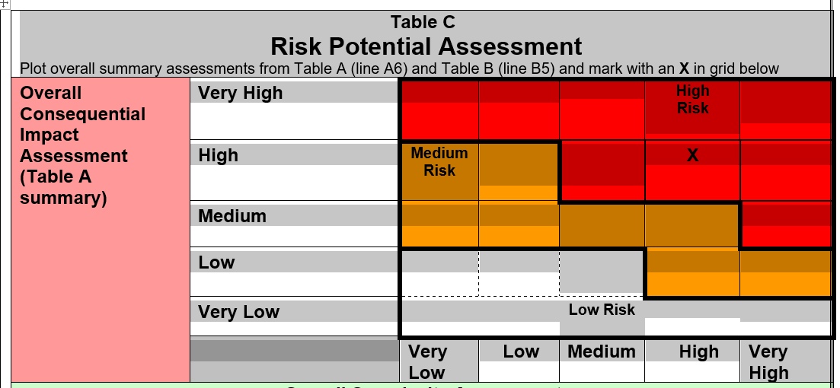

    - OBC Risks

During the development of the OBC workshops and project meetings helped to determine more detail on the risks to the project in terms of business risks, service risks and external risks. Many concurred with the risks as stated within the RPA and, for ease, are removed from the below:

Business Risk | Mitigation | Potential Cost
Economic risks from Covid-19 causing reduced or lack of funds to support developing hospitals. | Some early draw down funding received. Would have to review potential scope of scheme depending on what funding may be available. | Any value up to agreed funding of project – 0 – 21.3M.
Reputation risks from failure or delays to the provision of the new building. | Careful planning throughout development of the project. Involvement of external consultants for M&E, architectural etc. | Unquantifiable as emergency services income unlikely to be affected. May be a level of risk for the wider organisation in terms of elective work.
Service Risk | Mitigation | Potential Cost
Design Risk – service not adequately future proofed, leading to compromise on less critical areas which would still undermine quality and patient experience, e.g. paediatric and mental health areas. | Careful calculation of future demand based on ONS data and historical rise in demand at PHB ED. Working closely with architect to ensure accurate accommodation schedule and plan options to try to accommodate “core” list if compromised. | QALY cost on % harm to paeds from shared accommodation
The wider hospital does not ensure adequate response for patients no longer needing ED – facilities such as the Frailty Unit and adequate social care to help get patients home. Without this ED will remain full with long waits. | Medicine divisions plans to improve same day emergency care and reduce length of stay. Frailty is on the “desirable list”. | QALY cost on % potential # pt delays * potential impact on health
Inadequate provision of administrative and educational facilities. If the project focusses too heavily on clinical areas there is a risk that the design may not provide adequate space for administrative functions. There is also a significant need for staff to train, especially when working in resus. | Planning must be around 70/30 for clinical vs administrative and training space. Planning to include resus simulation room and seminar rooms. | Quantifiable in terms of resus performance.
Pathology results currently take too long to reach the department. The project has considered an incorporated laboratory within its optional list, although this will be expensive. | The service provider has provided an alternative of a dedicated air tube into the existing lab which will be cheaper and provide the same results. | Qaly – delays for diagnostic tests
Technological risk – IT systems in the department must be robust and communicate with existing systems. | Working closely with the ICT department throughout all aspects of the project to consider new and novel ways to incorporate better systems and hardware in clinical areas. | Quantifiable
External Risk | Mitigation | Potential Cost
Flood risk – Pilgrim Hospital is in a flood plain and has a potential risk of flooding. | Flood barriers can be brought in to protect the site as part of the business continuity plan. | Potential for damage to building if defences fail. Wouldn’t be full 21.3 but likely damage
Pandemic risk – if the design is not safe then there is a risk that patients could be infected by positive patients in the department. | Working with architect to design areas that can be segregated off. Multi-use spaces to allow function to be changed, e.g. minors to majors, in the event parts of the department are closed off. | QALY cost for ave attendance and % affected * potential harms
Technological risks – the NHS has had previous experience of “cyber-attacks” which may happen again in the future. | Boundary firewalls, segmentation, defence in depth, Dionach reviews etc. | 300k (based on Wannacry response)

    - FBC Risks

The risks in the FBC risk register are broken down into categories of briefing risks, design risks, planning risks, programme risks, construction risks, commissioning risks, performance risks, operating risks, revenue risks, termination risks, technology / equipment risks, control risks and other risks. Each category has a number of subcategories that enabled the project team to drill down into the risk location – new build, financial, business case etc. The detail therefore contains higher level risks such as the location of the site being within a flood plain as picked up within the OBC but also more specific construction risks such as the location of stairwells not fitting HTM guidance. The latter were more easily resolved with the risk register being discussed fortnightly and many of these risks were closed as the project moved forwards.

Risks within the FBC Risk Register are described as would be expected. Risks are assessed in terms of likelihood and impact, also pre and post mitigation. Costs are applied pre and post mitigation also. It is these post mitigated costs that went on to inform and correlate with the optimism bias applied to the budget.

Significant high=level risks within the risk register at this stage include:

 |  |  |  |  |  |  | 
 | Pilgrim Hospital ED and UTC Development Project - Risk Log 28/02/2022
 |  | Pre mitigation/Current Risk Score |  |  | Post mitigation/Current Risk Score
Risk ID | Description | Likelihood | Consequence | RAG | Likelihood | Consequence | RAG | Mitigation plan | Owner
33 | Shortages of materials / delays to supply goods impacting the project | 4 | 4 | 16 | 2 | 3 | 6 | Contractor to manage the supply chain as well as possible and forward order if necessary to ensure the project is not impacted. Alternatives to be proposed which are suitable / necessary to achieve the project. Contractor to utilise British materials where possible. Preferred list of Subcontractors has been approved by ULHT | Contractor
44 | Unrealistic scheduling & delays to approval | 4 | 4 | 16 | 3 | 3 | 9 | Good team collaboration and set sensible targets / approval dates with advance calendar notifications. Regular meetings with NHSE to keep up to date with latest FBC progress | ULHT
49 | The maternity block works must be completed to allow staff and services to be decanted into the space prior to demolition of the H Block | 4 | 4 | 16 | 2 | 4 | 8 | Good team collaboration and set sensible targets / approval dates with advance calendar notifications, to ensure the maternity block works are completed asap. Regular team meetings taking place to track progress. Asbestos contractor appointed 30/12/2021. Refurbishment contract awarded to GRAHAM | ULHT / Contractor
21 | Current inbound escape stair location is non-compliant with HTM05-02 | 5 | 3 | 15 | 1 | 3 | 3 | Further design review required to rectify non-compliance. ULHT to confirm relocation of East exit | Contractor
27 | Late request for piped Entonox (and manifold room) | 5 | 3 | 15 | 4 | 2 | 8 | GCL team to review options for adding the piped Entonox system and manifold room and confirm the impact, ULHT to confirm location. ULHT to consider the impact and confirm whether they wish to proceed with the change or continue using bottled Entonox as existing | ULHT / Contractor
81 | The existing fire escape staircase for Medical Records (to be repositioned to maintain a fire escape from Medical Records) may not be compliant with the latest building regulations / legislation | 3 | 4 | 12 | 3 | 3 | 9 | Trust to liaise with Fire Consultant to understand whether the existing fire escape staircase is compliant with the latest regulations / legislation. If this is not the case, the Trust are to confirm what action is to be taken to ensure compliance
109 | PHB is located in a flood plain area and has a potential risk of flooding | 3 | 4 | 12 | 2 | 4 | 8 | The Trust has had discussions with flood mitigation companies and will look to bring in flood defences at 200k. Price & Myers currently investigating mitigation measures with specialist advice. Design to incorporate required flood mitigation measures | ULHT / Contractor
4 | Development of design / design brief not finalised prior to GMP | 3 | 4 | 12 | 2 | 3 | 6 | Continued engagement with Clinicians, End Users, Estates etc throughout the design stage of the project to ensure requirements are met and the GMP can be produced to the required standard | ULHT / Contractor
28 | The position of the substation on the roof of the ED is not suitable for the Trust from a maintenance perspective and therefore, a late design change is required | 3 | 4 | 12 | 2 | 3 | 6 | GCL to check compliance against HTM00. Meeting held on 09.12.2021 to look at alternatives / discuss impact of any change. Trust to confirm preferred substation location on 13/12/2021 | ULHT / Contractor
71 | Disruption to patient waiting areas during construction activities | 4 | 3 | 12 | 2 | 3 | 6 | Further design development is required regarding the utilisation and accommodation of a waiting room during construction | ULHT / Contractor
74 | Unplanned incident where services are hit by construction works | 3 | 4 | 12 | 2 | 3 | 6 | GPR & Catscan to be undertaken by GRAHAM to locate underground services. 28/10/2021 borehole has been dug to commence investigations | ULHT / Contractor
94 | Removal of the lift will impact medical records staff as they use the lift to carry large amounts of physical medical records | 4 | 3 | 12 | 3 | 2 | 6 | Temporary lift could be put in place for staff use, consultation with medical records team required. Medical records to potentially move to maternity block (third floor) - designs have been produced. P+HS to explore a FF link from the new ED to the outpatients block | ULHT / Contractor
95 | The position of the substation on the roof of the ED poses as a maintenance burden for the Trust | 3 | 4 | 12 | 2 | 3 | 6 | GCL to check compliance against HTM00. Meeting held on 09/12/2021 to look at alternatives / discuss impact of any change. Trust to confirm preferred substation location on 13/12/2021 at which point any impacts will be discuss further | ULHT / Contractor
110 | Spend profile not achieved for 2021 / 2022 year end due to unrealistic scheduling | 3 | 4 | 12 | 2 | 3 | 6 | Trust to schedule and monitor the spend profile for the year | ULHT

Not all risks are possible to quantify and this would lead to an exaggerated risk budget. Risks costed in the register were undertaken with single point probability analysis in line with HMT Green Book methodology and reduced in line with mitigation values:

The risk register is frequently reviewed and mitigation adjusted. During development of the CIA the Trust were asked to remove the £21.3m political risk. However the project team felt it still needed acknowledging and reduced the mitigation factor from 3 to 2 – from £2,556,000 to £1,704,000 taking the overall risk to £2,143,440. This figure continues to vary somewhat, but has remained at c.£2.2m in the project budget.

Constraints

From the outset, the working group recognised that one of the biggest constraints to the project was the announcement of capped funding based on two separate strategic cases. This project should have started from a combined Strategic Outline Case and, whilst this would have given approximate indications of costs this would not have been confirmed until the Full Business Case is submitted. Placing a finite capital amount at the outset of the project could well constrain decisions on the design. A better approach would be to design a building that best fits the spending outcomes and work out the capital requirements afterwards. Designs can then be adjusted if capital funding is not available.

Roads and car parks to two sides and existing buildings to the North and West surround the ED and UTC. The preferred way forwards does not require a move to any of the roads as had previously been considered. However, the existing adjacent buildings will be protected during the works or, as in the case of some outpatient services, moved to the maternity block along with the services within the H Block. The outpatient move has a co-dependency in that it will allow UTC services to be moved there during the build and protect this service. This has all been scoped within the decant plan / arrangements.

Electrical infrastructure is insufficient. A key workstream within the project has been the discussion around power into the site with requirements from Western Power for an additional substation. As power requirements are an issue for the whole site only the requirement for the ED part of any cost has been considered within the project. Costs for substation to service the ED are included within GMP.

The fact that this is a busy service places a constraint on the project. The scheme will need to make allowance for continued provision of urgent care services by phasing the build. The design has taken into account the concept of multi-functional clinical spaces which will help in moving different acuity groups of patients as the works progress.

There is a potential constraint with the project being operated by multiple agencies. Each of these agencies is accountable for its performance, financially and operationally. By operating the workshops with full engagement of all system partners this constraint has been managed but will be monitored throughout the project.

Dependencies

There is an external dependency outside the project environment in that the success of the project – in terms of urgent care performance – is dependent on flow out of the emergency department to the wards. When this falls down patients remain in ED too long, affecting their outcomes and the Trusts performance. That is to say that the success of the projects outcomes is dependent on the external performance of business operations in the wider hospital.

The Trust is progressing towards implementing an EPR. This business case is not dependent on the EPR, it is standalone, however, it is recognised that there will be additional benefits from an EPR system to the ED, as with all other departments in the organisation.

Services such as diagnostics, portering, cleaning all provide input into the Emergency Department and have been kept aware of the progress of the project throughout. Although numbers into the ED are not expected to increase at the outset this would be reviewed as part of normal business as usual processes.

Provision of CT into the department is a new service and radiology have been consulted. During Covid an additional scanner was brought into the site and staffing increased for this. This scanner will move into the ED and any required staffing will go with it.

East Midlands Ambulance Service are a key stakeholder in the design. And have been consulted throughout. The additional space within resus and majors should have a positive impact on turnaround times and will be monitored as it is currently.

Various media have been in contact with the trust during the development of the FBC and this is expected to continue during the build. There is obviously high level interest in this project, especially so since the Prime Minister himself announced the funding at Pilgrim Hospital. The Trusts communications team have developed a communications plan (see management case) which is being deployed to help manage queries and keep the media and public informed of progress.

Summary of the Strategic Case

Summary of the Strategic Case
Investment Objective SO1: to develop a new building for the Urgent Treatment Centre
Existing Arrangement | 6 temporary clinical rooms extending into the OX (H) Block built due to increasing demand (at OBC 3 rooms)
Business Need | An increase in capacity to cope with rising demand and to take all minors patients out of ED
Potential Scope and Services | Space to see up to 9 patients in consultation rooms, step up rooms etc.
Potential Benefits | Improved access and patient satisfaction
Potential Risks | Reputational in the event of delays, failure or excess costs. Developing complex workforce systems
Potential Constraints | Location and pre-agreed capital
Potential Dependencies | No interdependency currently identified

Investment Objective SO2: to improve access to care for our most seriously ill patients
Existing Arrangement | 4 resus bays in a single room, 2 additional bays recently created at the opposite side of the department
Business Need | To increase capacity to cope with rising demand whilst improving the environment
Potential Scope and Services | 8 separate bays with physical division
Potential Benefits | Improved patient outcomes
Potential Risks | Novel working practises creating complexity, strategically our ability to staff the department, phasing issues
Potential Constraints | Location and pre agreed capital
Potential Dependencies | Internal dependency on creating flow within the wider hospital for the project to succeed

Investment Objective SO3: to improve flow and quality within the remaining ED
Existing Arrangement | 8 cubicles plus paediatric, clean treatment etc.
Business Need | Increased capacity due to demand are remodelling to improve dignity and care to patients
Potential Scope and Services | Space to see up to 43 patients in cubicles, speciality specific rooms, fit to sit areas etc.
Potential Benefits | Improved patient care and outcomes, staff satisfaction, improved access, reduced conversion rates
Potential Risks | Novel working practises creating complexity, strategically our ability to staff the department, phasing issues
Potential Constraints | Location and pre agreed capital
Potential Dependencies | Internal dependency on creating flow within the wider hospital for the project to succeed

Investment Objective SO4: to improve the turnaround of diagnostic and pathology services within the Emergency Department
Existing Arrangement | X-ray room and pathology department via air tube system
Business Need | Improved access to diagnostics for all patients, including Minors / UTC
Potential Scope and Services | Additional CT scanner and dedicated air tube system to labs
Potential Benefits | Improved patient outcomes, better performance
Potential Risks | No major risks currently identified other than whole project risks above
Potential Constraints | Wider hospital use of current pathology systems
Potential Dependencies | No interdependency currently identified

The Economic Case

Introduction

In accordance with best practise, as set out in HM Treasury’s Green Book (Central Government Guidance on Appraisal and Evaluation) and supporting guidance (Guidance to Developing the Project Business Case and Guide to Developing the Programme Business Case), this section of the FBC documents the wide range of options that have been considered in response to the potential scope identified within the strategic case.

The business as usual option is not considered a viable option within this business case as the strategic case demonstrated the current poor performance due to burgeoning demand within urgent care that, put simply, is putting patients at risk.

However, business as usual as described in section 2.7 will be considered as the benchmark to which improvements could be measured or compared against.

The workshops described in the introduction were moved around to ensure the correct information was in place to ensure full and adequate information was available to inform attendees (the project working group and SRO) ahead of any evaluations.

Ensuring full understanding of how the ED currently works and how it might work following any development was essential. The lead clinicians from the two main provider organisations, in conjunction with their clinical and management colleagues devised three options for the operational model. These service solution options were discussed in detail at an additional workshop. This is described further in the economic case but this enabled more detail to inform the carried forward options from the long list.

A wide range of options were evaluated at the outset. The initial Strategic Outline Cases had been developed in isolation and it was recognised that by reviewing the strategic case and combining them there were better options that would make more operational and commercial sense than the original idea for two separate builds. Both of the original designs involved moving roads and infrastructure and could potentially be poor value for money. The estates strategy indicated that surrounding buildings were poor quality and had significant backlog maintenance issues. A thorough appraisal of the business need and the site led to multiple options that were evaluated using the Green Book options filter methodology.

The preferred option, 4A, demonstrated best value for money. When commencing work on the FBC, new architects were employed to develop the detail. During one of the design review workshops issues with the original OBC design were raised. Comments from the NHSE estates team previously raised were around the high proportion of communication and circulation space hampering the extent of clinical accommodation. This has resulted in some compromises such as the increases resus capacity being split. Whilst this provided some protection in the event of an outbreak it also creates problems such as staffing efficiency and clinicians line of site. It was noted by the team that the design also mimicked the existing layout in that the ambulant entrance was next to where ambulance patients were being offloaded. This presents a risk to walking patients crossing a busy road where ambulances go past their entrance, and a lack of dignity for the ambulance patients.

The problem was resolved by inverting the UTC side of the design such that the ambulant entrance was now near the main entrance of the hospital. As well as solving the safety and dignity issues this had other advantages:

- It improves the look of the hospitals main entrance creating a large pedestrian area that will be landscaped;
- It is closer to the main patient car park;
- It facilitates easier construction – the entrance and waiting room can be developed first maintaining this facility for walking ED patients before the refurbishment of the UTC. The current waiting room – a modular unit at the front of the department has to be removed to start the refurbish work – would need to be relocated to maintain a waiting room otherwise.

The new design, as a hybrid of option 4 and 4A was labelled 4B. For the economic appraisal, as 4A had been shown to provide best value for money in the OBC, only BAU, 4A and 4B were carried forwards into the evaluation.

Critical Success Factors

The critical success factors were determined based on the information presented within the strategic case – the strategic fit in terms of national strategies, spending objectives and the service requirements, best value for money in terms of potential costs, benefits and risks, the potential supplier capability, affordability and achievability.

A second workshop was held on 27th November 2019 to agree the critical success factors, and analyse a range of potential site options based on a do minimum through to a do maximum scenario.

The CSF’s were agreed as:

CSF | Description
Strategic fit / business needs | How well the option meets the spending objectives to develop buildings for the UTC, improve resus, improve flow and quality in the remaining ED and improve the turnaround of diagnostic and pathology services.  Fits in with national strategies such as the five year forward view and Urgent Treatment Centres as well as local strategies such as the ULHT estates strategy and urgent care improvement programme.
Value for money | The potential costs, benefits and risks of each option, compared to the value in improved patient care they might bring about.
Affordability | Given the fixed allocation from the government of 21.3M and the constraint this could impose on the project, a view of how expensive each option could be was considered.
Achievability | How the health system, with ULHT leading the project would be able to deliver. This took into consideration the impact of continuing to provide emergency and urgent care services during the building works and the potential need to decant services if existing buildings were to be used.

The CSF’s were reviewed as part of developing the FBC and were still felt to be an accurate representation of the attributes required to deliver the scheme. In addition, the following was added to ensure the options carried forwards had measures that were essential to satisfy, so as to be considered as viable.

CSF | Description
Supplier capacity and capability | In view of the recent issues regards supply of materials and the risks that this could delay the project, options for contracting will need to ensure timely delivery of materials, preferably UK sourced.
Affordability | In view of the volatility in the worlds markets and rising inflation, cost advice is showing that the OBC design approved in 2021 would now cost between £4M and £10M more. The team needed to work closely with the contractors to ensure costs were kept as low as possible.

The Long List Options

Prior to evaluating the full long list of options 2 workshops were held to review the key service requirements and look at possible location options and how the clinical model of combining provider organisations to deliver an urgent and emergency care service might work.

    - Location Options
The second workshop, held on 27th November 2019 was designed to discuss where, in view of the combined project, possible building work could take place and the merits of each option. Attendees included clinicians and senior managers from ULHT, LCHS, CCG and Pathlinks (pathology provider) as well as patient representatives.

A range of options had been developed by ULHT consultant architect in response to the emerging accommodation schedule with do minimum, intermediate and do maximum options. In addition, the ULHT estates strategy had identified adjacent buildings in poor condition, which, with some moves of existing occupants, could be a good option to raise and rebuild.

After some debate the preferred options for a possible site location were options 4, 5, 11 and 12 with option 4 as the preferred, 5 and 12 as the preferred do minimum and 11 as the preferred do maximum. This would be taken into consideration at the long list appraisal workshop along with the output from the clinical modelling workshop.

The full list of different possible location options is given in Appendix J. The potential cost of each option was not considered at this stage. Option 4 (preferred) utilised a building dubbed the “H-block”. This option would involve demolishing the H Block and building a new, 2 storey facility in its footprint, with ED moving to the new building and UTC taking over the existing ED space which would be refurbished to current standards. The first floor would be used for the office space, training and storage as well as the possibility of some services such as clinical assessment.

Preferred Long List Location Option
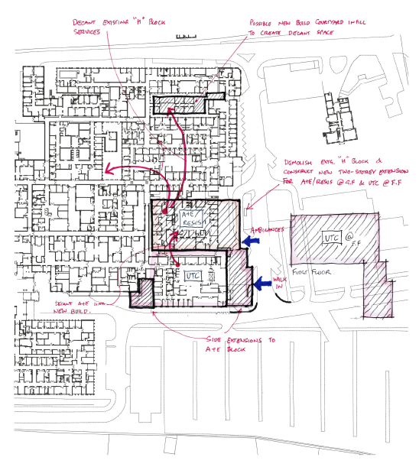

SWOT Analysis of Preferred Location
Strengths | No road diversions  No disruption to existing services during construction  Financially realistic in view of less building work and no road moves
Weaknesses | Reduced footprint and expansion of the existing ED is limited  Does not allow expansion without future road diversion  Design would be constrained by having to be “shoe-horned” into the space left from the H block
Opportunities | Demolition of H block removes backlog maintenance issues (offset cost of build)  Good connectivity between ED and UTC – promoting staff integration and new ways of working
Threats | Requires decant of existing services in the H block. Whilst possible to do, needs careful planning to minimise disruption to clinical services

A further option was considered later in the project to reduce costs by reducing some of the administrative space on the first floor and moving plant down to remove the need for a second floor. This option was termed 4A.

During the development of the FBC a new design team had a fresh look at the plans and suggested a further improvement by “flipping” the layout of the UTC. This would increase the benefits to patients and the hospital frontage. Further work by this team also reduced the circulation and communication space and removed the need for any clinical accommodation on the first floor. This option was termed 4B.

Note that options 4, 4A and 4B are effectively using the same footprint – demolition of the H Block and new build ED, extending in each option, out towards the road and infilling a courtyard to the rear.

    - Clinical Model Options
A subgroup was established to work through potential operational models for the new service.

A workshop was held on 6th February 2020 to debate potential models. 3 options were discussed and, following a meeting of the oversight group, the 3rd option, a do maximum, was put forward as the preferred option. This option is given below, with the other 2 options in Appendix K.

The options looked at how the department might operate given the intent for an integrated nature of the workforce. Site visits to Leicester and Hull were undertaken on 12th December and 23rd December respectively to look at how these two departments operated and inform the decision making.

The final model would have a single reception area for walk in patients with a single triage and assessment zone. All walk in patients would be booked in on the LCHS IT system and assessed by either LCHS or ULHT staff depending on availability, not acuity. Patient navigation to either majors or minors would be decided by senior clinicians working from a central hub or “command zone”. Patients’ needs would be fully assessed reducing risk before navigating the patient into a specific area.

During development of the FBC this model was reviewed and clinical teams confirmed that it was how the department would operate.

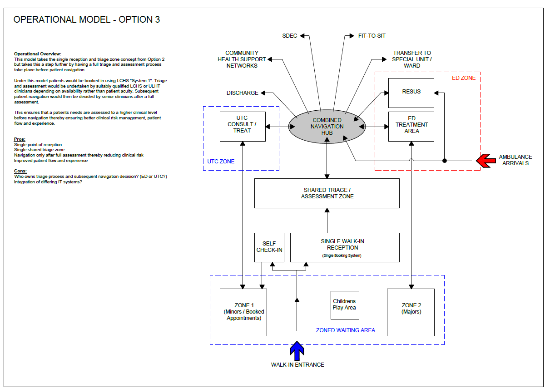

    - Improved diagnostics options
Several meetings with key stakeholders were held to discuss the requirements of Investment Objective SO4: to improve the turnaround of diagnostic and pathology services within the Emergency Department. This spending objective was deemed important early on in the project because of issues around the availability of CT scanning for the emergency department and the issue that sometimes turnaround times for blood tests were not good enough.

At the time the OBC was written PHB had just a single CT scanner which has now been replaced. During covid additional scanners were put into mobile accommodation and this second scanner provides some resilience for the site albeit in a remote location. CT is vital for acute emergency conditions such as poly-trauma and stroke. The plan developed through the FBC will be to move this remote scanner into the ED. This means that staff are not out of the ED for long periods of time transferring patients. This will remove the cost of an additional ED scanner.

Pathology departments are facing a time of change with increasing numbers of “near patient testing” devices which can do a limited range of the work of a full pathology lab but in the patients location saving the time it takes to transport samples. The working group paid a visit to Leicester Royal Infirmaries Emergency Department as part of the planning stage, where a pathology lab is co-located with the ED. That said it was noted that the department still used an air tube system to send samples to the laboratory.

After the discussions a paper produced by the pathology service highlights the preferred option. Provision of a dedicated air tube direct from the ED to the existing pathology department is the cheapest solution but also provides a direct access point between the two departments, prevents errors in staff sending samples to the wrong place and provides resilience in the system, (with the ED still being able to access the hospital tube system in the event of its own systems failure).

The project group therefore agreed that to meet spending objective 4 moving the CT scanner and dedicated air tube system was the preferred way forward.

    - Long List Options Appraisal
On 2nd April 2020 a further workshop was held to review the long list of options using the Green Book Options Framework. Based on the scope of the project, spending objectives and critical success factors each potential options was discussed. The design long list was reviewed with each option listed within the framework by category – intermediate lower (refurb and extend design options), intermediate higher (refurb, demolish and build adjacent) and do maximum (build new). The clinical model preferred option was reviewed to ensure this was considered when discussing the long list.

Service Scope:

- Business as usual includes the existing 4 bay resus area and UTC - 6 rooms at the side of the department;
- The do minimum option would be to have a co-located UTC and expanded resus area to 6 bays;
- The lower intermediate option would be to have the co-located UTC, expand resus to 6 bays, include a dedicated air tune to the labs, CT, additional section 136 suites and paediatric cubicles;
- The intermediate option would be as above, but with 8 bays in resus, frailty / SDEC services, a bereavement suite and full paediatric area (separate wait from the main waiting room etc.);
- A higher intermediate option would include the above, plus a clinic room for use by ED or AEC, community pharmacy and a dignity suite to assist dependant patients;
- The do maximum option would include additional services – emergency dentistry, have a volunteers area and concessions.

Service Solution:

- BAU consists of the current limited ED and UTC services as described;
- The do minimum option would be to look to refurbing the existing buildings to contain the required services;
- A lower intermediate option would be to refurbish the existing building and extend slightly to contain 2 additional resus bays. The UTC would have to be built into the existing refurbished building;
- An intermediate option might be to refurbish the existing building and build out to contain resus and the UTC;
- The higher intermediate option would be to demolish adjacent buildings, building new in the footprint and refurbish the existing building. This would allow new accommodation for resus / UTC or move the ED into the new building to refurbish the old for UTC;
- The do maximum option was to build new for all services.

These solutions were mapped to the long list evaluation of possible site options in order to give a potential capital cost for each option. The do minimum – 2 new build areas as originally conceived in the SOC actually does not represent the lowest cost as, when the SOC’s had been developed they had not looked at the potential to merge the schemes and use adjacent existing accommodation.

Service Delivery:

A range of options were discussed to use local or national contractors. International contractors were an unlikely option. The decision to use a framework provider was discussed although accepted that the trust had had poor experience of this in the past. The trust already has a number of contractors appointed directly that have worked on other projects and has experience of dealing with. The facilities management team felt this would be the most cost effective approach but would look at national framework agreements such as P2020 to establish whether a better deal could be found. In developing the FBC and after reviewing the framework options a decision was made to use the PAGABO framework and entering into a 2 stage design and build contract, as detailed in the commercial case.

Implementation:

Phasing of any work would be critical as the existing emergency services have to continue which includes access to large volumes of ambulances. Options to build around the existing service, build part then decant and refurbish vacated areas, bring in modular buildings to assist with the decant, or modular buildings to decant all of the emergency service were considered. At FBC a further option was considered that would reduce the need for modular options and increase non cash releasing benefits for backlog maintenance. This option, combined with a refreshed design of the ED/UTC became known as option 4B and is the preferred option as it was thought to be more cost effective and would remove c. £5.7M backlog maintenance.

Funding Options:

Funding options were in part already agreed with national funding available, but it was agreed to consider additional internal capital or loans depending on the outcome of the benefits appraisal. The capital allocation had been based on the previous STP separate bids for extending resus and developing a UTC. It is acknowledged that it made sense to combine the two bids into one project and in doing so allowed the opportunity to redevelop the existing emergency department.

A summary of the framework and outcome of the discussion is given below.

Options Framework

Short Listed Options and Preferred Way Forwards

The working group identified five shortlisted options for further appraisal. These included BAU, Do Minimum, the Preferred Way Forwards, and less and more ambitious preferred ways forward.

During the FBC the preferred way forwards was amended (see estates annex). Whilst the schedule of accommodation remained broadly the same in terms of rooms numbers the new design allowed for reduced communication and circulation space as well as an entrance closer to the main hospital entrance and away from the main road. This provided new benefits – safer access for ambulant patients, better dignity for patients arriving by ambulance and improvements to the environment for the main hospital entrance. The change was made following a design review workshop on 6th September 2021 mainly for phasing reasons – it would be possible to create the new waiting room ahead of the UTC refurbishment removing the need for portable accommodation for a waiting room during construction. This option and these additional benefits are considered in the financial appraisal and is labelled as option 4B. The original shortlisted options are given below as the location and design of 4A and 4B are similar.

    - Summary of the shortlisted options from the Options Framework
Summary of Shortlisted Options
Options | Business as Usual (BAU) | Do Minimum  (Option 8) | Preferred Way Forward (Options 4A / 4B) | Less Ambitious PWF (Option 5) | More Ambitious PWF (Option 4)
Project Scope | 1.1 | 1.3 | 1.4 | 1.3 | 1.5
Service Solution | 2.1 | 2.4 | 2.5 | 2.4 | 2.6
Service Delivery | 3.1 | 3.3 | 3.3 | 3.3 | 3.5
Project Implementation | N/A | 4.3 | 4.3 | 4.3 | 4.4
Project Funding | N/A

Each of these options are appraised in more detail below:

Description of Shortlisted Options
BAU | Rationale
Description | Existing services as described
Strengths | - No disruption to existing services  - No additional costs
Weaknesses | - Cannot contain the existing demand  - Cannot future proof services for growth in demand  - Not compliant with national standards for UTC  - Not compliant with constitutional standards  - Poor patient care
Opportunities | - Leaves potential space to expand into in the future
Threats | - Political pressure and consequences  - Damage to the organisations reputation  - May need to expand community services to cope, which threatens collaboration and integration of providers
Conclusion | This option was discounted for the reasons above, but will remain as the benchmark for value for money

Do Minimum (Option 8) | Rationale
Description | Expand the resus area to 6 bays and implement a small UTC with 11 clinical rooms. These would be co-located new buildings to the south and east of the existing ED and require roads to be moved. The existing ED would be refurbished. The trust would prefer to use own known national contractors but would look at framework options. A phased approach to build new buildings, decant into then and refurbish / extend former locations. The project has an agreement to fund centrally
Strengths | - Achievable as there would be new buildings co-located to the ED and an existing building – little disruption and simple construction  - Would provide the national requirement for a UTC and address some of the gap in provision of resuscitation capacity  - Phased approach to building would minimise disruption to the existing service
Weaknesses | - Will not provide sufficient capacity for peak times in demand  - The project will not be future proofed as it will involve putting new services into a building which is already in poor condition  - Poor connectivity between the ED and UTC  - Possible unforeseen costs in using the existing building
Opportunities | - Consolidates service providers and should improve recruitment  - Provides increased resus capacity and would improve outcomes
Threats | - No space to further expand in the future  - Extensive road diversions
Conclusion | This option was considered a potential solution of additional funding could not be sourced. It was agreed to carry the option through as a “do minimum” to the benefits evaluation

PWF (Options 4A) | Rationale
Description | With demolition of the adjacent “H Building” and a new build ED, the ED would be relocated and the former building refurbished / extended. This would provide an 8 bay resus and UTC, new majors area and additional services such as CT scanner, section 136 suites, paediatric area, frailty / SDEC and bereavement facility. The trust would prefer to use own known national contractors but would look at framework options. A phased approach to build new buildings, decant into then and refurbish / extend former locations. The project has an agreement to fund centrally
Strengths | - Provides sufficient capacity to contain existing demand and future proof services  - Financially realistic in view of less building work and no road moves  - No disruption to existing services during construction
Weaknesses | - Capacity is constrained compared to the do maximum option  - Does not allow future expansion without road diversion  - Constrained by shoe-horning new build into the space left from the “H Block”
Opportunities | - Does provide a level of increased capacity and would improve patient outcomes  - Removes backlog maintenance issues from H Block (offsets the cost to demolish and build new)  - Good connectivity between ED and UTC would promote staff integration and new ways of working
Threats | - Requires decant of existing services within the H Block
Conclusion | This option was felt to be the preferred way forwards in terms of providing most of the core and desirable requirements and satisfies the spending objectives. It was felt to be achievable by decanting some services out of the H block and would mean the work could be phased to minimise any disruption

PWF Less Ambitious (Option 5) | Rationale
Description | The adjacent building would not be demolished but refurbished to relocate the ED. The former ED building would be refurbished for the UTC. Floor area would be limited so services may be as preferred without SDEC / Bereavement / Paediatric Waiting Areas (would maintain paediatric cubicles) and resus would need to be capped at 6 bays. The trust would prefer to use own known national contractors but would look at framework options. A phased approach to build new buildings, decant into then and refurbish / extend former locations. The project has an agreement to fund centrally
Strengths | - Provides almost sufficient capacity to contain existing demand and future proof services  - Financially realistic in view of less building work and no road moves  - No disruption to existing services during construction  - Lower capital cost as no new building or demolition required
Weaknesses | - Puts new services into a building which we know to have backlog maintenance issues
Opportunities | - Good connectivity between ED and UTC would promote staff integration and new ways of working  - Does provide a level of increased capacity and would improve patient outcomes
Threats | - Building will have a “shelf life”  - Would impact on staff morale, without a modern, fully fit for purpose building
Conclusion | Whilst presenting a degree of the required capacity the reduced area restricts future proofing of services. However, it was still felt a significant improvement on the current facility. This was considered a serious contender, depending on available finance to meet the spending objectives but would require curtailing the desirable options

PWF More Ambitious (Option 4) | Rationale
Description | New build options could include greater space for a dignity suite, clinic rooms, and a possible pharmacy. Depending on design some of these options may be possible within a new build after demolition of the “H building” as in the PWF, although the do maximum would look at building new to the South and East of the current ED. The trust would prefer to use own known national contractors but would look at framework options. A phased approach to build new buildings, decant into then and refurbish / extend former locations. This option may need to look at additional modular buildings to support the decant. The project has an agreement to fund centrally although the trust could look at additional capital or loans
Strengths | - Meets spending objectives, and core, desirable and some optional requirements  - Whilst limits potential for future expansion the design would incorporate more than enough capacity to future proof the building for the planned demographic changes  - No disruption to existing services during construction – may also look at optional mobile clinical units to maintain services
Weaknesses | - Highest cost option  - Major road diversions  - Obstructs the view of the main entrance and may cause patients confusion
Opportunities | - Additional services could increase income to the organisation (e.g. pharmacy, concessions)  - Modern building as a show piece at the front of the hospital
Threats | - Potential poor connectivity between areas of the ED/UTC due to the sheer size  - Loss of parking income
Conclusion | Whilst all agreed that this would be a great opportunity to develop the site and services realistically the cost of the building would likely be prohibitive and certainly not the most cost effective for the benefits achieved. The option does fill the spending objectives and core, desirable and optional requirements

Following the appraisal of the short list and the preferred way forwards in the OBC clinicians and the architects met to look at developing the PWF more. The design (Option 4 in the long list) was modified to move the plant equipment on the first floor up into the ceiling space, giving more storage and potential office accommodation. Costs for this option came back at £48,822,997. The option remained labelled as Option 4. At a meeting with NHSE&I regional team on 19th October 2020 the original PWF as it stands in this case (now labelled 4A), the PWF with the plant in the ceiling space (4), the do minimum (8) and do less (5) options were discussed. The trust was asked to go back and redo the financial appraisal to look if costs could be reduced back down towards the 21.3M. The options reviewed, as above in the shortlist were subsequently re-classed as the following noting that these are cost advisor calculations for the scheme delivery excluding early draw down fees and NPV analysis that was incorporated in the CIA financials:

- BAU – Current situation with no changes. Annual costs incurred relating to reactive and planned preventative maintenance alongside backlog maintenance requirements and increased carbon emissions
  - £0.5m per annum
- Option 4 – ‘PWF+’ - with demolition of the adjacent H Block, new build ED with the old ED refurbished for the UTC. Plant would be moved up into the ceiling space.
  - £48,822,997
- Option 4A – ‘PWF’ – the original option 4 design, with demolition of the adjacent H Block, new build ED with the old ED refurbished for the UTC. Plant would be accommodation on the 1st floor.
  - £36,767,551
- Option 5 – ‘PWF-‘ - refurbished H Block for UTC with extension to the ED for resus.
  - £33,897,258
- Option 8 – ‘Do Minimum’ - as option 5 with much smaller extensions out
  - £27,931,892

The new option 4B developed during the design review as part of the FBC reads the same as the description for 4A above.

PWF 4B | Rationale
Description | With demolition of the adjacent “H Building” and a new build ED, the ED would be relocated and the former building refurbished / extended. This would provide an 8 bay resus and UTC, new majors area and additional services such as CT scanner, section 136 suites, paediatric area, frailty / SDEC and bereavement facility. The trust would prefer to use own known national contractors but would look at framework options. A phased approach to build new buildings, decant into them and refurbish / extend former locations. The project has an agreement to fund centrally
Strengths | - Provides increased capacity to future proof services  - Financially realistic with only moderately increased costs  - No disruption to existing services during construction  - Preferred decant option significantly reducing backlog maintenance  - Refreshed the appearance of the main entrance to the hospital  - Provides entrances that are safer and more dignified
Weaknesses | - Capacity is constrained compared to the do maximum option  - Does not allow future expansion without road diversion  - Constrained by shoe-horning new build into the space left from the “H Block”
Opportunities | - Does provide increased capacity and would improve patient outcomes  - Removes backlog maintenance issues from H Block (offsets the cost to demolish and build new) and maternity block  - Good connectivity between ED and UTC would promote staff integration and new ways of working  - By bringing the maternity block back into use and decanting some staff from the H Block and OP department into there, the space within OP can also be used for additional clinical accommodation
Threats | - Requires decant of existing services within the H Block
Conclusion | This option was felt to be the preferred way forwards in terms of providing additional clinical accommodation, more than satisfying the spending objectives. It was felt to be achievable by decanting services out of the H block and OP’s and would mean the work could be phased to minimise any disruption

    - Cost Evaluation of the Risks and Benefits of the Shortlisted Options
At OBC the Comprehensive Investment Appraisal model (CIA) was used to determine the option with the highest benefit – cost ratio. The model supported the preferred option from the team – 4A. A workshop was held with clinicians and management teams to confirm the model and costs.

Value for Money | Option 4 |  | Option 4A | Option 5 | Option 8
Risk-adjusted Net Present Social Value (NPSV) |  | £11,283.10 | £19,607.85 | -£13,226.17 | -£20,737.72
Benefit-cost ratio |  | 1.23 | 1.48 | 0.64 | 0.42

At approval of the OBC, DHSC requested that the Trust review all the monetisable risks and benefits (including wider benefits) in the CIA model to strengthen the benefit to cost ratio. A benefits review workshop, again conducted with clinical and administrative staff held on 26th November 2021, identified further benefits including the large reduction of backlog maintenance costs as well as a great deal of societal benefits. The societal benefits were not costed out at OBC. To support the cost to benefit ratio the Trust used the Social Value Engine (Rose Regeneration and East Riding or Yorkshire Council - https://socialvalueengine.com/) to attempt to quantify some of the social benefits. This “engine” pulls available research related to the benefit or uses a financial proxy to estimate the value. This provided much more data to evaluate the options.

For the FBC the analysis centred on the OBC preferred option (4A) and the revised plan (4B) as 4A had already demonstrated improved benefit to cost at OBC. The CIA model was again used to determine the option that provided best value for money. Key differences between the benefits of the two options were:

- An expectation that the new design, being more attractive and having better laid out and increased clinical / training space would do more to recruit and retain staff and reduce absenteeism;
- An expectation that the new design, with increased clinical capacity with an improved layout would improve outcomes and reduce admissions;
- A very significant reduction in backlog maintenance between the decant options (option 4A provided a new build, 4B refurbishing existing) of c. £5.7m.

Key assumptions:
- Covers an appraisal period of 60 years, and uses a discount rate of 3.5%;
- Costs, benefits and risks are expressed in prices at 2020/21 levels;
- VAT and transfer payments are excluded from cash flows; and
- CIA model inputs are described in the sections that follow.

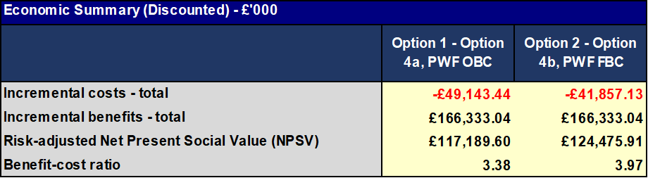

The full detail within the modelling is given below:

The CIA modelling undertaken at OBC:

Sensitivity analysis of preferred option
- The sensitivity analysis shows the robustness of the preferred option through testing how far key values would have to change for the preferred option to cease to be viable (switching values).

- These analyses show that the switching values at which viability is threatened are sufficiently far outside the likely range that the preferred option can be considered robust.

- As shown below, very significant movements in capital cost or benefits would be needed to alter the decision of the preferred option. As changes of this magnitude are unlikely the switching values analysis shows the selection of the preferred option is robust.

- The Commercial Case

  - The Commercial Case at OBC

The design at OBC had been worked up via a traditional procurement route with the Trust appointing its own contractors. In line with HM Treasuries Green Book to develop the FBC the Trust reviewed all elements of the OBC, national and local strategies, spending criteria etc. To get the design to FBC standard the Trust went out to tender for a 2 stage design and build contract. Turner & Townsend were appointed as cost advisors and John Graham Construction as primary construction contractor.
  - Procurement Route

This project involves building on new and refurbishing existing estate on an acute hospital site. At the point of OBC submission Boston Borough Council had been supportive of the proposal, as stated in their pre-planning advice letter and have now granted planning permission (Appendix F). They have confirmed that the Trust are able to build on the site. There are no existing PFI or NHS LIFT contracts in place that would adversely affect the proposal.

With a project of this size, complexity and spend level, the Governance for procurement states that the Trust would have to satisfy the requirements of a full OJEU tender and in order to do this, the Trust had numerous options open to it for procurement within the governance guidelines. This synopsis of the OBC commercial outline seeks to give information that was considered by the Trust to meet the governance requirements, but also consider how best it could achieve value for money with this process and maximise the commercial opportunity in such a large project for the region.

The first option considered was to carry out a full OJEU tender process for the works, and fully manage and control the project in-house using the ULHT Estates team. ULHT would have been required to write all the tender documents, ensuring that they complied with OJEU regulations and would have had to go out to the whole of the market using the online tendering package set up to carry out OJEU tenders. The Trust would have had to project manage the build and all associated works internally and be fully responsible for the project. Additionally, ULHT would have had to ensure that it had satisfied all of the local government requirements for added value and policy objectives.

The second option considered was to analyse the market and see if there were any compliant frameworks that exist, that have already carried out an OJEU tender process. This would have allowed the Trust to carry out a further competition and utilise the benefits of the framework package and the inherent support that this would bring. The use of a Framework as opposed to OJEU brings considerable programme advantages and competitiveness. Contractors have submitted OH&P rates to get onto the Framework, these rates cannot be exceeded when Contractors are tendering and pricing Schemes. This provided the Trust with the Value for Money statement before the procurement process started. The OH&P rates maintained by a Contractor are much more competitive via a Framework as they have based these on millions of pounds worth of work rather than just on one client’s project in isolation. Frameworks also reduce procurement risk and increase the ability to engage effectively with the market.

As this is such a large project with a large spend, there were a number of frameworks open to the Trust. ProCure 22 was a turnkey package option. ProCure22 (P22) was a Construction Procurement Framework administrated by the Department of Health (DH) for the development and delivery of NHS and Social Care capital schemes in England. It would have offered the Trust the ability to set the project requirements at a high level, then tender at this level to select its preferred supplier. The Trust would then have proceeded with more detailed project requirements using the preferred supplier chosen. Governance wise, the Trust would have been expected to use this procurement route unless good reason to use an alternative could have been provided. ULHT procurement had already been in touch with a contact on the P22 framework to discuss this. The P22 framework came to an end at the end of 2020 and was replaced. Additionally, there were only 5 suppliers in total on the framework and from discussions, the Trust did not believe that choosing that framework at the end of its life would have given the best outcome for the organisation. Commercially, ULHT would have been unlikely to get the best value for money available by utilising a framework that was about to expire.

The third option would have been to use the replacement framework to P22, P2020 now known as ProCure23. This framework is much larger compared to P22 and has a larger amount of potential suppliers on it.

ULHT were asked by NHSEI to consider this framework as the preferred way forward, despite the Trust feeling that it might not be the most appropriate solution. Whilst this framework would have met the requirements for governance, social values etc., it did not fit in with the timescales for this project. ULHT would need to have had tenders completed, costs and contracts known before the next phase of the process. The timescales given in P22 would not have allowed the Trust to meet the build schedule for the project. At the time of submitting this case for approval ULHT understands that this framework has still not gone live.

A fourth option was to use an alternative existing major works framework. After review of various Framework’s in the market place it was deemed that the Pagabo Major Works Framework offered best value. This framework provided the Trust with a compliant route for OJEU procurement and would offer a better Contractor selection pool. It was considered that this route would negate the commercial issues that present themselves on P22 with a small number of providers on the framework. The Pagabo Major Works Framework contains 13 suppliers and is for projects between £5m and £1bn. Recently launched, this framework expires in 2026 so was ready to use straight away and has a good longevity planned, as well as having recently tendered OH&P rates. It is operated in a very similar way to the P22 framework, and ULHT would get full support to tender this project as well as the framework team providing support throughout the project delivery, as P22 would do. There are fees associated with using this framework, but these are known up front and negotiated and these costs would be included as part of the full and final project costings to ensure value for money. Fees would also need to be considered on a whole-life cost basis, and in essence are negated through the competitive OH&Ps on the Framework as well as the support provided.

When selecting which of these procurement routes was best, the Trust needed to take account of the respective pro’s and con’s for each route. It was imperative that the project had a full and detailed specification document produced and that the Trust was clear what works were needed to be undertaken to complete the project and to mitigate any potential risks going forward. Additionally, if P22 or alternative frameworks were chosen as the best route for procurement, then ULHT would have needed to ensure that all enabling works were done and all risks highlighted to the potential bidders (for example, any potential asbestos issues need to be made clear).

There were pro’s and con’s to each of the routes that had been identified in the table below:

 | Pro’s | Con’s
ProCure22 | One Main contractor and one project team fully dedicated to this project – all resource fully supported from central point  Deadline date agreed and must be stuck to – penalties apply if not  Costs for the full project are fixed and known – can fix a guaranteed maximum price  Meets all governance requirements | Relies upon specification information being correct at the outset  Relies upon ensuring that buildings are ready to work on, and all enabling works ready – ULHT would also have to ensure everything is ready when the Trust said it would as the project progresses  P22 only has 5 suppliers on the framework. The XXXX supplier (and XXXXX on the framework) is XXX. The Trust have entered into legal action with XXX over the last P21 project that was carried out – it is highly likely therefore that XXX would not bid, and this may also affect other suppliers on the framework from bidding. Commercially, ULHT may struggle to get the best value for the Trust by using P22.
Full OJEU | Would be managed by in-house estates team who are fully familiar with the site and aware of the risks that may present themselves. | ULHT estates team is already very busy and working to capacity with “business as usual” projects – may be a big ask to get this team to run such a big project utilising existing resources only.  Large amount of work for both procurement and Estates, when this could be done by utilising an existing framework – do the pros justify the extra resource needed to choose this route?  Unknown OH&P levels  Longer Procurement Programme  Unknown Contractor pool  Market interest (of top performing Tier 1 Contractors) to bid this level of Scheme through an OJEU tender is minimal.
Alternative framework – Pagabo | One main contractor, as with P22  More contractors on the frameworks so commercially this would offer more choice to the Trust and hopefully drive better value for money.  Competitive OH&Ps that cannot be exceeded in competition.  All resource still given from central support, as with P22. Throughout the project lifecycle – from procurement to handover, including Contractor Performance Management.  Social value forecasted via Social Profit Calculator at design. Evaluated through tender and Contractor monitors on site. Trust can insert specific Social Value KPIs into Contract.  Deadline dates can still be agreed.  Can support with access to funding streams for projects too.  The Framework fee is minimal. No Fee during Pre-Construction activities. Paid by the Contractor once the project its site.  Flexibility. Can use a variety of contracts and ways of running the project to suit including GMP.  Training provided by XXXXXX (Pagabo Technical Director) who is an NEC4 ECC Drafter. | Relies upon Trust specification information being correct at the outset  Relies upon the Trust ensuring that buildings are ready to work on, and all enabling works ready – ULHT would also have to ensure everything is ready when it said it would as the project progresses
P2020 / ProCure23 | One Main contractor and one project team fully dedicated to the project – all resource fully supported from central point  Deadline date agreed and must be stuck to – penalties apply if not  Costs for the full project are fixed and known – can fix a guaranteed maximum price  Meets all governance requirements  Up to 20 suppliers on this framework, so potentially good value for money for the Trust | This framework is not ready yet – and therefore does not fit with the Trusts timescales  Relies upon the Trust’s specification information being correct at the outset  Relies upon the Trust ensuring that buildings are ready to work on, and all enabling works ready – ULHT would also have had to ensure everything was ready when it said it would as the project progressed

Having studied the pros and cons of all the different commercial options, ULHT procurement recommended that choosing the Pagabo Framework route would offer the best value solution. This was because it was complete from a compliance perspective, coupled with the fact that from a commercial perspective, ULHT would benefit from using the framework with a larger number of providers on, ensuring it would get value for money. The OH&P levels of the Framework Contractors were very competitive. The full invitation to tender document is given in Appendix Y.

Since the invitation to tender JGraham were appointed as main contractors with no changes to the contract since then.

4.3 Rationale for Using the Pagabo Framework

Following a meeting on 17th June 2021 with ULHT and NHSEI the Trust were again asked to provide additional information to justify the use of the Pagabo Framework as opposed to the P2020 (ProCure23) route.

ULHT have previously utilised the P22 framework on a XXXXX project at Lincoln County Hospital. Sadly, the project had a variety of issues with the appointed provider and ultimately ended up in litigation with them. When the Trust was evaluating the procurement route for the Pilgrim ED, it did look extensively at the P22 contract. On P22, there was a choice of 6 providers. An open and honest conversation was held with the then acting Procure 2020 Project Manager, to look at the commercial links between suppliers on the framework and the likelihood of bids being received. The overall feeling was that the previous contractor, with whom the Trust had had problems, were highly likely not to submit a bid, leaving a choice of 5 suppliers who potentially might. The acting Procure 2020 Project Manager described some of the suppliers as having good relationships with that provider and therefore he raised the question that some of these suppliers may have a reluctance to want to bid on this project and work with ULHT. Although the Trust had no firm evidence of this, it was an important consideration for the team when deciding on a commercially sound procurement route.

The Trust looked at carrying out an open tender by itself for the work, but also looked at whether there were other frameworks potentially available. As the Trust had carried out a lot of successful contracts on the Pagabo framework throughout Covid, the Pagabo Major Works framework was looked at. The table below lists the number of suppliers the Trust would be able to ask to bid on the P22 framework and the Pagabo Framework:

Supplier | P22 | Pagabo
ISG |  | x
Morgan Sindall |  | x
Sir Robert McAlpine | X – joint venture with VINCI | x
Skanska |  | x
VINCI | X – joint venture with Sir Robert McAlpine | x
Wilmot Dixon |  | x
Graham | x | x
Kier | x | x
Wates |  | x
Interserve | x
Galliford Try | x
BAM | x
Total Potential Bidders | 6 | 9

The P22 Framework had 6 suppliers on and the Pagabo Framework had 9 suppliers. The Trust suspected it was highly likely that the provider with whom the Trust had had difficulties would not bid for this project, which dropped P22 to 5 possible suppliers, and Pagabo to 8. The procurement team are hugely experienced with bids of this type and size and all of the Senior Procurement Team are Chartered Members of CIPS and concern was raised about only 5 potential suppliers being on the P22 framework. Ideally, to demonstrate good value for money and show good competition, the Trust would be aiming to get 4 good bid responses as a minimum for this project. This would mean it would need an 80% response rate from the P22 suppliers, but a 50% response rate if it used Pagabo to achieve the target.

As part of the decision making process, the Trust carried out a risk assessment to look at how likely it was that it would receive the minimum 4 bids it required from each of the frameworks. For the purposes of the analysis, it removed the provider it had had difficulties with from the equation as it did not believe they would bid. This meant that P22 had 5 suppliers and Pagabo had 8. The Trust analysed the likely risk of it not being able to get to the number of bids it targeted - 4. With P22, it needed to hit a return rate of 80% from the framework to meet the target of 4 bids. This is a very ambitious target for a framework return. As a Trust, ULHT run at a framework response of around 52% (taking into account both internal and external frameworks) so the Trust would have been looking at a significant uplift to hit its target. For Pagabo the Trust would have needed a response rate of 50% from the framework to meet its target of 4 bids. Given its experience and rate of tender return, the risk to the Trust of not hitting the 4 bid target with P22 was classed as high, whereas the risk of it not hitting the 4 bid target with Pagabo was classed as low. Both had severity impact to the Trust in terms of demonstrating value for money should it not have hit the 4 bid target.

 |  | Likelihood
 |  | 1 | 2 | 3 | 4 | 5
Severity | 5 | 0 | 0 | 0 | 0 | 0
Severity | 4 | 0 | 0 | 0 |  | 0
Severity | 3 | 0 | Pagabo0 | 0 | P220 | 0
Severity | 2 | 0 | 0 | 0 | 0 | 0
Severity | 1 | 0 | 0 | 0 | 0 | 0

A way of solving this issue would have been to utilise the replacement framework for P22 – P2020, now ProCure23, something NHSEI were keen for the Trust to do. This revised framework looked to have many more suppliers on than P22, so would have given the Trust much more choice and scope and reduced the risk that it would not have hit the required bids it targeted. Very sadly, however, despite the P22 contract supposed to be ending in 2020, it’s replacement – ProCure23 has still not gone live.

Another major element to the framework is the value added aspects that Frameworks provide to Trusts. A table of comparison was created to look at these added benefits between P22 and Pagabo:

 | Pagabo | P22
Ability to select suppliers based on healthcare experience | Yes | Yes
Proven process of tendering compliant with public sector procurement regulations | Yes | Yes
Dedicated support throughout the programme | Yes – programme manager is fully qualified project manager and fully NEC contract trained as well as having an MBA | Yes
Training support | Yes – Technical Director of Pagabo co-wrote NEC contracts and full training has been offered to all ULHT staff | Yes
Tried and tested contract templates | Yes | Yes
Supplier monitoring and KPI’s/performance management | Yes | Yes

In terms of added value, both frameworks gave ULHT added value and support in all areas. The specific NEC contract training from an author of the NEC contract was of particular benefit to the Trust as it moved to a different way of working with its capital schemes. Additionally, it was proposing it used NEC contracts with the ability to create its own bespoke Z clauses. Pagabo had confirmed that their Technical Director would be able to help the Trust refine and develop the NEC contract to suit its requirements and specifics that would come out of its tender process.

Given the risk analysis carried out on the likelihood of getting 4 bids from the P22 framework, and the fact that to ensure Value for Money for ULHT wanted to target 4 bid responses back, the Trust procurement team recommended the use of the Pagabo framework to tender the ED project at Pilgrim.

Due to the length of time in obtaining external OBC approval, ULHT were given the approval to start working on the FBC and to issue out tenders via the Pagabo Framework by XXXXXXXXXXXX Regional Director of Finance. A formal expression of interest was sent out to all 9 suppliers on the Pagabo framework – the Trust did not exclude the any provider and gave all of them the opportunity to bid.

As suspected, some of the suppliers declined to bid. When the Trust looked at the companies who declined to bid and looked at the suppliers on the P22 framework, it would have needed 100% of the remaining suppliers to submit a bid to hit its target of 4 bids. 2 of the remaining were potentially unsuitable. The Trust therefore believes it would have ended up with a maximum of 2 bids on P22.

After the EOI was returned, the Trust went forward with the full tender on the Pagabo framework and it received the targeted 4 bids it required. Only one of those suppliers was on the P22 framework, meaning that the Trust fully stand by the commercial decision to have opted to use the Pagabo framework at the time. In receiving 4 good bids it demonstrated value for money.

Since the OBC was first produced, and after the Trust selected its QS partner (Turner and Townsend) it has had discussions regarding its choice of framework and value for money. Turner and Townsend confirmed they carried out analysis for another Trust looking at value for money between P22, Pagabo and open market tender. The analysis confirmed that the best value for money for the projects that Trust were looking at was Pagabo. They further confirmed that they were in agreement with the Trusts analysis of which framework to choose and that ULHT selected the correct framework to get the best market response and best value for money.

  - Government Policy Objectives with Pagabo

As ULHT operate within the public sector, it is important if funding is approved it ensures that individuals, communities and businesses locally benefit from the investment being given to the project. As a procurement function, the Trust would need to play a major part in making sure this happens, especially for the people of Boston.

The Pagabo framework is ideally suited to supporting us to deliver on social value. The framework has already delivered an impressive amount of social value and are Pioneer members of Social Value UK, whose goal is to change the way society overall accounts for value.



Social value comes from employing people, developing skills and contracting with local supply chains. Through utilising the Pagabo framework, they are supporting the Trust to understand and measure the ways in which this project will deliver on social value. Pagabo can help the Trust to forecast the social value return expected on the Project at design stage, as well as evaluate the Contractor’s capabilities and proposed initiatives through the tender process. They will also support ULHT in creating Social Value KPIs specific to the Trust and local area to be managed throughout the delivery of the Contract. Also, by utilising suppliers on the framework, they are expected to specifically deliver and report on social value aspects. Pagabo have a Social Value Calculator, which can help the Trust to accurately calculate its social, economic and environmental impact and apply a financial value to that impact.




Apprentices
Total - 663
Total Value £22,264,963


New Jobs
Total - 2,519
Total Value £82,690,997



Benefit to Local Economies (LM3)
Total Value £1,345,420,102

Because Pagabo have actively measured social value on all the projects worked on, they boast some impressive figures to date on value that has been achieved. For example, 663 apprentices have been employed as a result of projects with over 2,500 new jobs created and over £1bn of investment into local economies. By choosing to work with Pagabo on this project ULHT are confident it can not only meet all the requirements for social value, but also have an excellent and proven method for capturing and measuring the information to be able to report how this project will have directly have contributed to social value in Boston and the surrounding area.

  - Form of Contract

With a project of this size, ULHT had a choice of what form of contract to use and how it would deal with risk contractually. Having weighed up the pros and cons of a variety of contract types, and held discussions with other procurement professionals, estates colleagues and framework providers, the Trust is settled on using NEC Option C for this Scheme. The Trust wanted to apply a fixed maximum cost to the project with out-turn financial risks shared between the Trust and the Contractor in an agreed proportion.

It was also proposed to use a Two Stage D&B tender process to appoint a preferred Contractor. This early Contractor involvement, would improve buildability, cost certainty, assist in interrogating and understanding risk as well as ensuring considered allocation of that risk. Essentially, ULHT would be able to manage out some of the potential pain share risk by investigating / developing the Contractor’s design; maximise the opportunities for value, engineering and innovation to ensure costs are minimised; as well as integrating design development with planning as early as possible to ensure an effective Programme. Contract given in Appendix Y.

  - Legal Report and Accounting Treatment

As ULHT were proposing to use a framework for the project, it had not carried out a full legal report, as its route to market was not novel or contentious. In terms of accounting treatment, the way ULHT would want to run this project would be to have a weekly meeting with contractors and estates to review what has happened in the week and review and monitor costs as the project develops. This meeting would include both procurement professionals and accounting professionals from the Trust, as well as the Contractor, Estates and professional services teams that have been employed to support the project. By getting the whole team together on a regular basis, ULHT would utilise the full benefit of the NEC Option C and guarantee excellent project tracking and controls, ensuring value for money.

The accounting treatment will be dealt with in accordance with IAS 16 and IAS 36 recognising new addition and impairment and/or future disposal of any properties impacted by the development. This will be included on the ULHT Statement of Financial Performance accordingly.

  - Procurement Information

Following on from OBC approval, the procurement route that was agreed via the Pagabo framework was implemented. Procurement held a “Meet the Buyer” event specifically to invite all framework suppliers to hear from the ULHT teams what the project was all about, learn more about our Trust and our ambitions and meet some of the key team members who would be working on the project. Our Chief Executive and our Finance Director also presented to the prospective suppliers, and a Q&A session was held so any queries could be asked to the whole project team. We sent out feedback forms following the event and hugely positive feedback was received, with 100% of suppliers saying they would attend another event with the Trust for a large project, as all of them found it useful and informative.

Following this event, the tender package was sent out via the Pagabo framework to all suppliers on the appropriate lot. Following the tender process, we received four strong bids – which was the target number we set out to achieve. Bids came in from XXXXXXX,XXXXX, John Graham and XXX. We asked each of the bidders to prepare a presentation to be held virtually and all team members, including our QS team, would evaluate this. Each of the team members gave scores and this was fed into the evaluation matrix. The bidder’s scores were as follows:

Element | Total Score Available | XXX | John Graham | XXXX | XXXX
Capacity and Case Studies | 10% | 8% | 8% | 6% | 8%
Project Team + Skill Set | 10% | 8% | 10% | 8% | 10%
Contractors Proposals - Fully worked detailed feasible programme | 10% | 6% | 8% | 8% | 8%
Contractors Approach and management of design process | 5% | 4% | 4% | 4% | 5%
Contractors Proposals – Project Delivery | 5% | 4% | 4% | 4% | 5%
Contractors Proposal – BREEAM | 5% | 4% | 4% | 4% | 4%
Contractors Proposal – Social Value | 5% | 4% | 4% | 4% | 5%
Cost Plan | FOR INFORMATION ONLY NOT WEIGHTED
Presentation/ Q&A’s | 10% | 8% | 8% | 6% | 8%
Total Quality | 60% | 46% | 50% | 44% | 53%
Total Price | 40% | 33.30% | 40% | 28.10% | 30.63%
TOTAL | 100% | 79.30% | 90% | 72.10% | 83.63%

Element | XXX | John Graham | XXXXX | XXXXXXXXXX
PCSA Tender Sum (RIBA Stages 2-4) | £1,017,512.00 | £787,425.00 | £954,355.00 | £829,914.00
Preliminaries (Inc Design) | £1,779,602.00 | £1,516,629.00 | £2,365,168.90 | £2,235,223.40
Total Cost (Ex Vat) | £2,874,034.64 | £2,392,760.08 | £3,405,831.52 | £3,124.907.58

Following the outcome of the tender and the evaluation process, the recommendation of the project team was to award the contract to John Graham, based on the scores for both quality and cost. This information was written up into a Contract Award Report and this was signed, along with Board Papers to approve the award to John Graham to proceed to GMP and FBC. Due to commercial sensitivity the evaluations are not available here but can be requested from the Trusts procurement team if required.

After the Board Approval, procurement actively worked with our QS team at Turner and Townsend, and our legal support at Browne Jacobsen to develop the NEC contract, along with the appropriate X and Z clauses. This contract was approved and signed and we have also worked on developing the NEC contract, which will be used if the FBC is approved. This contract includes the following X and Z clauses: (X2, X4, X5, X7, X8 X10, X11, X15, X16, X17 X18, X20, X21) , (Z 1- 36 with some core clause amendments) as well as W2, 4 and 5 for dispute resolution. It is planned to issue this contract under deed for the 12 year warranty period. The contract is given in Appendix Y.

Once Grahams had been appointed, they worked on the design elements of the project. Once designs were finalised, bids were sent out by Grahams for the various build packages to enable them to get to a GMP for the build. GMP was submitted to schedule and details of the GMP amounts can be found in the financial section of this report. If this FBC is approved, commercially we will need to get the NEC contract signed and issue out the tender award notice to the market.

Additionally, pre-work has been carried out on Social Value with the Graham’s Social Value Manager – XXXXXXXXX XXXXX holds monthly meetings with the procurement team and a Social Value plan has been drawn up, ready to be put into action if FBC is approved.

We have also drawn up a risk allocation table to show where various risks from this project sit commercially. Some risks sit with Grahams, some with ULHT and some risks are shared between the two parties.

Risk Category | Potential Allocation
Risk Category | Public | Private | Shared
- Design Risk
- Construction and Build Risk
- Operating Risk
- Variability of Revenue risk
- Legislative risk
- Financing risk
- Control risk
- Availability and Performance Risk
- Transition and Implementation risk
- Termination risk
- Technology and obsolescence risk
- Social Value risk
  - Management Plan

The Trust’s Procurement and Estates Team will manage the performance of this supplier throughout the term of the contract to ensure delivery of the services is in line with the specified requirements.

The extension period will only be initiated on the basis of the provider achieving expected performance levels and on mutual agreement between the Trust and the selected provider.

Both the Project Execution Plan (PEP, appendix Q) and NEC 4 contract data identifies clear overall ownership of the contract management across the organisation. Contract management reporting processes are aligned with organisational governance processes, operational board, and risk structures, all with senior level engagement.

The NEC 4 form of contract requires a collaborative approach from all parties, which encourages open management to mitigate problems and reduce risk. The current accepted programme is included in Appendix Q; the programme will be formally accepted (or not accepted) by the client Project Manager on a monthly basis, as per the contract.

As the Trust has entered into a 2-stage design and build contract should the FBC be approved there is no delay in proceeding with the programme, hence no procurement timeline at FBC.

The Financial Case

Impact on the organisation’s income and expenditure account
This case requires total capital investment of c£43.5m with recurrent revenue costs of c£1.0m for non-pay expenditure including depreciation/PDC impacts. There are no pay costs associated with this case as the department has adequate staffing for the current demand and any increase will be dealt with internally. There are also no income changes due to the same activity level being provided and the long-term impacts of the pandemic unknown however the right-sizing of the facility will ensure there is future proofing for increased activity levels and the income opportunity that presents.
Summary of the capital and revenue required and impact on I&E (SOCI) contained in the following tables, noting that recurrently, the level of cost reduction exceeds the costs incurred and contributes a £0.7m per annum:

To note that the SoCI, SoCF and SoFP represent just the impact of the UEC, and are not full Trust financial statements.

Capital Investment required
HM Treasury ‘Green Book’ methodologies have been used in assessing financial calculations.
This case requires capital investment of c£1.4m to complete the OBC/FBC as part of the early drawdown fees and a further c£42.1m for scheme delivery. The scheme delivery costs incorporate c£33.1m for the ‘Main Build’ and c£8.9m for the ‘Decant Scheme’ including risk – the value of risk is c£3.8m (including VAT). Also included is a c£1.8m inflationary increase allocation.
For purposes of calculating capital charges, the estimated useful life has been applied as follows:
• New Build 60 years
• Conversion 30 years
• Equipment 8 years

Capital costs have been aligned to project timescales and allocated over the period 21/22 to 24/25. All assets will be owned by ULHT.
In the main, capital charges are expected to be incurred from 2025/26 financial year upon the completion of the main build, however those related to the Maternity Decant scheme will start in 2023/24.
The calculation relating to any impairments has been finalised by the Trust Valuers. This equates to c£19.7m. The A&E and ‘H’ block have been valued as a single new block based on the scale of the remodelling. Asset lives have been adjusted accordingly. Upper quartile BCIS rates have been used.
Based on receiving a GMP for the main build, the OB calculation contained in the OBC has been removed for the FBC. However there remain allocations for OB within the GMP/Decant, together with inflationary risk and further to this there is a client direct risk contingency built in also covering both the main build and decant programme of works required – all of the above amount to c£5.6m i.e. 13%.
Capital allocations are managed by Lincolnshire ICS and prioritisation of schemes is determined through this mechanism. If additional or alternative funding sources were required then the process would be through this route.
Lincolnshire ICS are in agreement to prioritise as per the table below and provide assurance that this is affordable.
The OBC revised funding proposal and profile agreed with NHSE&I is as per the table below. At the request of NHSE&I, the OBC funding proposal has been altered to draw the 2021/22 financial requirements from the Wave 4b allocation rather than additional ‘top-up’ funding.
 | 2020/21  £000 | 2021/22  £000 | 2022/23  £000 | 2023/24  £000 | Total  £000
CDEL (spend) | 106 | 3,980.2 | 21,496 | 12,271.6 | 37,853.6
PDC Drawdown | 106 | 3,980.2 | 12,496 | 4,756 | 21,339.0
Trust (internally generated) | 0 | 0 | 0 | 3,437.6 | 3,437.6
STP envelope  (emergency PDC) |  | 0 | 9,000 | 4,077.2 | 13,077.2

The Regional NHSE&I team have agreed to ensure the ICS has sufficient CDEL linked to the OBC spend profile, however there is a c£5.7m uplift compared to OBC stage. Plans have now been validated and stress tested by professional cost advisors and there have been a number of variations to the costs. But at a global level the inflation element assumed in the OBC has increased by £4.7m and a further £1m in relation to net zero carbon in the FBC has been included. The latter being a specific change requested by the national team from OBC to FBC, the former based on a professional assessment and attributable to a change in the market conditions.
Equipment replacement programme will be included within annual capital planning processes to ensure affordability.
VAT advice has been sought and provided. VAT has been recovered in the forecast costs where possible. The basis of the VAT decisions has been as follows, based on the 4 key elements within the scheme:
- Demolition of the “H building”
  - No VAT recovery as there is no scope to recover on the demolition of buildings or the creation of new buildings.
- Building a brand new ED (Relocating the former ED to this new building)
  - No VAT recovery as there is no scope to recover on the demolition of buildings or the creation of new buildings.
- Refurbishing/extending the UTC
  - Costs associated with the refurbishment and/or extension of the UTC will yield a minimum VAT recovery of 20% and 5% respectively
- Decant works
  - VAT recovery of 20%

In summary, the following capital costs are due to be incurred:
- Completion of OBC/FBC c£1.4m
- Pilgrim ED Build c£33.2m
- Decant Programme c£8.9m
Net Zero Carbon impacts are included within the main build programme of works and the financial implications accounted for. These costs were not part of the OBC and therefore are part of the increased costs contained in the FBC. Inclusive of VAT, the costs have been calculated by the Trust cost advisors to be c£1m.
It is worth noting that within the OBC, there was £2.5m of inflation risk assumed. Calculations have taken place by the Trust cost advisors, following the recent worldwide events, to show that if this was updated with the latest PUBSEC inflation, based on the original programme with a mid-point construction of 3Q22 which shows movement of £1.7m just due to inflation movement, and then rebased with the updated programme (1Q24), which demonstrates a further £2.2m. Therefore, the scheme is currently accommodating an inflationary increase of £3.9m + VAT, equating to c£4.7m.

Revenue Investment required
No additional staffing costs are expected – activity is expected to remain at current levels. Additional workforce implications have been dealt with in previous establishment reviews for ULHT and investment has been made in Pilgrim ED accordingly. There are no workforce implications following the build development of the A&E/UTC. Work is progressing on scenario planning with regard to future growth in activity levels and, if required, a business case will be produced to reflect any future needs in terms of workforce.

Expectation of ongoing maintenance costs associated with new equipment - c£0.2m based on 10% of purchase price will be incurred, however in the year following replacement this will be reduced based on warranties provided when ‘new’.

Revenue costs will be included within annual planning to ensure affordability and will allow for options to manage any shortfall in years 2023/24 and 2024/25. In terms of affordability, income allocations through commissioners and increased CIP programmes would both be avenues with which to support the increased revenue implications of this build, however with the scheme being one of the highest priorities within Lincolnshire and an enabler to delivering more cost effective and safe services, this would be supported financially. From 2025/26 onwards, there is an annual contribution of £0.5m to the Lincolnshire ICS financial position – in essence the payback period is 3 years and 5 months.

Lincolnshire ICS letter of support outlines that revenue implications will be supported from within Lincolnshire funding envelopes or through increased CIP delivery. The ICS will ensure that the scheme has no impact upon the ICS financial trajectory.

VAT has been included and recovered where applicable e.g. maintenance agreements.

Cost Improvement / Benefits generated
A full assessment of all benefits has been undertaken, incorporating the use of a social value engine.
There are four types of benefit used within the model:
- Cash Releasing Benefits (CRB)
  - Cash releasing benefits (CRBs) are quantified in financial terms, where budgets would be reduced by the value of the benefit. These benefits reduce the costs of organisations in such a way that the resources can be re-allocated elsewhere. This typically means that an entire resource is no longer needed for the task for which it was previously used.

- Non-Cash Releasing Benefits (NCRB)
  - Non-cash releasing benefits (NCRBs) are quantifiable in monetary terms but no money is actually released from a budget. It can represent productivity savings whereby small elements of time are saved, which is not sufficient to make headcount savings, or re-allocate that resource to a totally different area of work.

- Societal Benefits (SB)
  - A societal benefit (SB) is one which is quantifiable in monetary terms but the benefit is realised by society outside DHSC/the NHS. For example, helping someone to recover from ill health and return to work earlier than otherwise, increases economic activity but does not impact DHSC or the NHS. QALYs are a common example of societal benefits arising from health care investments.

- Unmonetisable Benefits (UB).
  - Unmonetisable benefits (UBs) are benefits which are of value to society but cannot be monetised. For example, plans to deliver a five percentage point improvement in patient experience survey scores.

Work has been undertaken to finalise the benefits identified:
- Cash Releasing c£1.5m (including VAT, details below)
- Non-Cash Releasing c£6.6m (excluding VAT, see CIA model)
- Societal c£4.7m (excluding VAT, see CIA model)
- Unmonetisable £0.0m

Cost avoidance
- Unnecessary admissions
- Estimated backlog maintenance costs of Pilgrim Maternity Block amount to £6.7m including VAT/Fees and enabling works that would not be required with the preferred option.
- Estimated backlog maintenance costs of Block OX (the H-Block) amount to £993k including VAT/Fees and enabling works that would not be required with the preferred option.

Commercial Risks
- Risk calculated at 5% for change-risk due to the contractual agreements being in place.
- Contingency allocations within the ‘decant’ works are £1.3m excluding VAT
- OB and Contractors risk built into the GMP from John Grahams.
- Time delays in delivery of build – contract includes penalties / clauses
- Pandemics – for example Covid 19 has brought about the need to closedown construction and slowdown of economy

Affordability
The capital envelope has been agreed at OBC stage at £37.9m.

In terms of assuring affordability, as it stands, there is a requirement to financially support an FBC scheme value of £43.5m, an increase of £5.7m.

This increase is due to 2 factors:
- Plans have now been validated and stress tested by professional cost advisors and there have been a number of variations to the costs. But at a global level the inflation element assumed in the OBC has increased by £4.7m.
- A further £1m in relation to net zero carbon in the FBC has been included.
- The latter being a specific change requested by the national team from OBC to FBC, the former based on a professional assessment and attributable to a change in the market conditions.

As detailed in the ICS letter of support, Lincolnshire ICS have agreed to plan to support the original c£3.5m capital funding gap identified in the OBC and the further capital cost increase of c£5.7m caused by inflation and NZC implications. Lincolnshire will also support any revenue implications contained in the business case. Lincolnshire are supportive of prioritising this level of funding in order to support the preferred way forward. The funding to support this will be identified as part of the annual capital and planning prioritisation process that looks at a 5 year programme of schemes.

Regional NHSE&I have agreed to ensure the ICS has sufficient CDEL to cover additional capital spend at OBC stage however there is a need to cover the further inflationary and NZC implications that were not foreseen during the OBC development.

Source and applications table contained in the attached (this aligns to the recent discussion with Regional Team around the Lincolnshire capital envelope): :

Payback Period
When looking at the investment versus return, the preferred way forward, at FBC stage, shows that there is a 2 year and 11 month payback period.

- 2023/24 Loss of £0.2m
- 2024/25 Loss of £0.4m
- 2025/26 Surplus of £0.7m
- 2026/27+ Surplus of £0.7m

Opportunities
Whilst right-sizing the build, there allows for opportunity to effectively treat more patients in the future were that to the case in practice however future activity projections are now unknown with great assurance based on the COVID-19 pandemic.

The Management Case

6.1 Stakeholders

This project is managed through a project working group, reporting to a project oversight group (see Project Framework and Management Arrangements) under PRINCE2 principles.

It was necessary to ensure all stakeholder organisations and patient representatives had ample opportunity to contribute to the project development and final design of the building from the very beginning. Between developing the OBC and FBC the membership of the groups changed due to members of the teams leaving or taking on new positions and the oversight group was refined to a smaller group of more senior staff.

The project working group developing the OBC was extensive, including:

- Deputy Director of Operations (Project Manager and Chair), ULHT
- Consultant in Emergency Medicine, ULHT
- Medical Director, LCHS
- Consultant in Acute Medicine, ULHT
- Matron, Medicine, ULHT
- Deputy Chief Nurse, ULHT
- Lead Sister, Emergency Department, ULHT
- Capital Projects Manager, ULHT
- General Manager, Medicine, ULHT
- Operational Service Manager, Emergency Department, ULHT
- Clinical Applications Engineer, Clinical Engineering, ULH;
- Radiology Services, ULHT
- Pathology Services, Pathlinks
- Staff Side, ULHT
- Urgent Care Programme Manager, CCG
- Senior Commissioning and Performance Manager, CCG
- GP from LCHS
- Matron, Urgent Care, LCHS
- Senior Project Manager, LCHS
- Business Manager, LPFT
- EMAS Representative
- Patient Representatives (interests in different areas such as Frailty, Paediatrics etc)
- Adult Social Care

The project working group developing the FBC was smaller and more focussed but wider stakeholder engagement was maintained through a series of workstreams to tackle differing elements of the project. Additional events and informal site visits were undertaken to ensure all stakeholders remained briefed.

Through the planning process designs were in the public domain and the working group responded to comments and questions as appropriate. A series of staff briefings were also released to ULHT and LCHS staff to keep them updated as per the communication plan (Appendix S).

Project Framework and Management Arrangements

    - Project Management Budget
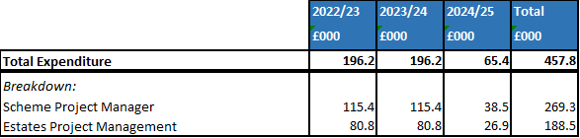

    - Project Management Structure Summary
The project management structure is detailed below. Briefly, the project is managed by an oversight group, reporting to the trust executive team, which oversees a working group (project team). The working group establishes and leads workstreams as required to develop the FBC.

At the outset of developing the OBC the working group planned in a provisional schedule of workshops to take the project back to the SOC stage - to review the scope, go through the long list options appraisal and develop the economic, commercial, financial and management cases. To develop the FBC further workshops were held to review the design, review IT solutions and work on further benefits. An additional meeting with colleagues from DHSC also took place to review the project. The workshops and site visits undertaken were:

The outputs from these workshops developed this business case. In addition to the workshop programme several subgroup “workstreams” of the working group were formed, each with a separate Terms of Reference and in some cases procurement strategies to tackle key areas of the FBC.

The project management structure is as follows:

The workstreams were each lead by a separate SRO. Each were made up, where relevant, of a mix of finance, procurement, clinical teams and patient representatives. These were:

Workstream | Title | SRO
1 | Decant Phase | Divisional Managing Director, Clinical Support Services
2 | Design Review | Director of Estates and Facilities
3 | Power | Head of Estates
4 | Design and Build Tender | Deputy Director of Procurement
5 | FBC Development and Approvals | Associate Director of Strategic Projects

In addition to the key internal workstreams project meetings were held with advisors and contractors. The key meetings held were:

- Principles Meeting

Facilitated by the cost advisors, Turner and Townsend, the Principles Meetings are a key meeting between the contractor, architects, other advisors and the Trust to discuss project progress, risks and issues. These meetings are held weekly.

- Strategies Meeting

Ad hoc meetings to discuss issues as they arise, for example procurement decisions, specific design decisions, evaluating contractors etc.

- Risk Review

Led by the cost advisors, Turner and Townsend, the Risk Review meetings are held to go through highest risks on the risk log to ensure mitigating actions are in place. These meetings take place fortnightly.

The project is managed under PRINCE2 methodology.

The project oversight group is chaired by the SRO, the Director of Finance and Digital. Regular reports are fed upwards from the Oversight Group. Once the Project Working Group has completed the FBC the approvals process is via the Oversight Group, then through Trust internal governance approvals in the following order:

- Capital, Revenue and Investment Group (CRIG – heads of departments, Divisional Directors, Clinical Leads, ICT, Engineering, Facilities etc);
- Trust Leadership Team (TLT - Exec Team, senior clinicians and divisional management teams);
- Trust Executive Team;
- Finance & Performance Estates Committee (FPEC – Non executive directors, executive directors to provide governance and control across finance, performance, estates and digital services);
- Trust Board for final approval.

The process for internal approval will take approximately 6 weeks. Terms of Reference for the Project Groups and Workstream Sub Groups are given in Appendix U

    - Membership of the Project Team
In addition to the use of contracted special advisors ULHT has appointed an internal project team that form the working group. The working group pulls in clinical expertise as required, accepting the pressures placed on these staff through the pandemic.

Role | Reporting To | Responsibilities | Proportion of Time on Project
Associate Director, Strategic Projects | Director of Improvement and Integration | Developing the business case | 75%
Senior Project Manager, Facilities | Director of Estates and Facilities | Developing the project to RIBA stage 4 and stage 5 post approvals | 75%
Assistant Director of Finance | Deputy Director of Finance | Developing the business case | 20%
Head of Category, Procurement | Deputy Director of Procurement | Procurement & Commercial Support | 10%
Senior Category Manager, Procurement | Head of Category, Non Clinical Procurement | Procurement Support / Business Case Development | 10%
Deputy Director of Procurement | Director of Finance | Procurement / contractual support | 5%
NEC Contract Supervisor | Senior Project Manager | Supervising local contractual issues as arise, Early Warning Notices etc | Ad hoc, as required
Director of Estates and Facilities | Chief Operating Officer | Project oversight | Ad hoc, as required
Communication Manager | Associate Director of Communications and Engagement | Supporting with internal and external communications and engagement opportunities | Ad hoc, as required

- Associate Director, Strategic Projects

Having worked for ULHT since 2009, XXXX knows the organisation extremely well. During that time he has undertaken roles in diagnostics, site management and urgent care. Having written the original business case to expand the Pilgrim Hospitals resus area whilst working in urgent care he was asked to lead the development after the Prime Ministers announcement of funding.

- Senior Project Manager, Facilities

XXXXX is a Senior Project/Construction Manager with over 23 years of design and construction experience, delivering multi-million pound construction projects worldwide. Within the last twelve months he has worked for Northern Lincolnshire and Goole NHS Trust delivering the new ED Projects on Scunthorpe and Grimsby sites. He joined United Lincolnshire Hospitals NHS Trust in November 2021 to deliver the PHB ED Project and all associated enabling projects. XXXX will bring complete lifecycle management, developing the project to RIBA stage 4, then following approval to stage 5. He will provide CPP development and acceptance, phasing plans and project / construction management throughout the build phase.

- Assistant Director of Finance

XXX has worked within the Finance department for ULHT since 1997. In that time he has worked across all finance functions and supported all clinical and corporate areas. Most recently XXX has moved into leading the largest capital programme in the Trusts history incorporating the Emergency Department development at Pilgrim Hospital, Boston.

- Head of Category, Procurement

A MCIPS qualified Head of Category XXX has worked as a Procurement Professional within a number of industries predominately Construction for more than 25 years. She has provided commercial and procurement support to the project since joining the trust in February 2021.

- Category Manager, Procurement

XXX has worked in the procurement department at ULHT for 2 years, on a variety of clinical and non-clinical projects. She is currently studying CIPS with the aim to become MCIPS qualified over the next two years. As well as supporting the business case XXX has been pivotal in providing procurement support through the appointment of Turner and Townsend LTD and Grahams Construction LTD.

- Deputy Director of Procurement

A fully MCIPS qualified procurement professional, XXXX has worked in procurement for 25 years. Her experience covers a number of industries including automotive, mobile communications and pharmaceuticals as well as a wide range of procurement categories, including a number of large capital projects. XXXX has worked for the Trust since 2020.

- Communication Manager

XXXX has worked in media and communications for more than 20 years and has worked at ULHT since June 2017. XXXX is the Trust’s communications lead for the medicine division and has been involved in the project since the Prime Minister’s announcement of funding for the transformation of the emergency department at Pilgrim Hospital, Boston.

The team have reviewed the skill set of those involved and the only gaps identified will be over some of the more specialist design areas, engineering, social value and BREEAM.

Outline Project Plan

Milestone activity | Date
FBC Complete, Internal Approvals Complete | 11/04/22
External Approvals Complete (NHSE&I, HMT) | 18/07/22
Maternity build and H Block decant complete | 31/10/22
New build ED | 08/07/24
Refurbish old ED for UTC | 28/02/25
Handover | 28/02/25

A detailed project plan is kept up to date on the trusts digital project management software, the latest version is given below and in Appendix Q. The project is being managed with PRINCE2 methodology and contracts will be managed as described within the economic case.

The plan is reviewed frequently through internal project team meetings and the Principles Meetings where the contracted design team are held to account, and any potential issues, early warning notices and requests for information are discussed.

Project Implementation Reviews will take place during the handover and implementation phase of the project and a benefits realisation review 6 months post handover in line with the methodology set out in the Magenta Book.

Use of specialist advisers

To develop the FBC, where necessary (where capabilities within the organisation have been insufficient due to the larger scale of this project) external advisers, providing an independent and impartial role have been used as per HM Treasury Guidance – “Use of Specialist Advisers”. These advisers have been largely used for design, technical and project management (cost advisers, design team etc).

Details are set out in the table below:

Specialist advisers
Specialist area adviser

Financial | Turner and Townsend QS, WT Partnership, DKP
Technical | P&HS Architects, Graham Group, DSSR Design Services, SDA Design Services, DAY Architects, Globe Architects, Mott McDonald
Procurement and legal | Internal ULH Teams
Business assurance | Internal ULHT Teams

The Trust have appointed an additional Senior Project Manager (XXXXXX) to assist with the project and a Strategic Adviser (XXXXXX) who between them bring experience of developing large scale healthcare capital projects including Emergency Departments.
Procurement maintain strong support with three experienced members of staff who can support the project as required, including the Deputy Director of Procurement. Pagabo, as the chosen procurement framework, will continue to support with the necessary documents, contracts and paperwork. Finance have the support of the Assistant Director who has in turn brought in additional support of the Head of Planning, Capital and Costing, who will continue to assist in developing the financial case and working with cost advisors to ensure the project runs to budget.

Change Management

This project is largely a reconfiguration of existing services. The human impact of change cannot be underestimated however and so the project has been consulting with the trusts Assistant Director of Improvement whose team have developed the organisations change management methodology.

The change management framework utilises a six stage approach helping to manage the human side of the project. The approach will help to achieve solid preparation for the delivery and handover of the project and help to sustain it as business as usual, through the PMO:

Responsibility for the new service remains with the Project Oversight Group and SRO. As with the PWG / POG approach the change management plan will have a similar governance route through the medicine division, up to the trust board:

Change Management Governance Structure
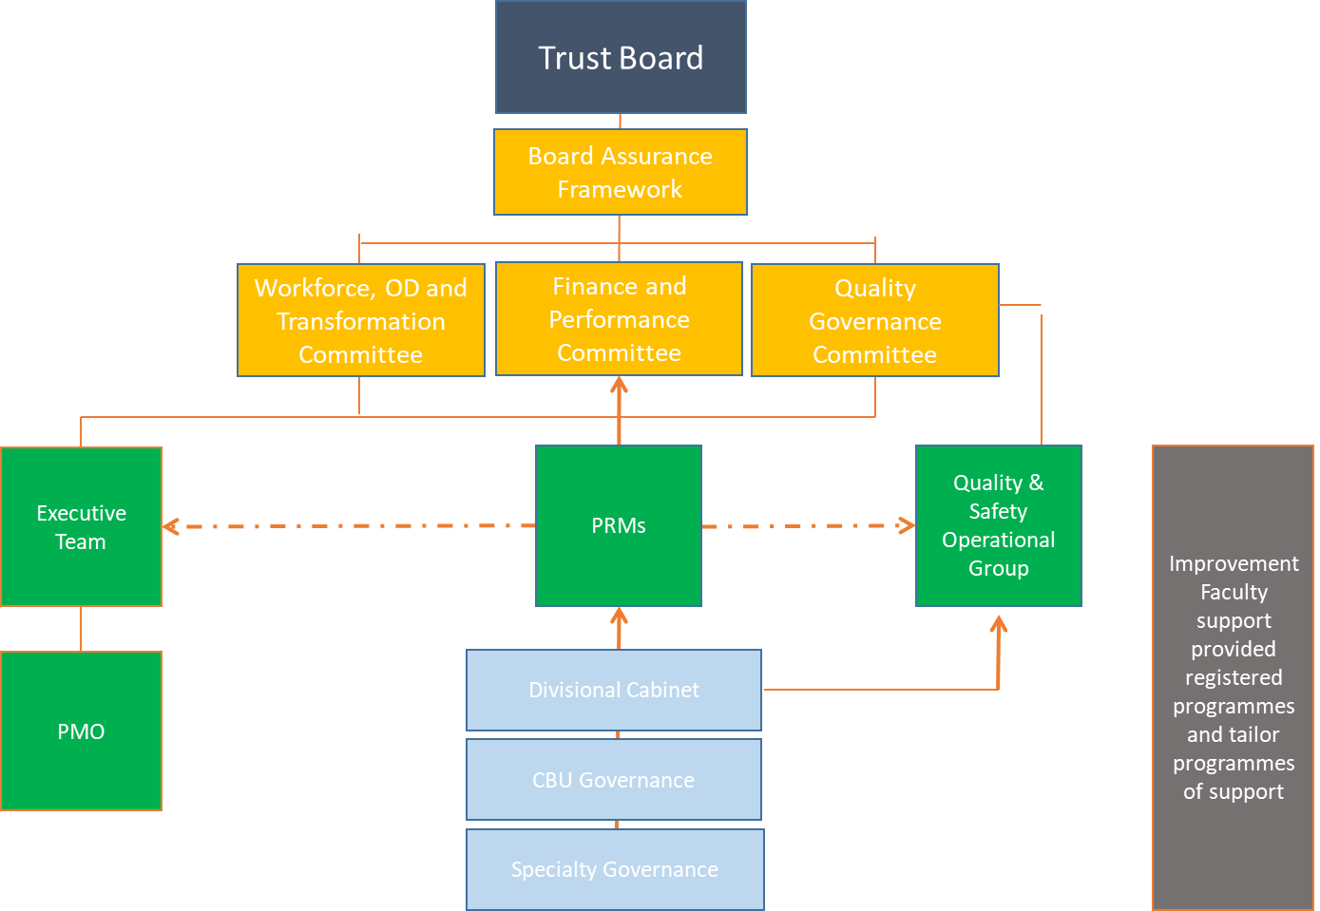

Support from Human Resources, Communications and staff side will be essential and is already provided within the PWG.

Communications Plan

The aim of the communications plan is to support the transformation of the ED department and any connected works. Making sure that all colleagues, partner organisations and interested parties are kept up to date and informed in a timely manner.

The communications plan is a tool that identifies the key audiences, wider than just the project stakeholders. It recognises the work done to date and sets out the plan for future messages:

Audience | Format or method | Message | Channel/ outlet | Timing | Progress
Staff | One off email | Funding announced and Boris visit | ULHT intranet  Email  Facebook  Round up  Blogs | August 2019 | Done
Public | Press release | Funding announced and Boris visit | ULHT website  ULHT social media accounts and Press release  Press release and media interviews | August 2019 | Done
Public | Column by A&E consultant | Work continues on project | Local media | March 2020 | Done
Staff | Staff update | Work is progressing | Weekly round up  Newsletter  intranet | July 2021 | Done
Staff | Staff update | Work is progressing | Weekly round up  Newsletter  Intranet | August 2021 | Done
Staff | Staff update | Work is progressing – these are the plans | ULHT intranet  Facebook  Round up  Blogs  Artist’s impression | From W/C 25/10/21 | Done
Public | Press Release | Work is progressing – these are the plans | Press release and media interviews  Story on website  Social media.  Artist’s impression  Stakeholder message | From W/C 25/10/21 | Done (social media ongoing)
Public/staff | Update | Plans have now been submitted for planning permission and are available here – link to council website | Update story on the website and social media | Early November 2021 TBC | Done
Public/Staff | Update | Enabling works are needed ahead of our ED build | Press release  Story on website  Social media  ULHT intranet  Email  Facebook  Round up  Blogs  Videos/pics | January 2022 | Done
Public | Published | Approved FBC | ULHT Intranet | August 2022
Staff | Staff update | Work will/has begun | ULHT intranet  Email  Facebook  Round up  Blogs  Videos/pics | TBC
Public | Press release | Work will/has begun | Press release – invite media  Social media  Videos/pics  Stakeholder message | TBC
Staff | Staff update | Key milestones | ULHT intranet  Email  Facebook  Round up  Blogs  Videos/pics | TBC as needed
Public | Updates | Key milestones | Social media  Columns  Videos/pics  Stakeholder message? | TBC as needed
Staff | Staff update | ED is completed and open | ULHT intranet  Email  Facebook  Round up  Blogs | TBC
Public | Press release | ED is completed and open | Press release – invite media  Stakeholder message and invitation  Social media  Columns  Videos  Pictures | TBC

The full plan is given in Appendix S.

Benefits Realisation

A benefits plan and register has already been established for the project (Appendix O), which supported the analysis within the strategic and economic cases. Benefits have been recorded onto the benefits register as identified through the workshops and meetings with the teams. Planning and modelling of benefits took place via a subgroup of the PWG, involving clinicians, finance and the project director. This subgroup discussed and assigned the realisation of benefits to the most appropriate person or team that will monitor the actual benefit once the project is complete.

Overall responsibility for benefits realisation remains with the SRO, but delivery will be through the groups as described, with the project director reporting to the POG. The benefits register will be reviewed and updated at each meeting continuously through the project to capture:

- Benefit category / class;
- Potential costs;
- Activities required;
- Performance measures;
- Target improvement;
- Full year value;
- Timescale.

Analysis of the benefits will be performed as part of the post project evaluation.

Risk Management

The Cabinet Office Risk Potential Assessment was completed at the outset of the project and scored as high risk. This was due to the large value of the scheme and the high level of political interest. The full RPA is given in Appendix I, results given below:

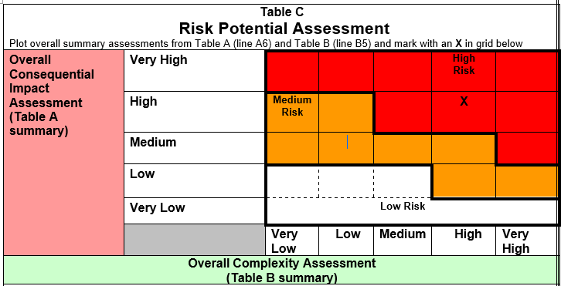

The RPA was used to form the basis of the original risk register. Risks identified at OBC stage were largely business risks such as how the new building might affect operational policy and how the new unit will be staffed. For the FBC, dealing with more detailed commercial requirements, the risk register has developed further to include design, service and external risks. Business risks for the main part are now picked up by the medicine division as part of their normal day to day governance processes.

The risk register is a standing agenda item on all Principles, POG / PWG and subgroup meetings. The register is available at all times to the group. Consideration of the risks in this manner has allowed early identification of potential risks and issues and subsequent mitigation where possible. This approach will be maintained throughout the project.

Ownership of risk throughout the project remains with the SRO, but is recorded and planned by the project director. The governance structure will ensure early recognition of any risks to afford time to consult, design and take any actions required to mitigate them.

The objective behind this approach is to provide assurance that the project is running to time and cost. At the OBC stage of the project a higher level of optimism bias (4% works, 24% capital) was being used but as risk has become better understood throughout the FBC process this has been greatly reduced.

By using this approach the scheme will have a resilient management framework, with support from Trust Board level, good communication of level of risk and clear and consistent management.

A copy of the full risk register at the time this document was presented is given in Appendix P.

Contract Management Arrangements and Plans

    - Informal Management Arrangements

Weekly “Principles Meetings” are chaired by the Cost Advisors and attended by ULHT, the main contractor and any relevant sub-contractor required at that time. By having senior members of the project team meeting with suppliers weekly a shared vision is created with buy in to delivering the project to a high standard on all sides.

Any potential issues affecting the contract can, where possible, be discussed and managed informally, managing expectations and keeping a grip on costs. The Cost Advisors will continue to hold these meetings throughout the course of the project.

    - Formal Management Arrangements
Day-to-day management of the contract including performance measures, minor changes and escalations are set out within the Project Execution Plan.

Project Assurance and Post Project Evaluation

From the outset, the trust and wider Lincolnshire health system have recognised the size and scale of this project and the need to develop skills in house where possible, rather than to solely use external consultants to ensure value for money. This will be one of the largest schemes undertaken for some time and there is recognition that organisations such as ULHT have lost experience it once had due to this passage of time. The lessons learnt from project assurance and post project evaluation will be essential to go on to inform future schemes and continue to develop in house skills.

    - Project Assurance
Monitoring during the project will provide upward assurance to the oversight group as described in section 6.2.2. This assurance will provide an analysis of:

- Whether the project is running to time and budget;
- Whether the project is providing the required outputs in terms of business case development through to building the ED;
- That the outputs are of sufficient quality to meet their objectives.

    - Post Project Evaluation
Post project evaluation will follow relevant guidance such as that set out in HM Treasuries Magenta Book and will take place in two forms:

- Project Implementation Review

Lessons learnt during the delivery phase leading up to the handover, implementation of the new service and first few months of use will be captured by the working group and fed upwards to the oversight group. This review will take place within 12 months of handover.

- Post Evaluation Review

This will take place 24 months post implementation to look at the original expected outcomes and benefits and evaluate as to whether the project delivered against them. If the implementation of the service is slow to achieve them the Oversight Group will look at how this may be improved. Critical to this will be capturing of whether the project was achieved to time and budget which will go on to inform our Capital and Revenue Investment Group and future case development in terms of refining our own optimism bias.

Data for the reviews will be provided by:

- Medicine Directorate data analysts for performance against constitutional standards, improved ambulance handover times;
- Human Resources and Finance for fill rates and agency spend;
- Estates and facilities for running costs, backlog maintenance, carbon reduction;
- CCG / ICS for incremental health gains.

This data will be used to form the answers to questions based on achievement of the benefits outlined in section 2.10 such as what has the reduction in staff agency costs been, how have ambulance handovers improved, how have inpatient conversions reduced etc. All this information is readily available within existing systems in the Trust and wider health community. No budgetary requirements are set aside for this as it is considered business as usual for the Trust to be monitoring its own performance.

As well as providing assurance that the project has delivered its aims and objectives it will provide an important evidence base for what went well and what has been learned. The Trust has not undertaken a capital project of this size for some time and skills from previous capital projects of magnitude have been lost. The trust is embarking on various capital projects and this, along with others will provide an important source of information and lessons learned.

As such key stakeholders will be involved in the reviews from finance, estates, communications, human resources and the medicine division but an important group will also be the teams from within the Emergency Department and the patient representatives that have been involved in developing the FBC.

The full Post Project Evaluation Plan is given in Appendix AF.

