Estates Annex
Full Business Case
Pilgrim Hospital, Boston – New Emergency Department
United Lincolnshire Hospitals NHS Trust
making the difference
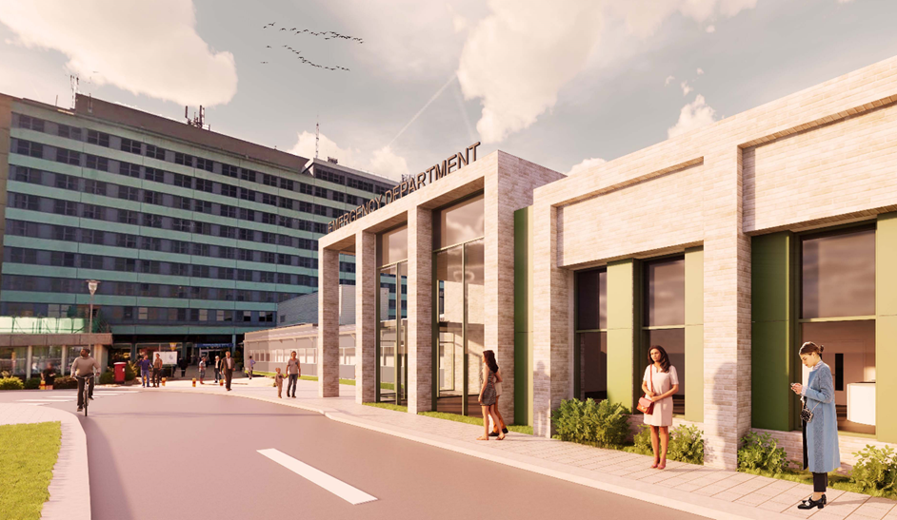


Contents
1 Executive Summary 2
2 Investment Objectives 4
3 Estates Strategy 7
4 Project Scope 21
5 Financial Case - Summary 59
6 Commercial Case - Summary 61
7 Management Case - Summary 69
8 Conclusion 74

Rev | Status | Originator | Approved | Date
0 | Draft |  |  | 24th March 2022
 | Full Draft |  |  | 30th March 2022
 | Final Full Draft |  |  | 6th April 2022
© Turner & Townsend Consulting Limited. This document is expressly provided to and solely for the use of United Lincolnshire Hospitals NHS Trust on the Pilgrim Hospital, Boston – New Emergency Department and takes into account their particular instructions and requirements. It must not be made available or copied or otherwise quoted or referred to in whole or in part in any way, including orally, to any other party without our express written permission and we accept no liability of whatsoever nature for any use by any other party.

Executive Summary

Introduction to the Estates Annex
This document forms the Estates Annex to the Full Business Case (FBC) for the project to Develop Resuscitation Facilities, Improve Urgent Treatment Centre Accommodation and Reconfigure the Emergency Department at Pilgrim Hospital, Boston.
In addition to the HM Treasury Five Case Model, the Estates Annex ensures that the estates content of the FBC is given due prominence in the overall case for change and is a requirement of NHS England & Improvement (NHSEI) as set out in the NHSEI Business Case Fundamental Criteria.
The Estates Annex does not seek to duplicate the main content of the FBC; however, it does provide a summary of the impacts of the project on the Estate, how the estate becomes an enabler for improved clinical outcomes and Trust performance and demonstrates alignment with the wider Estates Strategy. It should be read in conjunction with the main FBC documentation.

Context
Pilgrim Hospital, which opened in 1976, is situated north-east of the centre of Boston, Lincolnshire and is part of one of the biggest acute hospital Trusts in England, serving a population of over 736,700 people. The hospital provides all main specialities, as well as a 24-hour major Accident and Emergency (A&E) Department, which is the focus of this project.
The current A&E Department is positioned to the front of the hospital, which is heavily populated by traffic, including ambulances, and pedestrians; according to the latest Care Quality Commission (CQC) report (dated 08/02/2022) the Trust saw more than 147,000 emergency patients in the last year. The facility currently comprises of an Emergency Department (ED), Urgent Treatment Centre (UTC) and administration space.
The performance of United Lincolnshire NHS Trust (the Trust) against the 4-hour A&E target (patients arriving at an ED to be admitted, transferred, or discharged within 4 hours) has been poor. There have been growing attendances at the ED, and because of staffing difficulties and long lengths of stay for inpatients, backlogs into the “front door” have been created. It was recognised that the aging ED infrastructure had not kept pace with demand and modern medicine, and this was a significant contributing factor to performance.
CQC have undertaken a series of visits, during which it has unfortunately rated the urgent and emergency care at Pilgrim Hospital, Boston (PHB) as ‘requires improvement’. In response to this rating and following a visit from the Prime Minister Boris Johnson on 5th August 2019, it was confirmed that the Trust would receive £21.3 million of funding. A plan was then developed to use the funding to develop the Resuscitation facilities, improve the Urgent Treatment Centre (UTC) accommodation and reconfigure the Emergency Department (ED), to help improve the service to the required standard.
The Trust are the provider of acute and planned care hospital-based services at PHB.

Investment Needed
The FBC seeks approval for a capital investment of £43.5m and a recurrent revenue impact of c. £1m (non-pay expenditure) for improvements to the UTC, an expanded resuscitation facility (Resus) and reconfiguration of the remaining ED at PHB.
The project will support provision of modern urgent care facilities in line with the Lincolnshire Urgent and Emergency Care Strategy.
As owner of the site, the Trust was asked to develop and lead the investment project, working in close collaboration with partner organisations, including the Clinical Commissioning Group (CCG) and the Integrated Care System (ICS).
The OBC was approved at the Joint Investment Sub Committee (JISC – DHSC & NHSEI) on 12th August 2021.
Both the OBC and FBC have been developed in accordance with the underlying principles of the HM Treasury Green Book and the NHSEI Business Case Fundamental Criteria; to develop clear spending objectives, benefits and risks and use these to develop the best value for money option to satisfy the spending criteria.

Current Status
For the most part, the FBC deals with procuring the contractor for the scheme and ensuring rigorous contractual arrangements are in place. However, the Trust utilised a “design and build” contract through the Pagabo framework to relook at the OBC design and develop the detailed drawings required.
The Trust took the decision to “flip” the UTC side of the refurbished building. Whilst this leaves the layout of the UTC similar to the OBC design, it provides an entrance close to the hospitals main entrance, improving the look of this area. It means ambulant patients can enter the building over a much quieter road with a pedestrian crossing. It also means that patients arriving by ambulance maintain much better dignity.
The FBC also considered a revised strategy for the decant of staff within the “H Block” by bringing back into use an adjacent building – the Maternity Block. This building was closed due to asbestos and clean water issues; however, work is ongoing to bring it back into use to support this scheme, eradicating some £6.7m of backlog maintenance and creates more than enough space for the decant.
In terms of demonstrating best value for money a revised Comprehensive Investment Appraisal (CIA) was undertaken with this solution (option 4B) and the original OBC design (4A). The other options in the OBC were not appraised again as option 4A had already demonstrated best value for money. The benefits used within the model were also updated in line with the conditions of the JISC approval.
The appraisal demonstrated that the new design offered far better value for money within the same cost envelope and is being taken forward to delivery.

Investment Objectives
In order to address the issues facing A&E services, including urgent care in Boston, a workshop was held on 13th November 2019 with all service commissioners, providers, and users to agree a single, unified vision for the new ED department.
The agreed Investment Objectives are as follows:
Investment Objective SO1: to develop the accommodation for the Urgent Treatment Centre, addressing compliance
Specific | A co-located building (new build or refurbished existing infrastructure) that conforms to “Urgent Treatment Centres – Principles and Standards” (NHS England, July 2017)
Measurable | The service will be designed to provide the correct number of HBN compliant facilities in line with the business needs and will be reviewed from the design and schedule of accommodation
Achievable | Within new premises or existing, redeveloped buildings from the capital allocation received
Relevant | Fits within local and national strategies at a time where demands on the ED exceed the capacity of the existing infrastructure
Time Constrained | To be completed at the outset of the new building going live, in line with the project programme

Investment Objective SO2: to improve access to care for our most seriously ill patients, addressing effectiveness
Specific | A co-located building (new build or refurbished existing infrastructure) that provides capacity to cope with highest demands of patients requiring resuscitation facilities
Measurable | The service will be designed to provide the correct number of HBN compliant facilities (or agreed derogations) in line with the business needs and will be reviewed from the design and schedule of accommodation
Achievable | Within new premises or existing, redeveloped buildings from the capital allocation received
Relevant | The demand analysis demonstrates a lack of provision (which correlates with what our senior doctors have told us) for our most unwell patients who require treatment within a “resuscitation department” or resus
Time Constrained | To be completed at the outset of the new building going live, in line with the project programme

Investment Objective SO3: to improve flow and quality within the remaining ED, addressing effectiveness
Specific | By moving minor injury and illness to the UTC we will reconfigure the remaining Emergency Department to improve outcomes and quality for major illness and injury attendances (majors) and paediatrics
Measurable | The service will be designed to provide the correct number of HBN compliant facilities (or agreed derogations) in line with the business needs and will be reviewed from the design and schedule of accommodation
Achievable | Within the existing footprint of the ED, within the capital allocation received
Relevant | The demand analysis demonstrates a lack of provision for our “majors” category of patients
Time Constrained | To be completed at the outset of the new building going live, in line with the project programme

Investment Objective SO4: to improve the turnaround of diagnostic and pathology services within the Emergency Department, addressing effectiveness
Specific | Reduce delays from poor quality of samples and out of date technology.
Measurable | Turnaround times of pathology samples (current contract is 90% within 1 hour for ED tests  Performance for pathology is just over 90% for all tests except Cardiac Troponin at 89%, this objective will improve all results to over 90% (expected 92%)  For CT the current number of patients scanned within an hour of requesting is less than 50%. This is expected to rise to over 90% with the scanner in the department
Achievable | Options are around improving access by having services closer to patients or improving the infrastructure such as air tubes that deliver services
Relevant | To help improve performance against standards and improve patient care
Time Constrained | To be completed at the outset of the new building going live, in line with the project programme

The workshop agreed a single project to develop each of the Investment Objectives, and it should be noted that the construction of a new ED department will facilitate the Trust to deliver against each Investment Objective.

Estates Strategy

The Existing Estate
United Lincolnshire Hospitals NHS Trust is situated in the county of Lincolnshire and is one of the biggest acute hospital trusts in England, serving a population of over 720,000 people.
The Trust provides a broad range of clinical services including community services, population-screening services, and a comprehensive range of planned and unscheduled secondary care services including specialised services for stroke, vascular and cardiac services.
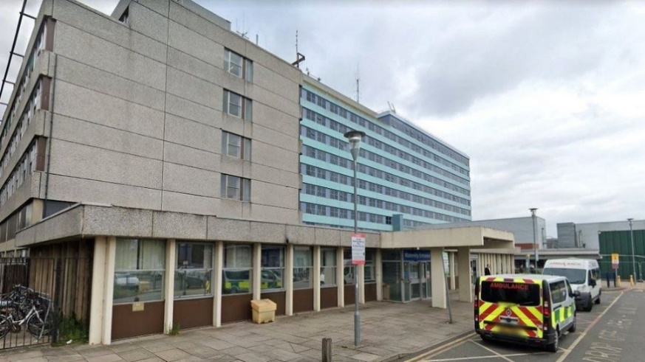
The Trust’s services are provided from three principal hospital sites:
- Lincoln County Hospital
- Pilgrim Hospital, Boston
- Grantham and District Hospital.

In addition, a number of services are provided from community hospitals closer to patients’ homes at Louth County Hospital; John Coupland Hospital, Gainsborough; Johnson Community Hospital, Spalding and Skegness and District General Hospital.
In an average year, the Trust treats more than 150,000 accident and emergency patients, over 600,000 outpatients, over 140,000 inpatients and delivers over 5,000 babies.

Current Estate: Size
The Trust operates across three sites in Lincolnshire: Lincoln County Hospital, Pilgrim Hospital Boston and Grantham and District Hospital.
The estate has a total floor area of 467,000m2, consisting of a building stock of varied ages, design, configuration, and condition.
Areas | Unit | Lincoln County Hospital | Pilgrim Hospital Boston | Grantham and District Hospital | Total
Gross internal site floor area | m² | 73,095 | 56,880 | 27,453 | 157,428
Site land area | m² | 212,900 | 169,600 | 84,500 | 467,000
(Information in table above taken from ERIC data 2020/21).

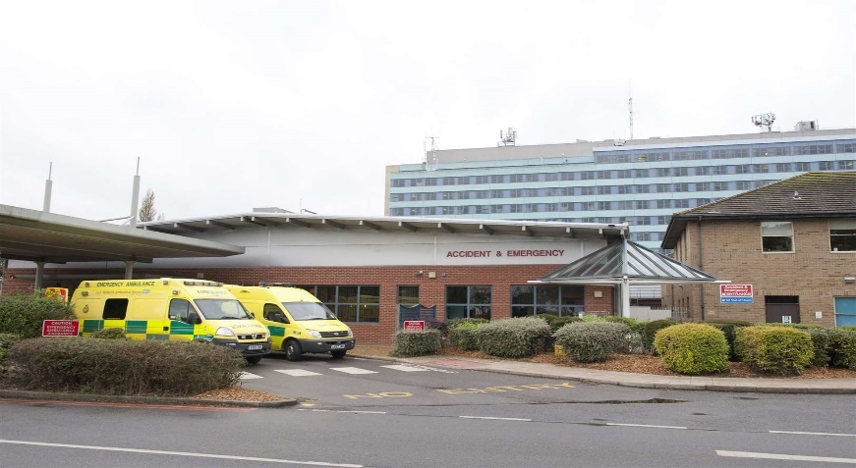
Pilgrim Hospital, Boston
Pilgrim Hospital is a District General Hospital located to the north of Boston, officially opened in 1977. It has 347 beds and provides all major specialities with a 24-hour Type 1 ED (major Emergency Department providing 24-hour consultant led services with resus facilities).
The hospital sits to the west of the main entrance from Sibsey Road. The ED is situated at the front of the site, along with the majority of Outpatient services (OP). A 10-floor tower block behind it contains the majority of the wards and IP services.
The current ED and UTC facilities are constrained in their ability to deliver services. There is a reception with triage, resus area, majors area and a minors area within the ED and a co-located Urgent Treatment Centre. There are three small cubicles designated as “minors” although this is not in a separate area to majors. PHB ED has just eight majors cubicles and a fit to sit area created within a further cubicle.
The UTC accommodation is constrained within the building adjacent to the ED. It meets the criteria for UTC but does not provide sufficient capacity or HBN compliant accommodation. There are 6 consultation rooms. Lincolnshire Community Health Services NHS Trust (LCHS) provides the UTC services within the Pilgrim Emergency Department. A current site plan of PHB is shown below:

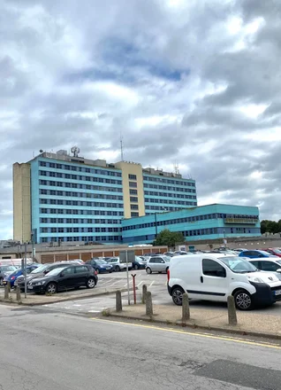
Emergency Department
The gross internal area of the current ED (including circulation areas) is approximately 1200m2. The area of the department used for the UTC is 150m2.
If the current ED treatment areas were “sized up” to meet current HBN requirements their overall footprint would increase from 241m2 to 395m2. The department is approximately 61% smaller than it should be before considering the need to meet demand.
Just over 15% of space is used for non-clinical reasons, well in line with the Carter Report, 2016, which recommends no more than 35%.
Further comments on the existing estate are detailed below:
- Capacity and demand modelling showed that, for our most ill patients requiring resus, the Trust does not meet the demand and doctors have to make difficult decisions on which patients can go into the resus area.
- There is frequently a requirement for 6 cubicles, not the current 4 (plus 2 separate overflow spaces created recently to try and cope), and often demand peaks at up to 8.
- The resus area at PHB does not meet the Health Building Note 15-01: Accident and Emergency Departments (April 2013) which recommends standardisation of room-handling.
- The majors and minors areas of the ED are similarly compromised, and the patient feedback received demonstrates clearly a need to improve the dignity and quality of clinical space;
- The Trust receives many negative comments through patient feedback regarding the quality of the accommodation.
The CQC continues to rate the department “inadequate”.
Note - the business case prepared deals with the issues around poor and inappropriate estate for our patients. It does not request additional staffing, although it provides the rationale for future demand and staffing increases. This has been discussed and agreed pending future business cases with commissioners.

Urgent Treatment Centre
An Urgent Treatment Centre is in place within the ED but is based on the previous “Primary Care Streaming” accommodation and is constrained within the building adjacent to the ED. It is felt this could be developed to provide better accommodation, take the minors patients out of the main department, and improve the flow within urgent care. The current accommodation meets the criteria for UTC but does not provide sufficient capacity or HBN complaint accommodation.

Diagnostic Services
Diagnostic performance is also a big problem in the ED affecting the time taken for blood results to come back and for imaging investigations (notably CT scanning) to be completed. A single in-house CT scanner is in place in the hospital, which is quite a distance from the ED and, when not functioning, causes major diversions across the county and beyond for very ill patients, which affects their chances of recovery as well as causing logistical problems for our ambulance provider, East Midland Ambulance Service. As of March 2021, an additional mobile scanner is available at the current time but again, is a distance from the ED and external to the building. If needed to be used for the ED an ambulance would be required to move the patients to the scanner.
The current site plan of ED and UTC at PHB is shown below:

PHB ED Existing Lay out
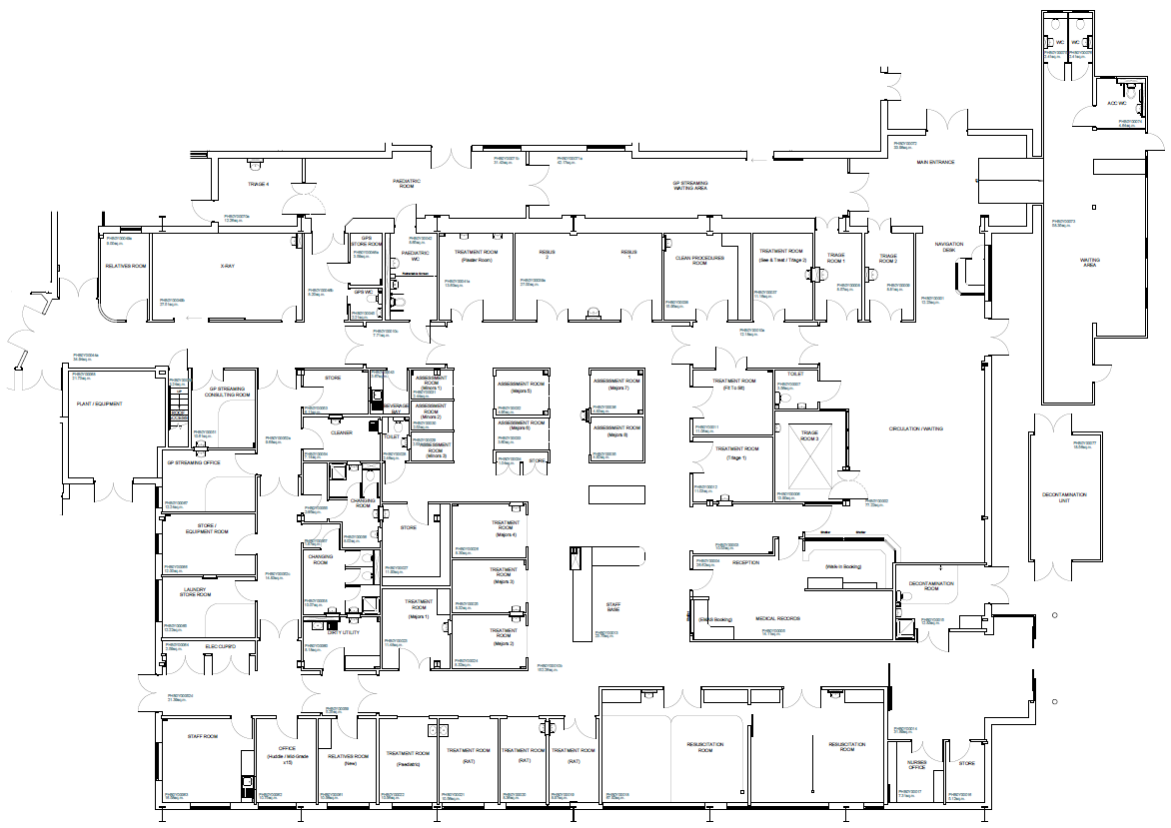

UTC within the “H Block”
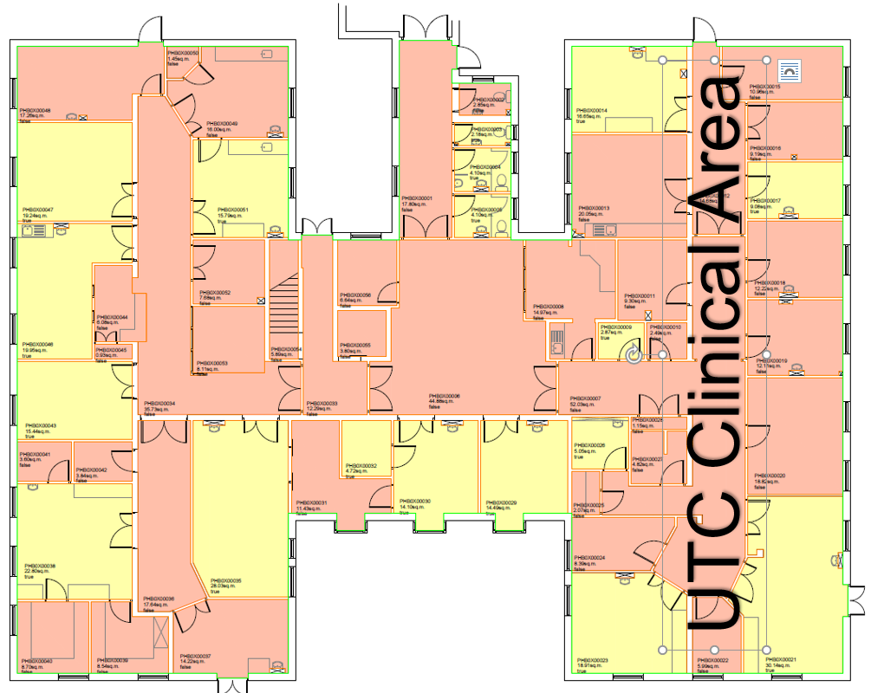

Estate Performance
The Trust Estates Strategy, 2022, recognises that within the NHS estate in Lincolnshire, and particularly the acute hospitals, some of the estate buildings are aging and not fit for purpose in providing modern and reliable healthcare to the local population.
Extensive backlog maintenance and ongoing deterioration in the hospital estate impacts directly on the quality and reliability of service that can be offered to patients. This includes concerns raised by external bodies about the standard and size of the estate and recent regular failures in critical infrastructure, which have led to service disruption, high repair costs and poor patient and staff experience.
Clinical and financial improvements are required to improve patient outcomes, quality of care and lift the Trust out of Level 4 in the new NHS System Oversight Framework. It will also be cognisant of the board assurance framework priorities which identifies a fit for purpose environment for the three acute sites.
There are a number of schemes/developments which have been identified which require investment within the 2022-2025 capital programme; one of the current schemes which will greatly improve the patient and staff experience and enable the delivery of quality care, is the £43.5m ED project at PHB.

Current Estate: Constraining Performance
The current ED at PHB was completed in October 1999. At the time, demand and subsequent planning was based on attendances of 130 patients per day. Primary Care Streaming opened in October 2017 providing an additional 3 clinical rooms to see minor injury and ailments. The department now sees an average of 205 patients per day.
The Trust is often one of the worse performing trusts in the county achieving just 62.1% of patients seen, treated, discharged, or admitted within 4 hours in September 2021 (ED 50.2%, UTC 86.4%), against an average of all trusts of 75.2%.

Current Estate: Physical Condition
In 2017, Monaghan’s carried out a six-facet survey. At the time of collating the report, it identified that the square meterage of estate falling below the required Condition B standard was between 88-94% by floor area and 77-82% by block across all three sites.
In early 2019, the Trust carried out a visual review and attended a series of workshops to review and update the six-facet information block-by-block on each site. The result of that exercise was that over a three-year period the estate had reduced further in condition, due to minimal investment and increased backlog across the sites, reducing the amount of estate at Condition B further.

The table below show the results from the workshop involving Consultants and Estates carried out in 2019 for PHB.
Condition | Total Number of Building Blocks
Condition A | 0
Condition B | 5
Condition B/C | 3
Condition C | 15
Condition C/D | 0
Condition D or D(X) | 4
Total | 27

The diagram below illustrates the estate condition across each block:
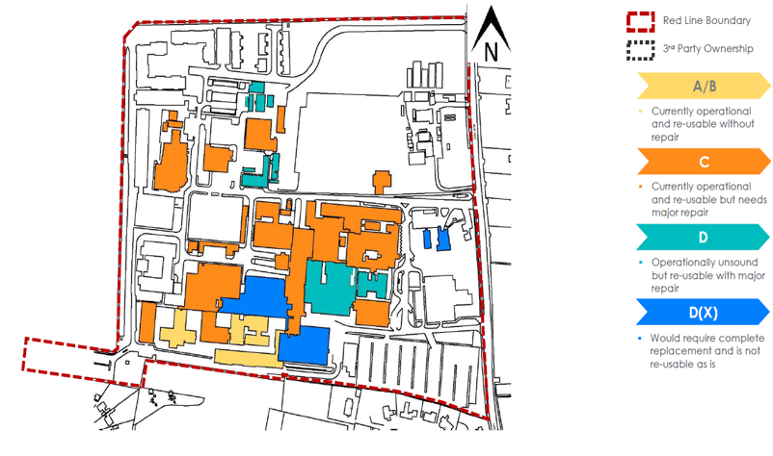

Current Estate: Backlog Maintenance
The Trust backlog maintenance costs as per published Trust ERIC 2020/21 return are shown for PHB in the table below.
The backlog maintenance at PHB was over £31m as summarised below:
Backlog ERIC Data 2020/21 | Description | Value
High Risk | Must be addressed as an urgent priority in order to prevent catastrophic failure, major disruption to clinical services or deficiencies in safety liable to cause serious injury and/or prosecution. | £1,058,488
Significant Risk | Require expenditure in the short term but should be effectively managed as a priority so as not to cause undue concern to statutory enforcement bodies or risk to healthcare delivery or safety. | £15,407,545
Moderate Risk | Should be addressed by close control and monitoring. They can be effectively managed in the medium term so as not to cause undue concern to statutory enforcement bodies or risk to healthcare delivery or safety. These items require expenditure planning for the medium term. | £5,458,391
Low Risk | Can be addressed through agreed maintenance programmes or included in the later years of your estate strategy. | £9,503,985
Total |  | £31,428,409

The backlog cost stated above is the cost to bring the estate assets below condition B up to condition B. The backlog out-turn costs would be significantly higher and include a number of other costs such as:
- Professional Fees
- Planning Contingency
- Optimism Bias
- Inflation
- Decant & Phasing costs
- VAT.
The capital investment for the priority capital projects will progressively reduce both the total backlog and risk-adjusted backlog over the two-year period of the works but it will not eliminate backlog completely as the existing estate will continue to age. An annual review of survey findings and risk assessments will monitor the estate condition and support the annual investment planning process.

Current Estate: Critical Infrastructure Risk
As part of the process to establish backlog maintenance, the Critical Infrastructure Risk (CIR) is also calculated. CIR is the total of the high and significant risk backlog maintenance. It represents the amount of capital investment needed to eliminate safety and resilience risks from the operational estate.
The risks are made up of three categories:
- Non-compliance with statutory and mandatory requirements
- Patient, staff, and visitor safety issues
- Infrastructure works to ensure continuity of services.

The CIR based on the ERIC return for high and significant risks at PHB equates to £16,466,033

Current Estate: Existing Primary Infrastructure
In 2020, a Mechanical and Electrical (MEP) review carried out a review of the current primary infrastructure across all three sites, building on the 2017 six-facet survey. Since this review was carried out, the Trust has spent £9.6 million addressing critical infrastructure risk across the three sites, with the main results below for PHB, and some specific works in the ED department:
Infrastructure Item | Status | Action in Year 0-2
HV Network | Peak demand over that of the Authorised Supply Capacity would occur should the Combined Heat & Power (CHP) be offline. Additionally, the HV infrastructure is at the end of its life expectancy and some HV switchgear is subject to switching restrictions due to ageing, failure, and non-availability of spare parts. Trust wide scheme to review and increase capacity and resilience. | Feasibility study
Generators | The resilience of generator 5 is very weak as it is a standalone generator which has completed over 14,000 run hours yet supports ICU, endoscopy, and the medical air plant. Issues with maintainability of change-over contactors. | Feasibility study
Steam mains | Issues with steam mains and frequent leaks, including access due to confined space limitations and the presence of asbestos. | Incorporate in NZC study
Gas Mains | Issues with steam mains and frequent leaks, including access due to confined space limitations and the presence of asbestos. | No action
Medical Gas | O2 VIE plant resilience issues. Trust wide scheme to review and increase capacity and resilience. Feasibility stage complete. | No action
Building Management System (BMS) | Large parts of the BMS are obsolete, with limited environmental controls or strategies, leading to over/under heating of areas or poor temperature control. | Feasibility Study
Chillers | Decentralised system. Some R22 refrigerant noted as still in use | No action
Potable Water | There are significant issues with the water systems. Pipe failures are frequent, and Chlorine Dioxide has been turned off due to its corrosive nature, therefore large sections of pipework require replacing. It is noted that a new UTC was constructed 2020-2021 and it is not understood at this time the impact to the infrastructure this capital project had. | Infrastructure survey
ED Refurbishment | ED was enhanced during 2020 and it is not understood at this time the impact to the infrastructure this capital project had. | Infrastructure Survey
Ward refurbishment | During 2020/2021 14 wards Trust wide received ward enhancements of immediate redecoration and IPC enhancement. Due to time constraints and COVID-19, key backlog infrastructure was unable to be addressed. Key wards to be addressed include Family Health at Lincoln and Boston. | Infrastructure survey

Premises Assurance Model
The Premises Assurance Model (PAM) has been developed by the Dept. for Health & Social Care to provide assurance for Boards on estates and facilities management on a consistent basis to prompt investigations and dialogue with regards to estate performance.
The assessment follows a structured process of self-assessment on specific legislation and estate guidance under 5 domains:
- Safety (hard and soft FM)
- Patient Experience
- Efficiency
- Effectiveness
- Organisational Governance.

The graph below illustrates the Trust’s current scores, which shows a varied picture across each domain, but the majority scoring in either Requires Minimal to Moderate improvements, with ‘Safety’ and ‘Governance’ requiring the biggest amount of improvement.
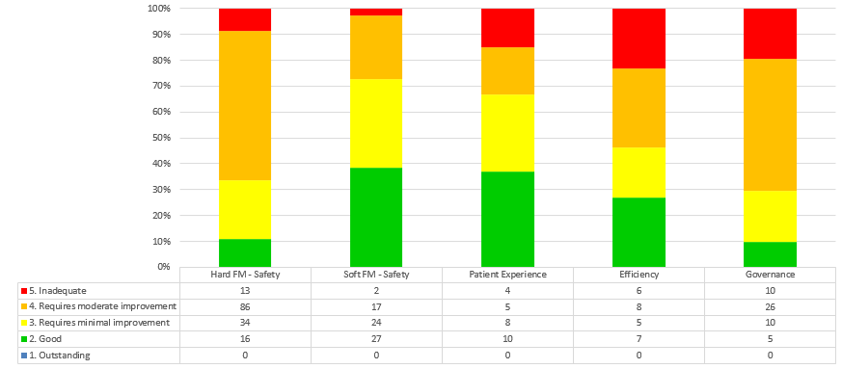
Trust PAM scores 2020/21

Proposed Changes to the Estate
The Estates Strategy is about improving the clinical environments in our hospitals, to make them fit for purpose in delivering quality, reliable care to the people of Lincolnshire, as well as providing a state-of-the-art environment for our staff to deliver care from. This is part of the broader Lincolnshire Health Infrastructure Programme to transform the provision of healthcare across Lincolnshire.
The Trust has also received Health and Safety Executive (HSE) Improvement notices. The 10-year estates strategy is split into two phases:
- Phase 1 - priority works years 0-2 to address critical infrastructure risks and ensure clinical services can continue to deliver safely without disruption.
- Phase 2 - includes enabling works and key infrastructure and a number of new build developments.
This is based on a detailed design strategy and estates review, seeking to minimise service disruption, and spread capital costs.

Trust Priority Spend Year 0-2 (Phase 1)
With regards the short-term vision for the estate and Phase 1 investment, the Trust has a clear set of aims to support the quality, safety, and effectiveness metrics:
- To develop a two-year plan to upgrade the overall condition of the estate and reducing further deterioration and risk. (Critical Infrastructure Risk)
- To ensure any immediate/ urgent clinical and service developments are facilitated.
- To ensure any estate physical solution to these service developments are, as far as possible, in accordance with the Trust’s emerging clinical strategy, system acute services plan and dovetail into the development control plan and overall ICS strategy.
- To create an energy infrastructure plan to upgrade the Trust’s supply plant and equipment. Investment has already been secured to ensure improvements, through successful bids for Department of Health and Social Care grants and using interest-free loans.
- To review the efficiency of the estate and facilities services, taking all opportunities to reduce cost and align with the model hospital metrics and the Lord Carter report.
- To rationalise the estate and generate capital from the sale of surplus land and assets, as well as improving the utilisation of space and prioritising clinical services.
- To deliver substantial improvements in car parking facilities across the sites.
- To ensure any previous or short-term capital investment is not wasted.
The Trust’s 0–2-year priority spend has been reviewed against the ICS reconfiguration to ensure alignment.

Ten Year Estates Strategy (Phase 2)
There is a wider capital investment programme for PHB outside of this business case for the New Emergency Department. Phase 2 includes enabling works and key infrastructure and a number of new build developments.
This is based on a detailed design strategy and estates review, seeking to minimise service disruption, and spread capital costs:
Lincoln County Hospital, Phase 2: | Pilgrim Hospital, Boston, Phase 2: | Grantham and District Hospital, Phase 2:
Women’s and Children’s | Inpatients | Women’s and Children’
Haematology and Oncology | Women’s and Children’s (W&C) | Inpatients
Endoscopy and Therapies | New ward block | Haematology and Oncology
 | Refurbishment of existing ward block | Imaging
 | Theatres and Critical Care | Outpatients, incl. Day Surgery, Cardiac, Endoscopy, Therapies
 | Haematology and Oncology | Support services
 | Outpatients incl. Cardiac & Endoscopy
 | Imaging

Development Control Plan for PHB
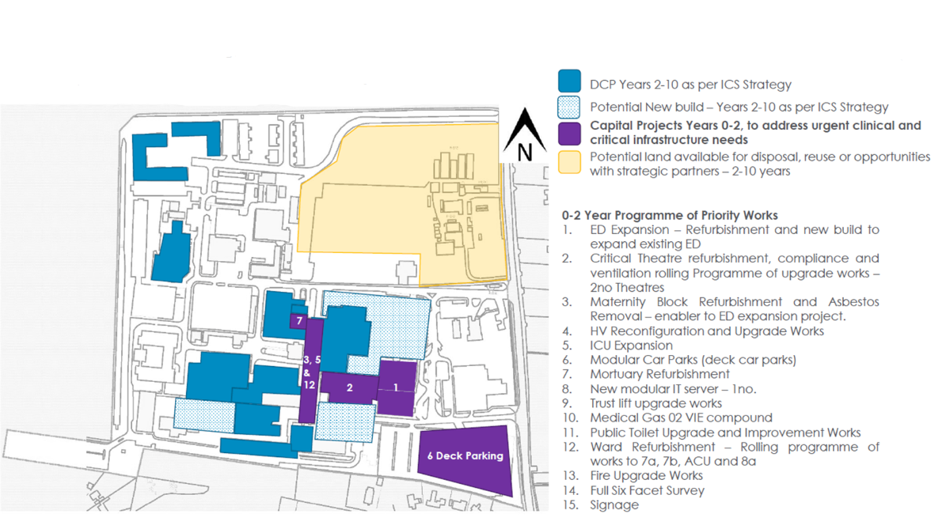
Development Control Plans have been developed to support the delivery of the Estate Strategy at each hospital site. The image below is of the PHB plan and sets out the Phase 1 enabling works including the ED expansion project.

Land and Property Disposal and Acquisition Programme
The Estates Strategy does include plans for property disposal.
The sale of surplus land, either with or without planning permission, generates a one-off capital receipt.
Many Trusts and other public bodies are considering alternatives to outright disposal and a capital receipt, and as an alternative retaining an interest in the land, and/or buildings and converting that interest into a long-term revenue stream for the Trust. Areas identified as potential areas for disposal at PHB are as follows:
Land identified for potential disposal
However, there are no property disposal elements forming part of this business case.

Project Scope
A workshop was held on 13th November 2019 to discuss the scope of the project, key service requirements and benefits, risks, constraints, and dependencies. This group defined the scheme as a “Project to develop resus facilities, improve the Urgent Treatment Centre and reconfigure The Emergency Department”.
The business scope was split into core, desirable and optional requirements:
Range | Core | Desirable | Optional
Scope | Provides the minimal functionality to operate a modern Emergency Department | As for Core but has the scope for additional income through ED clinics and has improved facilities for paediatric patients and bereaved relatives | As for Desirable, plus additional diagnostics and better facilities
Service Requirements | - Expansion of Resus to 6 bays (min)  - UTC  - Redesigned Majors area  - Paediatric clinical rooms  - Seminar room  - Training room  - Plaster room  - Administrative space  - Places of Safety(s136)  - Staff room  - Good access / egress to wards  - CT scanner & X-ray | - ED clinic room  - Dignity suite / changing places  - Frailty / AEC clinic rooms  - Pharmacy  - Paediatric waiting area separate to main  - Volunteers’ area  - Bereavement suite  - Emergency dentistry | - EMAS facilities  - Ultrasound scan room  - Café / concessions

The core model is a simplistic design that fits the scope of increasing resus capacity, building a UTC and redeveloping the space left behind for majors cases. However, more desirable options would improve throughput, have the potential to bring patients back faster to clinic and improve facilities for children.
Analysis of the current demand plus an increase for anticipated future demand / population growth showed that the following clinical space would be required, as an absolute minimum. Any additional rooms would future proof the service.
 | Current cubicles | Increase required | Total required
Resus | 4 (+2 separate overflow spaces) | 4 | 8
Majors | 8 | 35* | 43*
Minors & UTC & GP | 3 | 6 | 9
* The significant increase in majors space includes a large volume of “fit to sit” spaces to cope with peaks in demand. The fit to sit area, step up rooms and speciality specific rooms will all be available for the use of both UTC and Majors.

Preferred Option
In accordance with the requirements of HM Treasury’s Green Book and supporting guidance, a wide range of options were considered in response to the project scope above.
The business-as-usual option was not considered a viable option within this business case as the strategic case demonstrated the current poor performance due to burgeoning demand within urgent care that, put simply, is putting patients at risk.

Location Options
A workshop was held on 27th November 2019 was designed to discuss where, in view of the combined project, possible building work could take place and the merits of each option.
A range of options had been developed by the consultant architect in response to the emerging accommodation schedule with do minimum, intermediate, and do maximum options. In addition, the Estates Strategy identified adjacent buildings in poor condition, which, with some moves of existing occupants, could be a good option to raise and rebuild (see Design Annex).
A site options review was undertaken and option 4 utilised a building dubbed the “H-block” was confirmed as the preferred. This option would involve demolishing the H Block and building a new, 2 storey facility in its footprint, with ED moving to the new building and UTC taking over the existing ED space which would be refurbished to current standards. The first floor would be used for the office space, training, and storage as well as some services such as clinical assessment.
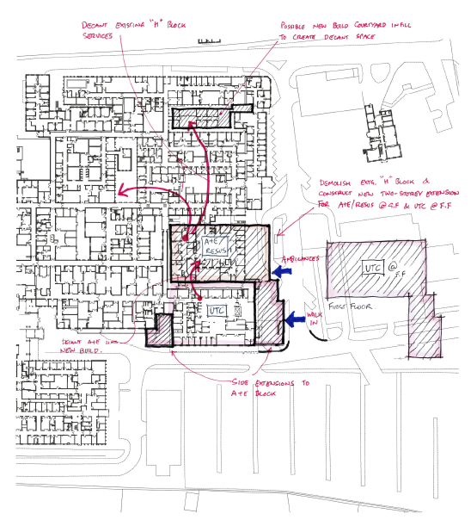
See Preferred Long List Location Option:

SWOT Analysis of Preferred Location
A SWOT analysis of the preferred location was developed:
Strengths | - No road diversions  - No disruption to existing services during construction  - Financially realistic in view of less building work and no road moves
Weaknesses | - Reduced footprint and expansion of the existing ED is limited  - Does not allow expansion without future road diversion  - Design would be constrained by having to be “shoe-horned” into the space left from the H block
Opportunities | - Demolition of H block removes backlog maintenance issues (offset cost of build)  - Good connectivity between ED and UTC – promoting staff integration and new ways of working
Threats | - Requires decant of existing services in the H block. Whilst possible to do, needs careful planning to minimise disruption to clinical services

Options Appraisal
At OBC stage a short-listing exercise was undertaken and the working group identified five shortlisted options for further appraisal. These included BAU, Do Minimum, the Preferred Way Forward, and less and more ambitious preferred ways forward:
The indicative costs for the different options considered at OBC were as follows:
Note, these costs are indicative, a higher level (24%) of optimism bias was built into the financial summary
Following meetings with NHSEI on 19th October 2020 the indicative costs were reviewed again and a further economic analysis of options to bring costs closer to the original £21.3m was requested. Further cost advice was taken on the design after meetings with NHSEI estates teams focussed on ensuring rooms were HBN compliant, circulation spaces were more accurate and more information on BREEAM and Modern Methods of Construction were considered.
The options subjected to further cost advice and financial appraisal (see financial case – CIA modelling) were:
- Option 4: the designs were re-appraised after the clinical team requested more space on the 1st floor and plant was moved into the ceiling space. This considerably increased costs at £48,822,997.
- Option 4a: the original option 4 was reviewed and included the above detail such as HBN compliant rooms. The cost for the option increased slightly to £36,767,551.
- Option 5: the original option to refurbish the H Block and build out to the rear of the building for resus. This option was re-costed at £33,897,258.
- Option 8: a refurbished H block without the large extension for resus. Whilst this would significantly limit the accommodation costs were much closer at £27,931,892.

Cost Evaluation of the Risks and Benefits of the Shortlisted Options
The Comprehensive Investment Appraisal model (CIA) was used to determine the option with the highest benefit – cost ratio. Costs were evaluated using data available to the Trust and looking at wider QALY data where available. A workshop was held between teams from operations to confirm the model and costs. Analysis looked at the sensitivity of the model to see how much a risk or benefit would need to be amended or switched in order to change the outcome. The model was conclusive in demonstrating the preferred way forward offered the greatest benefits per amount of capital spent:
Key assumptions:
- Covers an appraisal period of 60 years, and uses a discount rate of 3.5%
- Costs, benefits, and risks are expressed in prices at 2020/21 levels
- VAT and transfer payments are excluded from cash flows
- CIA model inputs are described in the sections that follow.

The economic appraisal however did not support option 8 as the best value for money option. Neither did it support the clinicians preferred model – the revised option 4 with additional space on the first floor.
Option 4a – the original plan to demolish the H block and rebuild for ED, with plant located on the first floor – remained the best value for money option.
Alterations to option 4a at FBC (option 4b) did not greatly alter the layout within the ED or the appearance, the only difference is the inversion of the building to create an entrance at the opposite side to option 4a.

Option 4a characteristics
Characteristics, benefits and disadvantages of the preferred option, Option 4b, are provided below:
Characteristics | - Demolition of the existing Support Services Block  - New build A&E infilling the space between existing A&E and OPD previously occupied by the Support Services Block  - New build A&E clinical accommodation provided at ground floor level  - FAU, bereavement, administration, staff, and training facilities at first floor level  - AHU and general plant also at first floor level  - Bed lifts and stairs provided to front and rear of main floor area  - Existing A&E reconfigured to provide clinical accommodation of UTC over a single floor (ground)  - Front (east) of existing A&E extended to accommodate new entrance and reception complete with Paeds area and ancillary toilets etc  - Rear (west) of existing A&E extended to accommodate psychiatric rooms.
Benefits | - Provides ED and UTC accommodation side by side with good connectivity.  - Clinical team have advised that layout of resus, RAIT, Majors and Minors allows for good temporary compartmentation of areas from an operational perspective which would allow flexibility in use in the event of an infectious disease situation.  - Single point of entry with ED and UTC Triage and internal navigation hub for streaming  - Large ambulance entrance lobby containing weighbridge and 5 trolley spaces, together with CBRN store  - Bereavement suite provided, adjacent and above resus  - Diagnostics suit available to both ED and UTC, located between the two for ease of access and containing both CT and X-Ray  - Two room psychiatric suite achieved with separate entrance  - Training and seminar accommodation provided, this at first floor level away from clinical areas.  - Staff changing, toilet and mess facilities at first floor level. Additional local provision for staff toilets etc provided in both Resus / ED and UTC areas.
Disadvantages | - Frailty capacity reduced from 4 to 3 rooms  - Very little storage for ED stock – would need to find alternative space or reduce office space  - Existing staff from the H Block need to be accommodated in alternative space – plans include c1.2M for expansion of OP’s or portable buildings.

Option 4b characteristics
Following the design review as part of developing the FBC the design remained relatively unchanged apart from the inversion of the UTC side of the building. This gave the same advantages as above but the plan reduced some of the disadvantages:
Benefits | - Provides ED and UTC accommodation side by side with good connectivity.  - Clinical team have advised that layout of resus, RAIT, Majors and Minors allows for good temporary compartmentation of areas from an operational perspective which would allow flexibility in use in the event of an infectious disease situation.  - Single point of entry with ED and UTC Triage and internal navigation hub for streaming  - Large ambulance entrance lobby containing weighbridge and 5 trolley spaces, together with CBRN store  - Bereavement suite provided, both viewing and family room now adjacent to resus on the ground floor  - Diagnostics suit available to both ED and UTC, located between the two for ease of access and containing both CT and X-Ray  - Two room psychiatric suite achieved with separate entrance  - Training and seminar accommodation provided, this at first floor level away from clinical areas.  - Staff changing, toilet and mess facilities at first floor level. Additional local provision for staff toilets etc provided in both Resus / ED and UTC areas  - Reduced communication and circulation space allowing all clinical accommodation on the ground floor  - Separation of the ambulant and non ambulant entrances meaning safer access and better dignity for patients  - Improved look to the main hospital concourse creating a large, landscaped pedestrian area  - Improved storage  - Additional clinical capacity for frailty / mental health will be created once the UTC moves out of its interim accommodation.

Disadvantages | - Existing staff from the H Block need to be accommodated in alternative space – a new plan to eradicate backlog maintenance by bringing back into use the maternity block.

Preferred Option – Detailed Plans
The preferred option (Option 4b) involves building on new and refurbishing existing estate on the Pilgrim Hospital site. The project brief is to develop the Resuscitation (Resus) facilities, improve the Urgent Treatment Centre (UTC) accommodation and reconfigure the Emergency Department (ED/Majors) ensuring the facility is able to provide a seamless care for all patients (circa over 200 a day on average).
Following numerous workshops undertaken by the Trust, it was agreed between the stakeholders that the preferred and most beneficial way forward to achieve this would be by demolishing the ‘H block’ and rebuilding for the ED, and then refurbishing/extending the existing ED for the UTC. The proposed layout, which has been developed and signed off by all the appropriate stakeholders.

Project Requirements
Below we have listed out the specific project requirements and deliverables at RIBA Stage 4 through to delivery:
- Location - The project is located in Boston, Lincolnshire and will be carried out within the boundaries of the existing Trust site.
- Ownership - The site is owned by United Lincolnshire Hospitals NHS Trust. It contains several directly adjoining departments and a blue light route. The proximity of these facilities presents a physical constraint, which will require consideration at all times; this has been considered as part of the phasing plan developed with the Contractor.
- PFI - There are no existing PFI or NHS LIFT contracts in place that would adversely affect the proposal.
- Standard - The project must comply with the Department of Health & Social Care’s Health Building Notes (HBN) and Health Technical Memorandum (HTM). Where this has not been possible, for example due to design constrains, derogations will be sort and agreed with the Trust.
- KPIs - The project is also subject to Key Performance Indicators (KPIs), as set by the Trust and the framework manager, Pagabo.
- BREEAM – it is the Trust’s intention to achieve a ‘Very Good’ rating for the refurbishment element of the works and an ‘Excellent’ rating for the new build and a specialist supplier, Envision, has been appointed by the appointed contractor, Graham, to help manage and achieve these targets (Appendix AD)
- Modern Methods of Construction (MMC) – MMC will be used, where possible, to maximise opportunities for reduced construction time and to achieve a high standard of quality in components and energy efficiency, in addition to reduced ongoing maintenance costs
- Net Zero Carbon (NZC) – The project is to align, as far as possible, with the emerging NHS Net Zero Carbon Building Standard. This will be achieved by delivering zero emissions from the development, through the reduction of carbon and then offsetting of the remaining carbon emissions.
- BIM - BIM level 2 is to be achieved on this project in accordance with PAS 1192-2:2013 and the Government mandate (since April 2016). Graham Construction Limited (GCL) have produced a BIM Execution Plan for the project. 3D modelling is to be presented to the Trust in an agreeable format, at the appropriate time.

Detailed Drawings
The design subgroup held a number of workshops with the clinical teams to develop the final plans. The plans have been ratified and signed off by the Medicine divisional management team.
The design complies with HBN 09-09 Infection Control in the Built Environment (May 2021), and with the NHS Safe Design / Design for Patient Safety indicators have been followed and inform the final design / layout.

Detailed Drawings – Option 4b (Ground Floor @ 1:100)
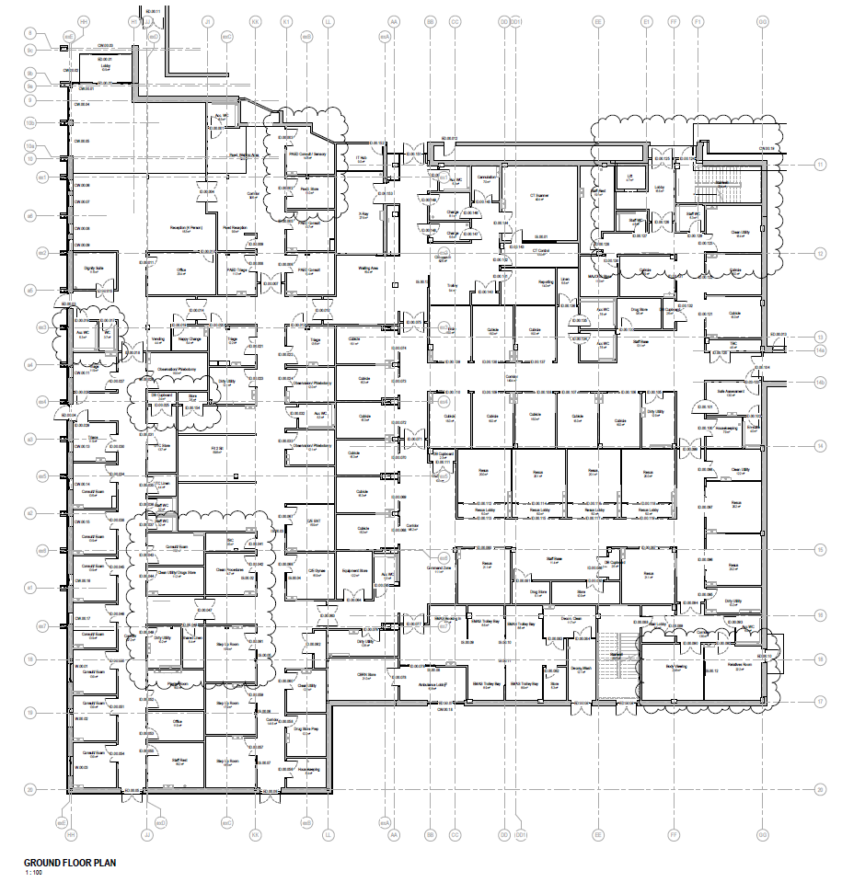

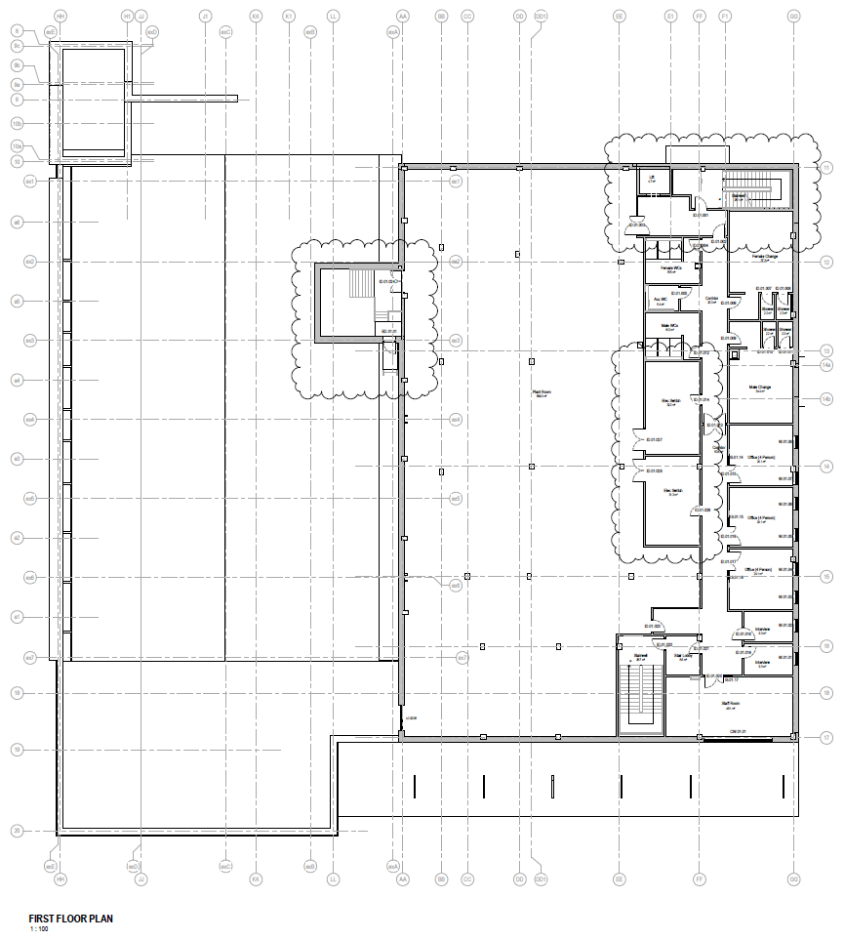
Detailed Drawings – Option 4b (First Floor @ 1:100)

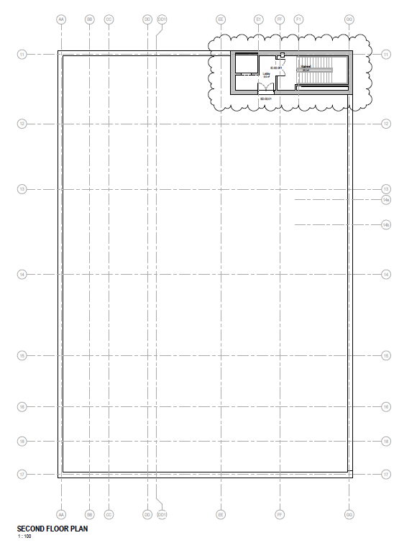
Detailed Drawings – Option 4b (Second Floor @ 1:100)

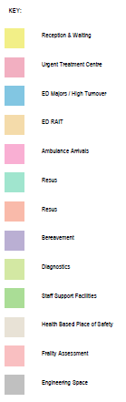
Clinical Requirements & Departmental Arrangements
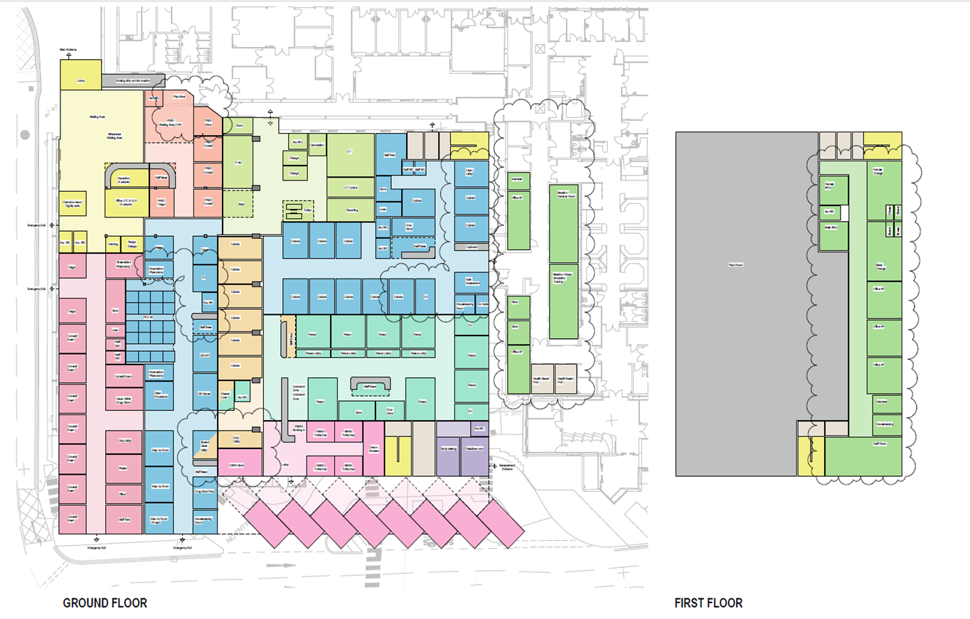

Elevations (@1:200)
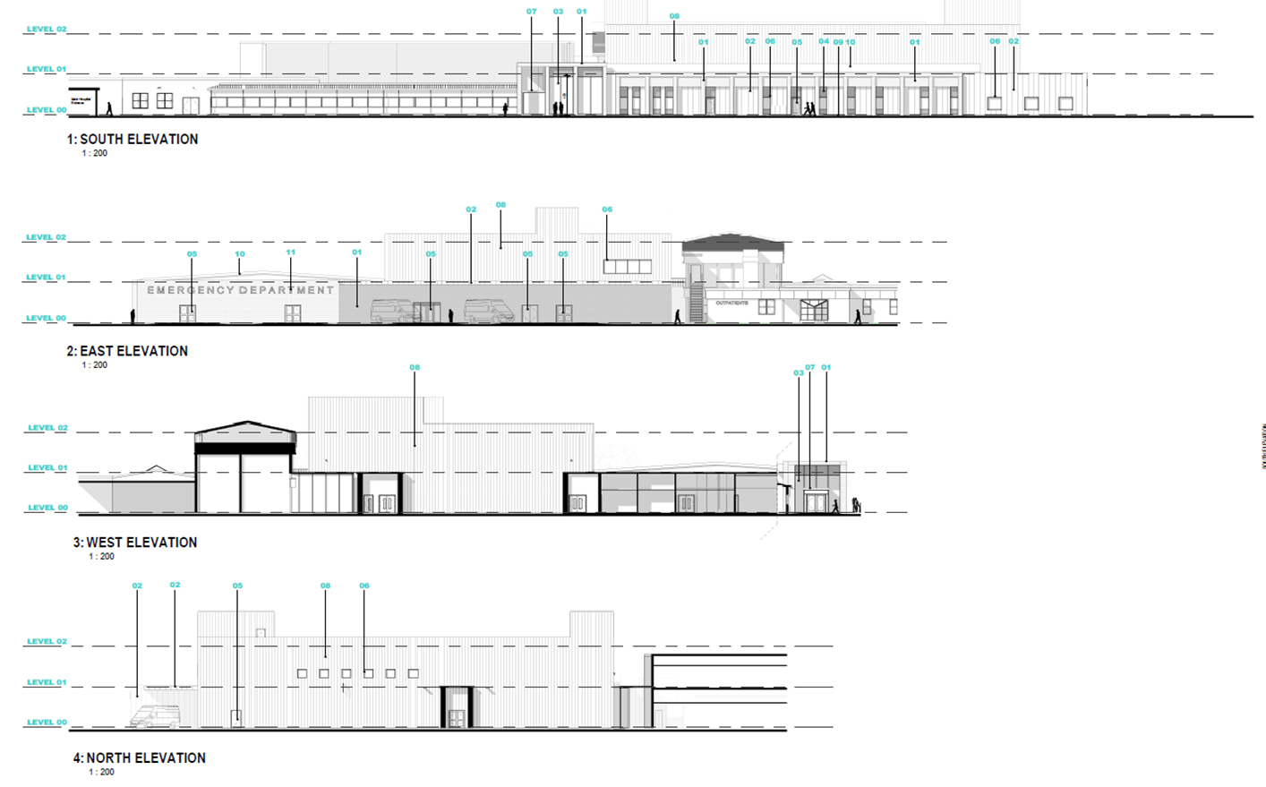

Ground Floor Signage Plan (@1:100)
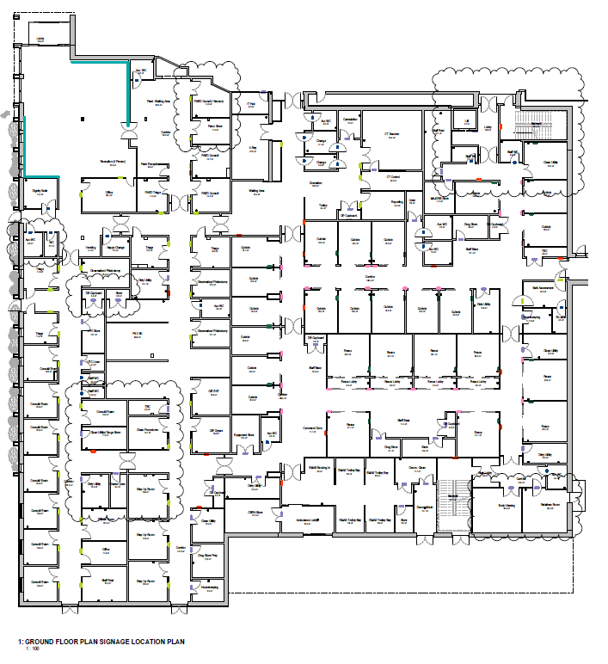

Phasing Strategy – Phase 1 A/B/C works (1:200)
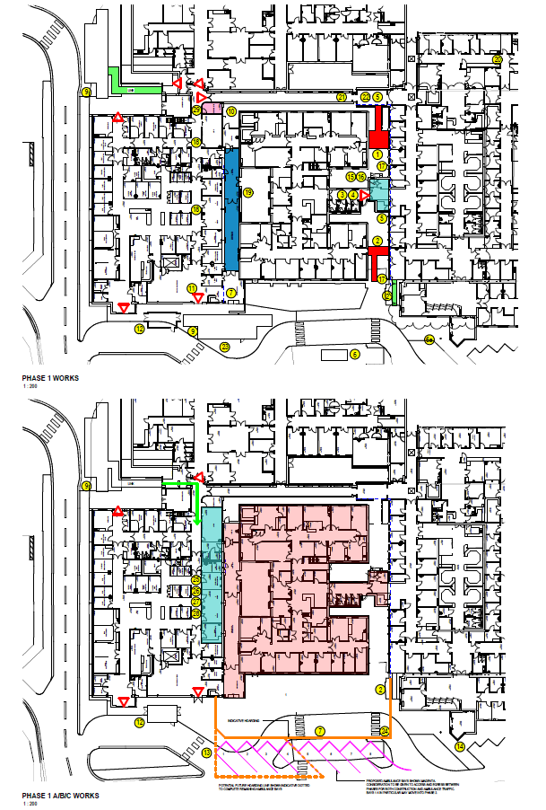
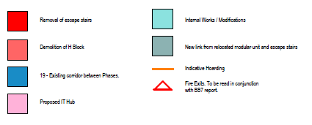
Notes:
- Rear Escape stairs to be removed to NW corner of H block. Fire strategy to be reviewed and long term escape strategy needs to be defined
- Front Escape stairs from the UTC building to be removed (NE corner of H block) and an alternative temporary solution to be determined: possible existing could be re-utilized
- Decant existing H block building (Trust activity)
- R&D Asbestos survey to be carried and subsequent removal to be carried out
- Any Fire Compartmentation or protection to the North, West & South Elevations TBC (Trust to confirm preferred scope of protection to Med.Records and outpatients’ windows to South Elevation a. Polyethene, b. plywood
- Existing bus stop to be re-located to RHS of road of the front entrance to the Hospital
6a - Existing Car parking pay machine to be relocated
- Hoarding to be erected closing off the work area and enabling all construction traffic to come off the road – Further discussions to be had Re: Coordination with Ambulance traffic (Boundaries of which for both phases will be fairly tight to the kerb of the roads – East and South) Just in time deliveries to be co-ordinated. - NO Stopping on road.
- Temporary power, water and drainage for all phases to be agreed including to the Site Offices/compound
- Modular Units and Paediatrics reception to be relocated to the existing lobby to the South West corner of the A&E Department. Cabins re-configured to abut West double door set and ensure emergency exit is facilitated from main building - either around or through the cabins. toilets to be maintained - cabins to become fit to sit then PAEDs waiting to be moved into Outpatients, Outpatient entrance to be reconfigured to allow entry from North and reconfiguration internally to accommodate patient flow.
- Access to the flat roof of the West Corridor to be considered as current ladder access is from within H block zone and will need to be removed – Trust mentioned there may be another access
- No work required.
- Trust confirmed the Decontamination Unit (to the front of A&E) cannot be re-located until new provision is available
- 13. New barriers may be required outside A&E to segregate pedestrians / Staff from vehicular movement (further discussed later in the meeting with a solution being to send walk-in patient’s to either the Outpatients entrance or to the new entrance on the SW corner, therefore keeping as much pedestrian traffic away from the Ambulance Drop off/New construction zone as possible)
- Further meeting required to confirm the vehicle / ambulance movements – new crossing would need to be installed to the NW corner of the carparks to enable pedestrians to walk to the Outpatients entrance.
- Existing HVAC to the North of Phase 1 to be confirmed, presently determined all 4nr units serve the H Block
- Electric cup’d to the North side of Phase 1 to be isolated and all M&E to be confirmed as serving H block only to enable disconnections
- Board up existing Medical Records building windows to safeguard against noise and dust
- Existing M&E intake ductwork between Phases 1 & 2 to be redirected through the roof of A&E away from the ‘Construction zone’ and to terminate facing South in order to minimise dust (confirmed as intakes) FURTHER DISCUSSIONS REQUIRED.
- Existing corridor between Phase 1 & 2. Works in this location to straddle phases. Condensor units in PEADs courtyard feeds into A&E - to be moved onto the A&E roof to Continue operation.
- Re-routing of existing pathways to be organised i.e. Med. Records using Lift within H block
- Consider logistics of breaking through into West corridor (Co-ordination)
- Confirmed - Make Good Only
- Hydrant to Front Elev. (between Phase 1 & 2), needs to be accessible at all times
- Movement of materials discussed – ‘Just in time deliveries’ to be arranged and agreed, materials stored in compound - agree ‘out of hours’ times to be transported onto site (Both Phases) Phase 1 A, B, C
- The rooms which sit on the line of Phase 1 and 2 are generally accessed from Phase 1 but cannot be constructed until Phase 2.
- Agreed in principle (Final design pending) openings and walls on Phase 1 will be built and then sealed towards the end of Phase 1 works
- Prior to commencing Phase 2 these rooms will be entered and works carried out above and within i.e., roof amendment’s and connections into new Plant room Façade above to ensure water tightness
- To be developed further once design complete – these mid phases will need Structural/M&E/Arch. Co-ordination
- IT hub (magenta room on plan) to be complete for handover of Phase 1.

Phasing Strategy – Phase 1A/B & 2 works (1:200)
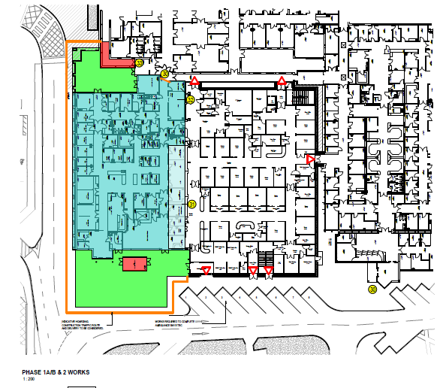

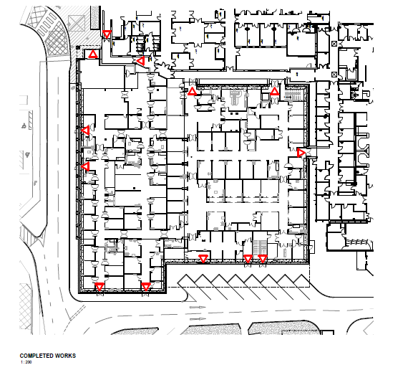

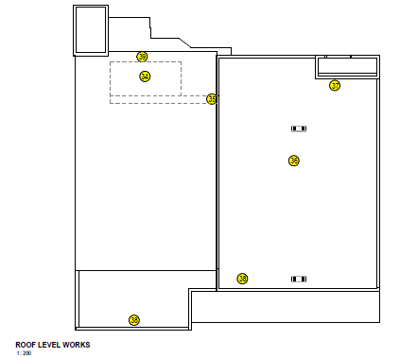
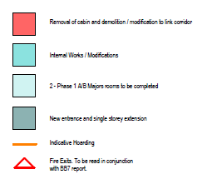

Notes: Phase 1 complete / Start Phase 2:
- Walk in patients to use the reconfigured entrance to the UTC to access Phase 1 via the West Corridor. Access to Phase 1 also via reconfigured outpatients entrance
- When the re-sus rooms are operational in Phase 1, the Phase 1 A/B Majors rooms to be completed and existing doors to be closed off (no further access from Phase 2). Majors rooms to be phased in to operation
- X-ray and Rapid Assessment room will be done at the same time as the Majors rooms. The Rapid Assessment room will become the new IT Room. The IT Room must be done earlier to enable opening of Phase 1
- Ground Floor Fire escape from the West corridor (adjacent to the West Lobby), to terminate at the final door and the existing corridor to be opened up. Door will only be able to open from the inside. Door to have access control. Phasing to be agreed for the construction of new entrance corridor (highlighted in red) which will mean this entrance point will not be available
- Existing Plant Room in the roof space above Phase 2 will remain in place. The roof may potentially be lifted locally above the plant room to allow service routes for the ventilation ducts and better access routes
- Additional access door to the Plant Room to be constructed
- Discussed as part of the Generator works - possibility of having the Transformers on NW Corner of plant room
- The Architect confirmed that the existing access stairs from the Ground / First Floor, in Phase 1, would be extended up to allow access to the roof
- Maintenance of roof plant to be considered i.e. removing and renewal of parts or whole equipment i.e. access, egress, locating and installation. Cost vs practicality to be considered -
- Consider possible exit from internal Plant roof from West gable end onto flat roof (Fire Escape)

Quality Assurance and Standards Compliance

Planning Permission Status
Boston Borough Council has been supportive of the proposal, as stated in their pre-planning advice letter and planning permission was granted on 25 February 2022 for the Demolition of the existing support services building (H block) and the erection of a two-storey extension to the emergency department in its place including full refurbishment at Pilgrim Hospital, Sibsey Road, Boston, PE21 9QS.([Pre planning and the actual planning approval given is provided in the Design Annex).

Fire Safety Compliance
The design has been developed according to HTM 05-02: Fire Code; Fire safety in the design of healthcare premises for all levels, which have been divided in plan by fire-resistant construction and doors into compartments, sub-compartments, protected shafts and hazard rooms. There are numerous exits from the ground floor to external air. Upper floors have access to the two fire staircases, both of which are also in general use so well known to users. The staircases are to mattress evacuation standards. The two lifts will also be useable as they are to be evacuation lifts with the necessary essential power supplies.
Further work to determine the operational policies has commenced but will be completed in the next phase.
The Fire Safety Advisor for United Lincolnshire Hospitals reviewed the business case and was satisfied that the application for the Emergency Department at Pilgrim Hospital and the associated works does not impede or frustrate the fire safety compliance. Moreover, the works will assist in complying with fire safety regulations and provide some additional fire prevention control measures for the existing premises and support business continuity.
The Fire Safety Advisor and Trust AE for fire have been involved in the design and layout of the new project and has been an active member of the design team from its inception.
A Fire Strategy has been prepared for the project and can be accessed in the Design Annex. Derogations schedule are given in relation to HTM 02-02.

Infection Prevention & Control (IPC)
The Deputy Director of Infection Prevention and Control for United Lincolnshire Hospitals has confirmed the following:
The application A & E Pilgrim Hospital and associated works does not breach infection prevention and control (IP&C) compliance within the A & E or other areas of Pilgrim Hospital. I have been fully involved in the design and layout of the premises. My team will be supporting the project operationally to ensure that IP&C compliance is maintained throughout, and oversight will be reported through the Trust Infection Prevention and control Group.

Post Covid Design
Lessons learned following the coronavirus pandemic have been included within the design. To reduce infection risks cubicles will mainly have sliding door access. The clinical area on the ground floor has been divided roughly down the centre, with door access to both ends. This would allow a decant from one side of the area to the other to isolate any major number of infective patients coming into the department.

Modern Methods of Construction
This scheme involves both refurbishment and new build; currently the combined level of MMC based on costs is approximately 70.2%. It is recognised that the new build element of the project presents the most opportunity to achieve a high percentage of MMC in particular use of manufactured and component elements in construction. The site characteristics at Pilgrim Hospital does have some limitations for MMC as it will be necessary to ensure that the new building is tied into existing structures on either side of the building, and this may require a more bespoke approach in certain areas.
MMC is important to the Trust to maximise opportunities for reduced construction time and to achieve a high standard of quality in components and energy efficiency. There are also potential benefits for reduced ongoing maintenance costs.
In terms of pre-manufactured value adopting a qualitative measure, the project is likely to be ‘medium’ for the factors outlined above although we will strive to achieve a high level for the new build element.
The Trusts commitment to use of MMC is indicated by recent project at Lincoln County where a modular unit was delivered to provide a new 11 bed respiratory unit, including 4 negative pressure rooms. The unit was factory assembled with a project plan from order to proceed to handover of 6 months. See also Appendix AE.

NHSEI MMC business case guidance to NHS trusts.
In line with the Government 2019 statement - ‘Presumption in Favour of MMC’ DHSC and NHSEI assume that all schemes start out as MMC
The government’s Infrastructure and Projects Authority (IPA) guidance ‘Transforming Infrastructure Performance’ (2017) also refers to MMC as ‘smart construction’ defined under the following three categories which covers a range of techniques with greater levels of activity taking place off site and increased levels of standardisation, underpinned by digital design and engineering.
- Manufactured: whilst not widely used this offers the greatest opportunities to improve delivery efficiency and boost productivity. This approach enables high levels of customisation by developing and using standard components and assemblies.
- Volumetric: e.g., fully fitted modules.
- Components: e.g., standardised design elements (WC/shower ‘pods’, pre-assembled bed head services etc).
In addition, there is:
- Traditional construction: e.g., methods that are relatively unproductive, with projects individually designed and constructed with little consistency in either the design solution or construction method, even for similar projects.
Within ‘Transforming Infrastructure Performance’ these four approaches are used and set out to help illustrate benefits of MMC, please see below:
# | Heading |  |  | Requirement
1 | New build GIA/m2 |  |  | 3321 m2
1a | Major refurbishment GIA/m2 (<90% > 65% of new build project average cost £m2/GIA) |  |  | 1225 m2
1b | Other refurbishment GIA/m2 (<65% of new build project average cost £m2/GIA) |  |  | N/a
Total project GIA/m2
2 | New build total estimated outturn cost excluding VAT and inflation |  |  | Outturn cost £s  See Financial Case in FBC
2a | Major refurbishment total estimated outturn cost excluding VAT and inflation |  |  | Outturn cost £s
2b | Other refurbishment estimated outturn cost excluding VAT and inflation |  |  | Outturn cost £s
Total project estimated outturn cost excluding VAT
3 | Which of the following is the trust currently considering and for how much of the total project GIA/m2 and estimated outturn cost excluding VAT and inflation?
3a | Volumetric |  | GIA/m2 (Outturn cost £s)  £1503/m2
3b | Manufactured |  | GIA/m2 (Outturn cost £s)  671/m2
3c | Component |  | GIA/m2 (Outturn cost £s)  1752/m2
3d | Traditional |  | GIA/m2 (Outturn cost £s)  770/m2
4 | What is the likely option or what is the agreed option for procuring these works? The business case will require additional details in the Commercial Case as described the NHSEI Business Case Checklist  https://improvement.nhs.uk/documents/459/NHSI_Capital_Regime_Investment_Annex_1_-_V5_final.docx
4a | Pre-tendered framework: | Pagabo framework for 2 stage D&B contract.
4b | Other procurement process: | Details in brief
5 | Are the current designs considered to be standardised / repeatable |  | Yes
5b | If ‘Yes’ to # 5 provide details of which other NHS organisations have used these designs and when | Lincoln County Hospital (O&L Architects for ULH NHS Trust July 2021 )  Diana Princess of Wales Grimsby Emergency Dept & Scunthorpe General Hospital Emergency Dept – 2021 / 22
5c | If ‘No’ to # 5 provide details why ‘MMC’ options are not being considered and where in the business case there is evidence to support this | N/a
6 | Trust are required to complete an updated version of the MMC tracker (attached) at each business case stage  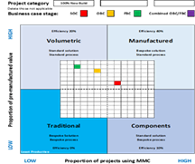 |  | 

Net Zero Carbon
As an NHS Trust, the carbon footprint of the built environment is significant. The Trust’s Carbon Footprint in 2020/21 was 99,523 tCO2e, of which emissions from the built environment at Pilgrim Hospital equated to 5,039 tCO2e:
- 58% Gas
- 42% Electric.

As the Trust provides critical services 24 hours a day, energy and resource consumptions are substantial. Therefore, there is a need to optimise energy use in buildings and move away from using fossil fuels to meet NHS Net Zero goals.
The strategy to meet these targets must therefore encompass a number of strategic objectives and areas of focus as set out in the Trust Green Plan and includes Estates & Facilities energy targets which any capital project must endeavour to support and align to.
Energy and sustainability in design, construction and in operation is also a fundamental objective in relation to the future hospital estate in order to achieving these key drivers. In addition, the zero carbon policy drivers need to be considered and aligned with essential environmental and clinical objectives, which will be of equal importance in a modern clinical setting. The net zero carbon methodology for new build and refurbishment projects is outlined in the engineering strategies in the next chapter.

Travel Plan
The Travel Plan is an important tool, which will also support future planning applications for new developments across the three hospital sites. The implementation of a robust travel plan has the potential to reduce or negate the need for costly improvements and/or planning conditions relating to any planning approval. In light of this, it is crucial that the Trust’s Travel Plan, which has been submitted as evidence to Boston Borough Council as part of the planning application, is not only implemented but also kept up to date. The Trust has recently made a major commitment to continued development of the 2014 Travel Plan by employing a Trust-wide Travel Plan Co-ordinator, whose role it is to source and implement attractive measures to promote alternative travel options for staff and visitors.
A living framework travel plan is being developed, together with site-specific plans on an online platform, where initiatives and actions are updated to meet the targets and objectives that the Trust has set. The objectives include working with partners, including local authorities and service providers, to support the local transport strategies and local transport plans. As one of the largest employers in the county, the Trust is committed to reducing CO2 emissions, improving the local environment, and improving air quality. The travel plan will be utilised when progressing with the emerging estates strategy and development control plan.

BREEAM Pre-Assessment
BREEAM assessors, Envision, have been appointed to the project (Appendix AD). Two BREEAM assessments have been undertaken relating to both the new build and refurbishment:
- The refurbishment part of the build will be designed to achieve BREEAM Good
- The new build section designed to achieve BREAAM Excellent.
The current BREEAM rating from the assessors for the new build element is 74.38% with potential for an additional 3.07%.
The current BREEAM rating from the assessors for the refurbishment and fit out element of the scheme is 66.93% with potential for an additional 13.87%.
The Trusts Green Plan and this development, albeit only a relatively small part of the overall campus, will be in line with the principles of net zero carbon; adopting high energy efficiency standards such as LED lighting throughout, high standard BMS systems, upgraded ventilation/insulation, Potential PV, and careful choice of building materials.
There are some limitations in respect of this build however as it will be necessary to connect into existing services. Maximising energy efficiency opportunities will form part of the Trust’s design brief.
The H block, which is an inefficient building with a high backlog of maintenance, will also be demolished in line with the Trusts development control plan.

Sustainable Development Management Plan (SDMP)
The Trust SDMP, prepared in 2016, is a board approved document to assist the Trust to ensure that the principles of Sustainable Development are understood and embodied within the entire organisation.
It is written on the basis that by reducing energy consumption and Trust carbon footprint, he Trust can save money, enhance and protect our reputation and help everyone in the fight against climate change.
The SDMP outlines the Trust’s commitment to ensuring that Sustainable Development becomes central to the way we do things in every aspect of our organisation, it describes the process by which the Trust will direct, implement, monitor, evaluate and report on our progress in this area, it highlights appropriate activities and targets with regards to Sustainable Development in our procurement and use of resources including: materials; buildings; energy; water and transport and it addresses our activities and progress in reducing waste and our Carbon Footprint and celebrates increased efficiencies, financial savings and reduction in waste and CO2e1
Finally, it contains a high-level action plan to deliver a number of projects and activities which the Trust has identified as the priority next steps and key opportunities to meet our Sustainable Development targets and outlines our approach to partnership working with others in the health and care community together with other public and private sector partnerships.
It outlines a number of key actions and targets, of which the new ED will support the Trust to achieve, including:
- A behaviour change programme to reduce energy consumption by 3% per year though system and individual behaviour change
- Leadership development, training and staff engagement with regards to Sustainable Development
- The creation of appropriate HR, Procurement and Communications strategies to support Sustainable Development within the Trust in line with the NHS Sustainable Development Unit’s Route Map for Sustainable Development3
- Structured engagement with the Trust’s business units, review business plans to reflect sustainable development and ensure the SDMP is fully aligned with the Trust’s “Sustainability Transformation Plan”
- The implementation of capital projects including an overarching “Energy Performance Contract (EPC). Investing in the installation of energy efficient technologies and optimisation of all systems.
- Leading to guaranteed savings of £859k per annum and further reductions in energy consumption by 10% - 15%
- Reduction in Carbon emissions.
- Reduction in clinical waste by 10%
- Reduction in water usage by 10%
- Increase in recycling levels by 15%

Design Appraisal Toolkit (DAT)
The Procure 22 Design Appraisal Toolkit (DAT) process was selected to enable a review of the designs with peer user groups evaluating design of the preferred option. DAT is a tailored version of the Achieving Excellence Design Evaluation Tool (AEDET) which is approved by NHSEI as meeting the requirements of an independent Design Appraisal as referenced within the NHS Business Case Checklist.
A DAT workshop was facilitated on the 18th January 2022. Key findings below illustrated that the design is performing above all target scores:
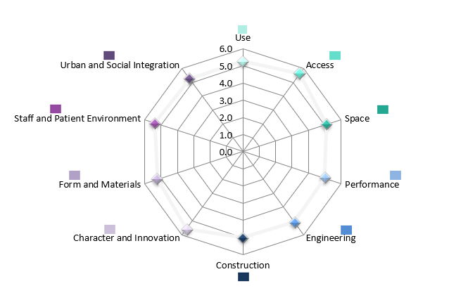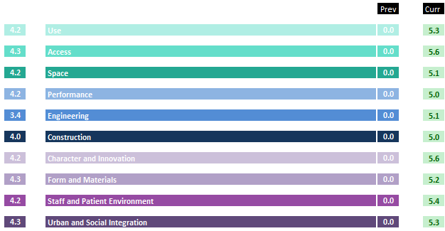

Building Information Modelling (BIM)
Throughout the development of the OBC and FBC, BIM level 2 has been used to help present developing ideas to the wider stakeholders in digital formats and understand their needs, ensuring the project progresses as quickly and efficiently as possible with a reliable basis for decision making.
BIM standards have been employed between design team disciplines to establish collaboration between services for economic space utilisation. This process has set the foundation and standard for the delivery of the scheme and beyond in terms of asset and facilities management. These processes continue to align with the Government Soft Landing initiative.

Government Soft landing
The project has taken an approach under the Government Soft Landing (GSL) process to improve the whole life value generated from the design and construction process, ensuring increased effectiveness of investment via a structured consistent mechanism.
During the delivery of the OBC and FBC, the project team have strived to better understand the needs of the users to ensure the best brief possible is relayed to the design team.
The project has committed to offer a planned, smooth, and gradual process from construction into handover, closeout, and facility operation, that offers the potential to optimise facility performance as soon as possible by:
- Setting clear measurable targets from the onset
- Mapping stakeholders and developing roles and responsibilities
- Reviewing lessons gained from similar projects
- Appointing suppliers familiar with GSL
- Timely user training
- A seasonal commissioning process
- Provision of extended aftercare
- Accurate and complete information exchange to the operational management team.

Building Revenue Consequences
Whilst overall the backlog maintenance costs will go down, it is anticipated that by fully modernising the space there will be an increase in lifecycle costs and day to day maintenance costs.
Using the estates and property maintenance m2 rate from the 2021 / 21 ERIC return, building maintenance will be impacted as follows, equating to a maintenance cost increase of £97,020.89:
Area | m2
Existing GIA (inclusive of GP Streaming, plant areas, new paediatric waiting, and external decontamination unit) | 1291
Core ED element GIA | 967.00
The H Block ground floor GIA | 749.66
The H Block first floor GIA | 715.20
Total existing floor area | 2,431.86
ERIC 20/21 £/m2 | £51.33
Existing cost- Estates and Property maintenance £/ m2 | £124,827.37
Proposed GIA | 4,322.00
Proposed cost- Estates and Property maintenance £/ m2 | £221,848.26
Difference | £97,020.89

These increased costs will be mitigated where possible through the use of technology, condition-based monitoring and using the Building Management System as a focal point for maintenance activities and energy efficiency. Additionally, equipment will be carefully selected to consider full life cycle costs vs installation costs.

Backlog Costs
A survey of the estate by Monaghans in 2017 gave exact figures for the maintenance of each building, rather than figures based on the Trusts average backlog maintenance within the ERIC return. For the OX (H Block) the figures was £827,500 and for the maternity block £5,589,445.

Schedule of Accommodation
The Design Team has engaged with both clinicians, members of Estates & Facilities and the Project Team to develop a Schedule of Accommodation for the project, which is based on Health Building Note 15-01: Accident and Emergency Departments (April 2013).
The total area of the new Emergency Department is 2,092 m2
See the Appendix X for full accommodation schedule.

Equipment Schedule
At FBC stage, the cost for Group 3 equipment totals £1,700,500.
Note - due to the age of existing equipment little can be reused.
See the Appendix Z for the equipment schedule.
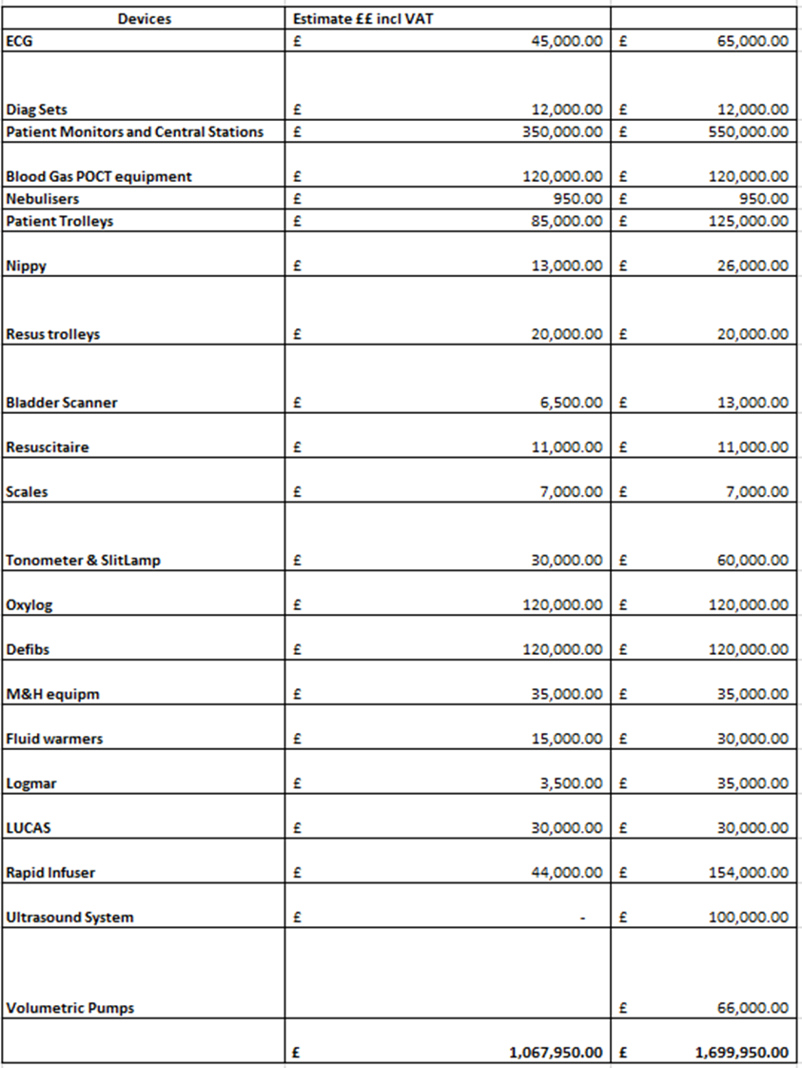

Digital Strategy
As part of the equipment requirement a significant increase in IT equipment is planned. The digital strategy describes the need to bring about full digitisation of all systems including clinical technology, information resources and processes. That are required to underpin the transformation of the Trusts services. The improved IT within the service will support the strategy by ensuring clinicians have the right information, in the right place, at the right time to ensure optimal patient care.
The project links in with the implementation of an EPR that supports information sharing and removal of paper notes. The improved digital infrastructure will also support information from the wider ICS, improving patient care and experience as well as outcomes from relevant data being available to clinicians.

Resilience
HBN 00-07 Planning for a resilient healthcare estate provides guidance on service resilience, approaching the issue from a number of different angles. Key to the PHB Design is section 4: Design and planning considerations for a resilient healthcare estate. Within this section, there are some broad recommendations, or areas to consider during the design process. Whilst a lot of the scope of this document goes beyond the architectural design (Trust site-wide considerations and MEP design are a significant part of providing service resilience), the Trust is comfortable that the design follows the principles of the guidance without specific derogations:
- The scheme follows the BIM process
- Site selection was considered by the Trust at Stage 2, then validated by the design team at Stage 3
- Radon controls are not required
- Good vehicular accessibility for emergency services
- Alternative routes around the site are available if required
- Pedestrian entrances were reviewed and altered during Stage 3 design to improve control
- HBN 05-02 considered during design
- Security Needs Assessment completed with Lincolnshire Police to determine appropriate security measures and perimeter controls
- Framed construction utilised, as recommended
- Thermal comfort report includes assessment of projected future climates
Resilience has been inherent within the design brief from the outset. Examples include:
GM21-PHS-Z1-00-D-A-70628 – RESUS TYPE 1.pdf
In line with planning permission and despite the successful deployment of the Boston Flood Gates, wall protection and electrical is set at 1300mm, flood zone set at 1000mm.
GM21-PHS-ZZ-00-DR-A-68501 – GROUND FLOOR FIRE STRATEGY
Details the 30 minute construction, 30 minute sub compartments, 60 minute compartments, 60 minute construction and 120 minute construction. Associated escape routes are detailed.
GM21-PHS-ZZ-00-D-A-68001 – GROUND FLOOR SECURITY LAYOUT
Details methods of access control
GM21-PHS-ZZ-00-D-A-20001 – GROUND FLOOR PLANDetails the inclusion of CBRN store, Decon Wash and Decon Clean facilities
The Trust also has Business Continuity Plans for every area as advised by the Emergency Planning Officer and, with experience of incident situations such as the wannacry attack and more recent arson attack evidences the high degree of planning and protocols that were successfully deployed

Benefits
In developing the OBC and FBC a series of workshops were held with key stakeholders to capture scheme benefits. The first workshop on 13th November 2019 and considered the strategic dimensions to the case including benefits. A further workshop, with stakeholders, staff, and patient representatives, was held on 26th November 2021. This session was used to review the existing register in the OBC to make sure it was still relevant and accurate. The workshop also considered any additional benefits the options may bring to help strengthen the cost benefit ratio.
As part of the approvals process for the OBC the Trust was asked to review the benefits as part of the FBC to improve cost benefit ratio and comply better with the Public Services (Social Value) Act, 2012. To assist the Trust has been grateful to have support from the PAGABO framework in identifying social benefits and from the Social Value Engine jointly developed by Rose Regeneration and East Riding of Yorkshire Council. This software assists in calculating what may have been unquantifiable social benefits by using financial proxies from reliable sources.
The results from both workshops and the wider OBC and FBC authoring was a long list of anticipated benefits tempered to what should be achievable and scrutinised to make sure they were relevant at the correct impact. The quantified benefits informed and strengthened the benefit cost ratio to demonstrate the best solution within the Comprehensive Investment Appraisal model – please refer to section 5.2.
The total of costed benefits related to estates at OBC was £1,293,292 (exc VAT)
The total of costed benefits related to estates at FBC was £7,702,428 (exc VAT)
The increase at FBC was mainly due to the refreshed decant plan for the maternity block, a non cash releasing benefit.
The specific ‘Estates’ benefits are set out below:
Title | Description | Measure / Baseline / Method | Calculation of Benefit (exc VAT)
Improved running costs- reduction in ongoing maintenance | Reduction in ongoing maintenance post implementation due to newer accommodation | Estates & Facilities budget | £41,667
Improved running costs of a new build | New build or refurbished accommodation will reduce the costs of energy by using modern building methods and zero carbon standards | Estates & Facilities budget | £41,667
Reduced absenteeism | An improved working environment with reduced stress will reduce staff sickness levels | Absenteeism rates pre pandemic vs post-handover rates (5.43% of 132 staff. Assumes a 1% decrease for 1.32 WTE | £80,000
Reduce backlog maintenance | New build and refurbished accommodation for the ED will significantly reduce the outstanding backlog maintenance issues within the existing infrastructure | Trust estates strategy | £827,500
Reduced backlog maintenance | Asbestos and improved water supply to the maternity block for the decant will reduce the outstanding backlog maintenance issues within this building | Trust estates strategy | £5,589,445
CO2 savings | By achieving better performance against zero carbon standards, emissions will be reduced, | Total CO2e Emissions per occupied floor area | £8,333
Improved access | A new design will facilitate safer access to the building, reducing risk | Proxy - collaboration savings | £58,463
Improved access | A new design will facilitate improved dignity for patients arriving by ambulance | Proxy - average spend on health per person | £638,051
Improved reputation | A state-of-the-art department with better patient outcomes and staff retention will improve the organisations reputation | Proxy - Cost of Family Therapy | £417,302
Total Estates Benefits |  |  | £7,702,428

Risks
Key estates risks are given below, which were used to inform the evaluation of the shortlist of options, and have also informed the CIA model.
The likelihood and consequences of the risks will vary depending on the option taken forward:
Risk | Mitigation | Potential Cost
Design Risk – service not adequately future proofed, leading to compromise on less critical areas which would still undermine quality and patient experience, e.g., paediatric and mental health areas. | Careful calculation of future demand based on ONS data and historical rise in demand at PHB ED. Working closely with architect to ensure accurate accommodation schedule and plan options to try to accommodate “core” list if compromised. | QALY cost on % harm to paeds from shared accommodation
During the building work there will be considerable disruption the site and may compromise existing accommodation. Construction teams and equipment on site may impeded patient or ambulance access, disruption to the ED may mean parts have to be closed, changes to power may impede clinical systems. | The project team must consider the phasing of the works. Depending on the preferred way forward it may be possible to decant areas adjacent to the building and temporarily relocate ED, or to bring in portable units to temporarily house emergency services. If the option is to build out from the existing building this may be negated. | Cost of portable units’ max value.
Flood risk – Pilgrim Hospital is in a flood plain and has a potential risk of flooding. | Flood barriers can be brought in to protect the site as part of the business continuity plan. | Potential for damage to building if defences fail. Wouldn’t be full 21.3 but likely damage?
Pandemic risk – if the design is not safe then there is a risk that patients could be infected by positive patients in the department. | Working with architect to design areas that can be segregated off. Multi-use spaces to allow function to be changed, e.g., minors to majors, in the event parts of the department are closed off. | QALY cost for ave attendance and % affected * potential harms?
Technological risks – the NHS has had previous experience of “cyber-attacks” which may happen again in the future. | Boundary firewalls, segmentation, defence in depth, Dionach reviews etc. | 300k (based on Wannacry response)

See Appendix P for more information.

Financial Case - Summary

Capital Investment required
HM Treasury ‘Green Book’ methodologies have been used in assessing financial calculations.
This case requires capital investment of c£1.4m to complete the OBC/FBC as part of the early drawdown fees and a further c£42.1m for scheme delivery. The scheme delivery costs incorporate c£33.1m for the ‘Main Build’ and c£8.9m for the ‘Decant Scheme’ including risk – the value of risk is c£2.5m. Also included is a c£1.8m inflationary increase allocation.
At the request of NHSEI, the OBC funding proposal has been altered to draw the 2021/22 financial requirements from the Wave 4b allocation rather than additional ‘top-up’ funding.
Lincolnshire ICS are in agreement to prioritise as per the table below and provide assurance that this is affordable. At the request of NHSE&I, the OBC funding proposal has been altered to draw the 2021/22 financial requirements from the Wave 4b allocation rather than additional ‘top-up’ funding.
Equipment replacement programme will be included within annual capital planning processes to ensure affordability.
VAT advice has been sought and provided by XXXXXXXXX VAT Consultants Ltd. VAT has been recovered in the forecast costs where possible. The basis of the VAT decisions has been as follows, based on the 4 key elements within the scheme:
- Demolition of the “H building”
  - No VAT recovery as there is no scope to recover on the demolition of buildings or the creation of new buildings.
- Building a brand new ED (Relocating the former ED to this new building)
  - No VAT recovery as there is no scope to recover on the demolition of buildings or the creation of new buildings.
- Refurbishing/extending the UTC
  - Costs associated with the refurbishment and/or extension of the UTC will yield a minimum VAT recovery of 20% and 5% respectively
- Decant works
  - VAT recovery of 20%.

Net Zero Carbon impacts have been removed from the financial calculations. Whilst these may be required, a separate source of funding will be sought to fund. These costs were not part of the OBC and therefore are excluded from the FBC. Inclusive of VAT, the costs have been calculated by the Trust cost advisors to be c£1m.
It is worth noting that within the OBC, there was £2.5m of inflation risk assumed. Calculations have taken place by the Trust cost advisors, following the recent worldwide events, to show that if this was updated with the latest PUBSEC inflation, based on the original programme with a mid-point construction of 3Q22 which shows movement of £1.7m just due to inflation movement, and then rebased with the updated programme (1Q24), which demonstrates a further £2.2m. Therefore, the scheme is currently accommodating an inflationary increase of £3.9m + VAT, equating to c£4.7m.

Cost Improvement / Benefits generated
A full assessment of all benefits has been undertaken, incorporating the use of a social value engine, and have been used in the CIA model.
The following have been identified:
- Cash Releasing c£1.5m
- Non-Cash Releasing c£6.6m
- Societal c£6.2m
- Unmonetisable c£0.0m

Cost avoidance
As a result of the scheme the following costs will be avoided:
- Unnecessary admissions
- Estimated backlog maintenance costs of Pilgrim Maternity Block amount to £6.7m including VAT/Fees and enabling works through the decant plan.
- Estimated backlog maintenance costs of Block OX (the H-Block) amount to £993k including VAT/Fees and enabling works that would not be required with the preferred option.
Further information can be found in the FBC.

Commercial Risks
The following commercial risks have been identified:
- Values included for the decant plan are indicative until procurement deal is signed
- Risk calculated at 5% for change-risk due to the contractual agreements being in place.
- Contingency allocations within the ‘decant’ works are £0.3m.
- OB and Contractors risk built into the GMP from John Grahams.
- Time delays in delivery of build – need to ensure contract includes penalties / clauses
- Pandemics – for example Covid 19 has brought about the need to closedown construction and slowdown of economy.
Further information can be found in the FBC.

Commercial Case - Summary

Procurement Route

Rationale for Using the Pagabo Framework
Following a meeting on 17th June 2021 between the Trust and NHSEI, the Trust were again asked to provide additional information to justify the use of the Pagabo Framework as opposed to the P2020 (ProCure23) route.
The Trust has previously utilised the P22 framework on a maternity project at Lincoln County Hospital. Sadly, the project had a variety of issues with the appointed provider and ultimately ended up in litigation with them. When the Trust was evaluating the procurement route for the Pilgrim ED, it did look extensively at the P22 contract. On P22, there was a choice of 6 providers. An open and honest conversation was held with the then acting Procure 2020 Project Manager, to look at the commercial links between suppliers on the framework and the likelihood of bids being received. The overall feeling was that the previous contractor, with whom the Trust had had problems, were highly likely not to submit a bid, leaving a choice of 5 suppliers who potentially might. The acting Procure 2020 Project Manager described some of the suppliers as having good relationships with that provider and therefore he raised the question that some of these suppliers may have a reluctance to want to bid on this project and work with ULHT. Although we had no firm evidence of this, it was an important consideration for the team when deciding on a commercially sound procurement route.
The Trust looked at carrying out an open tender by itself for the work, but also looked at whether there were other frameworks potentially available. As the Trust had carried out a lot of successful contracts on the Pagabo framework throughout Covid, the Pagabo Major Works framework was looked at. The table below lists the number of suppliers the Trust would be able to ask to bid on the P22 framework and the Pagabo Framework:
Supplier | P22 | Pagabo
ISG |  | x
Morgan Sindall |  | x
Sir Robert McAlpine | X – joint venture with VINCI | x
Skanska |  | x
VINCI | X – joint venture with Sir Robert McAlpine | x
Wilmot Dixon |  | x
Graham | x | x
Kier | x | x
Wates |  | x
Interserve | x
Galliford Try | x
BAM | x
Total Potential Bidders | 6 | 9

The P22 Framework had 6 suppliers and the Pagabo Framework had 9 suppliers. The Trust suspected it was highly likely that the provider with whom the Trust had had difficulties would not bid for this project, which dropped P22 to 5 possible suppliers, and Pagabo to 8. The procurement team are hugely experienced with bids of this type and size and all of the Senior Procurement Team are Chartered Members of CIPS and concern was raised about only 5 potential suppliers being on the P22 framework. Ideally, to demonstrate good value for money and show good competition, the Trust would be aiming to get 4 good bid responses as a minimum for this project. This would mean it would need an 80% response rate from the P22 suppliers, but a 50% response rate if it used Pagabo to achieve the target.
As part of the decision-making process, the Trust carried out a risk assessment to look at how likely it was that it would receive the minimum 4 bids it required from each of the frameworks. For the purposes of the analysis, it removed the provider it had had difficulties with from the equation as it did not believe they would bid. This meant that P22 had 5 suppliers and Pagabo had 8. The Trust analysed the likely risk of it not being able to get to the number of bids it targeted - 4. With P22, it needed to hit a return rate of 80% from the framework to meet the target of 4 bids. This is a very ambitious target for a framework return. The Trust run at a framework response of around 52% (considering both internal and external frameworks) and would have been looking at a significant uplift to hit its target. For Pagabo the Trust would have needed a response rate of 50% from the framework to meet its target of 4 bids. Given its experience and rate of tender return, the risk to the Trust of not hitting the 4 bid target with P22 was classed as high, whereas the risk of it not hitting the 4 bid target with Pagabo was classed as low. Both had severity impact to the Trust in terms of demonstrating value for money should it not have hit the 4 bid target.

Form of Contract
With a project of this size, the Trust had a choice of what form of contract to use and how it would deal with risk contractually. Having weighed up the pros and cons of a variety of contract types, and held discussions with other procurement professionals, estates colleagues and framework providers, the Trust is settled on using NEC Option A for this Scheme. The Trust wanted to apply a fixed maximum cost to the project with out-turn financial risks shared between the Trust and the Contractor in an agreed proportion.
It was also proposed to use a Two Stage Design & Build tender process to appoint a preferred Contractor. This early Contractor involvement would improve buildability, cost certainty, assist in interrogating and understanding risk as well as ensuring considered allocation of that risk. Essentially, the Trust would be able to manage out some of the potential pain share risk by investigating / developing the Contractor’s design; maximise the opportunities for value, engineering, and innovation to ensure costs are minimised; as well as integrating design development with planning as early as possible to ensure an effective Programme.

Legal Report and Accounting Treatment
Given that a decision has been made by the Trust to use a framework for the project, it had not carried out a full legal report, as its route to market was not novel or contentious. In terms of accounting treatment, the way the Trust would want to run this project would be to have a weekly meeting with contractors and estates to review what has happened in the week and review and monitor costs as the project develops.
This meeting would include both procurement professionals and accounting professionals from the Trust, as well as the Contractor, Estates and professional services teams that have been employed to support the project. By getting the whole team together on a regular basis, the Trust would utilise the full benefit of the NEC Option A and guarantee excellent project tracking and controls, ensuring value for money.
The accounting treatment will be dealt with in accordance with IAS 16 and IAS 36 recognising new addition and impairment and/or future disposal of any properties impacted by the development. This will be included on the Trust Statement of Financial Performance accordingly.

Contractor Appointment
The Trust chose the PAGABO framework to achieve four good, strong commercial bids to demonstrate good value for money.
Following a “meet the buyer” event, the tender package was sent out via the Pagabo framework to all suppliers on the appropriate lot. Each of the bidders to prepare a presentation to be held virtually and all team members, including our QS team, would evaluate this. Each of the team members gave scores and this was fed into the evaluation matrix. The bidder’s scores were as follows:
Element | Total Score Available |  | John Graham
Capacity and Case Studies | 10% | 8% | 8% | 6% | 8%
Project Team + Skill Set | 10% | 8% | 10% | 8% | 10%
Contractors Proposals - Fully worked detailed feasible programme | 10% | 6% | 8% | 8% | 8%
Contractors Approach and management of design process | 5% | 4% | 4% | 4% | 5%
Contractors Proposals – Project Delivery | 5% | 4% | 4% | 4% | 5%
Contractors Proposal – BREEAM | 5% | 4% | 4% | 4% | 4%
Contractors Proposal – Social Value | 5% | 4% | 4% | 4% | 5%
Cost Plan | FOR INFORMATION ONLY NOT WEIGHTED
Presentation/ Q&A’s | 10% | 8% | 8% | 6% | 8%
Total Quality | 60% | 46% | 50% | 44% | 53%
Total Price | 40% | 33.30% | 40% | 28.10% | 30.63%
TOTAL | 100% | 79.30% | 90% | 72.10% | 83.63%

Following the outcome of the tender and the evaluation process, the recommendation of the project team was to award the contract to John Graham.
We have also drawn up a risk allocation table below to show where various risks from this project sit commercially. Some risks sit with Grahams, some with the Trust and some risks are shared between the two parties.
Risk Category | Potential Allocation
Risk Category | Public | Private | Shared
Design Risk
Construction and Build Risk
Operating Risk
Variability of Revenue risk
Legislative risk
Financing risk
Control risk
Availability and Performance Risk
Transition and Implementation risk
Termination risk
Technology and obsolescence risk
Social Value risk

Management Plan
The Trust’s Procurement and Estates Team will manage the performance of this supplier throughout the term of the contract to ensure delivery of the services is in line with the specified requirements.
The extension period will only be initiated based on the provider achieving expected performance levels and on mutual agreement between the Trust and the selected provider.
Both the Project Execution Plan separate document and NEC 4 contract data identifies clear overall ownership of the contract management across the organisation. Contract management reporting processes are aligned with organisational governance processes, operational board, and risk structures, all with senior level engagement.
The NEC 4 form of contract requires a collaborative approach from all parties, which encourages open management to mitigate problems and reduce risk.

Delivery Programme
The current accepted programme is included in the Project Execution Plan (please refer to the Design Annex) the programme will be formally accepted (or not accepted) by the client Project Manager on a monthly basis, as per the contract.

Value for Money Assessment
An independent value for money assessment was undertaken by Turner & Townsend Cost Management Limited (TTCM) to appraise the second stage tender received from John Graham Construction Limited (GCL) to construct the new Emergency Department at Pilgrim Hospital.
Following the submission of GCL’s second stage tender, TTCM reviewed the commercial aspect of their submission and agreed a suitable contract sum which the Trust accepted as follows:
Contract Sum
 | Construction Cost | Cost per m2 (4,790m2)
Submitted Second Stage Tender | £24,131,419 | £5,038
Agreed Contract Sum | £23,750,000 | £4,958

The contract sum is comprised as follows:
Total Contract Sum
Total Contract Sum
 | Construction Cost | Cost per m2 (4,790m2)
Building Works | £19,119,109 | £3,991
Preliminaries | £1,561,062 | £326
Main Contractor D&B Risk | £620,405 | £130
Inflation | £1,500,545 | £313
OHP | £877,843 | £183
Pagabo Fee | £71,037 | £15
Total | £23,750,000 | £4,958

Benchmarking

Contract Sum benchmarking
Seven projects of a similar nature were identified, and their cost adjusted for time and location. Although the project benchmarks slightly above the average £/m2 against similar projects, this is explained by the high levels of volatility the construction market is experiencing at present; there are well documented supply chain issues, significant skills shortages, and an increase in fuel prices, so the project benchmarking slightly above was as we would expect in the current market.

Preliminaries benchmarking
The preliminaries from the projects noted above have been extracted and compared to Pilgrim A&E, the results demonstrate that the preliminaries are well within the benchmarked preliminaries.

Net Zero Carbon
Section 20 of GCL’s second stage tender submission includes the Net Zero Carbon Report produced by Envision. TTCM reviewed the commercial content of this report and highlight the following:
- Construction offset cost at completion - The report includes an estimated off-setting estimate of £25/tonne at practical completion (approx. £49,000). Given the project is planned to complete in 2025 and the demand for offsetting continues to rise across the world, we would advise that the Trust increase this allowance to approximately £100/tonne and regularly update the calculation for carbon that will be generated throughout the construction phase. At practical completion the off-set cost can be accurately measured and therefore have its cost fixed.
- Annual offset cost - The report advises that the annual offset cost will be £2,326/annum. This can be reduced or omitted in its entirety if the Trust reverts to procuring electricity from wholly renewable sources when the new A&E is operational.

Contract Sum Analysis
GCL submitted their second stage tender on 28 January 2022. Following a detailed review of their submitted tender and subsequent negotiation, they submitted a final offer on 5 February 2022. The movement between both offers is as follows:
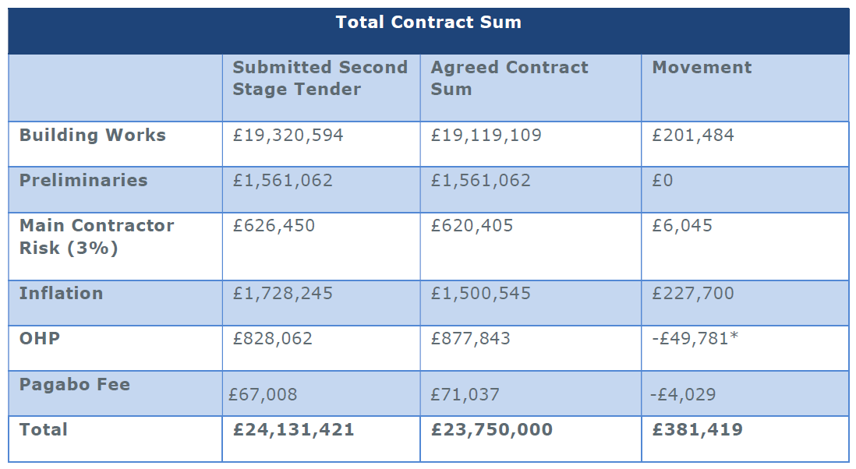

Contract Documents
The NEC4 PSC contract has been agreed, signed, and completed for the first stage. Second Stage Appointment: Main Works (NEC4 ECC Option A). Contract Data Part I and Z Clauses are currently being reviewed by the GCL legal team. Upon approval of the FBC and instruction from the Trust, Contract Data Part II will be issued to GCL for completion and signature.

Value for Money Assessment Conclusion
Following the analysis of GCL’s work packages and overall, second stage tender offer, TTCM recommend GCL are awarded the Pilgrim Hospital, Boston A&E project to the sum of £23,750,000, exclusive of client direct costs (Group 3 FF&E, Professional Fees, Legal Fees, Finance costs, Operational costs, VAT and Section 106 and 278 works).

Management Case - Summary

Project Management Arrangements
The scheme is an integral part of the Urgent and Emergence Care Improvement Programme, which comprises a portfolio of projects for the delivery of improvements in Urgent and Emergency Care across the Trust.
This project is being managed under PRINCE2 methodology and has a Project Oversight Group (POG) chaired by the SRO and a Project Working Group (PWG) chaired by the project director.
Reporting lines and governance arrangements are:
The Project Working Group was rationalised to produce the FBC. At OBC stage this included many more clinicians and partner organisations. To complete the commercial and financial cases it was more efficient to streamline the project team to relevant staff within the Trust (detailed within the FBC management case).
A number of workstreams were set up to develop the FBC, one of which was a design review which did still include many of the original clinical teams and partner organisations from the OBC.
A number of additional meetings with advisors and contractors have also been established including project update and strategy meetings and risk reviews.

Membership of the Project Team
In addition to the use of contracted special advisors the Trust has appointed an internal project team that form the working group. The working group pulls in clinical expertise as required, accepting the pressures placed on these staff through the pandemic, and includes:
Name | Role | Reporting To | Responsibilities | Proportion of Time on Project
 | Associate Director, Strategic Projects | Director of Improvement and Integration | Developing the business case | 75%
 | Senior Project Manager, Facilities | Director of Estates and Facilities | Developing the project to RIBA stage 4 and stage 5 post approvals | 75%
 | Assistant Director of Finance | Deputy Director of Finance | Developing the business case | 20%
 | Head of Category, Procurement | Deputy Director of Procurement | Procurement & Commercial Support | 10%
 | Senior Category Manager, Procurement | Head of Category, Non-Clinical Procurement | Procurement Support / Business Case Development | 10%
 | Deputy Director of Procurement | Director of Finance | Procurement / contractual support | 5%
 | NEC Contract Supervisor | Senior Project Manager | Supervising local contractual issues as arise, Early Warning Notices etc | Ad hoc, as required
 | Director of Estates and Facilities | Chief Operating Officer | Project oversight | Ad hoc, as required
 | Communication Manager | Associate Director of Communications and Engagement | Supporting with internal and external communications and engagement opportunities | Ad hoc, as required

Use of specialist advisers
To develop the FBC and to, where needed, act as client representatives, where necessary (where capabilities within the organisation have been insufficient due to the larger scale of this project) external advisers, providing an independent and impartial role have been used as per HM Treasury Guidance – “Use of Specialist Advisers”. These advisers have been largely used for design, technical and project management (cost advisers, design team etc).
Details are set out in the table below:
Specialist area adviser | Supplier Name
Financial | Turner and Townsend QS, WT Partnership, DKP
Technical | P&HS Architects, Graham Group, DSSR Design Services, SDA Design Services, DAY Architects, Globe Architects, Mott McDonald
Procurement and legal | Internal Trust Teams & resources
Business assurance | Internal Trust Teams & resources

Outline Project Plan
Key milestone activities are listed below:
Milestone activity | Date
FBC Complete, Internal Approvals Complete | 05/04/22
External Approvals Complete (NHSE&I, HMT) | 18/07/22
Maternity build and H Block decant complete | 31/10/22
New build ED | 08/07/24
Refurbish old ED for UTC | 28/02/25
Handover | 28/02/25

A detailed project plan is kept up to date on the trusts digital project management software, the latest version is given in the Project Execution Plan (Refer to the Design Annex). The project is being managed with PRINCE2 methodology and contracts will be managed as described within the economic case.
The plan is reviewed frequently through internal project team meetings and the Principles Meetings where the contracted design team are held to account, and any potential issues, early warning notices and requests for information are discussed.
Project Implementation Reviews will take place during the handover and implementation phase of the project and a benefits realisation review 6 months post-handover in line with the methodology set out in the Magenta Book.

Benefits Realisation
A benefits plan and register has already been established for the project (Appendix OO), which supported the analysis within the strategic and economic cases. Benefits have been recorded onto the benefits register as identified through the workshops and meetings with the teams. Planning and modelling of benefits took place via a subgroup of the PWG, involving clinicians, finance, and the project director. This subgroup discussed and assigned the realisation of benefits to the most appropriate person or team that will monitor the actual benefit once the project is complete.
Overall responsibility for benefits realisation remains with the SRO, but delivery will be through the groups as described, with the project director reporting to the POG. The benefits register will be reviewed and updated at each meeting continuously through the project to capture:
- Benefit category / class
- Potential costs
- Activities required
- Performance measures
- Target improvement
- Full year value
- Timescale.

Analysis of the benefits will be performed as part of the post project evaluation.

Project Assurance and Post Project Evaluation
The lessons learnt from project assurance and post project evaluation will be essential to go on to inform future schemes and continue to develop in house skills.

Project Assurance
Monitoring during the project will provide upward assurance to the oversight group as described in section 6. This assurance will provide an analysis of:
- Whether the project is running to time and budget
- Whether the project is providing the required outputs in terms of business case development through to building the ED
- That the outputs are of sufficient quality to meet their objectives.
An objective assessment will be ensured by using specialist advisors such as the appointed QS. Design consultants will also be engaged to assure the project is on track via gateway assessments and RIBA stages.

Post Project Evaluation
Post project evaluation will follow guidance as set out in HM Treasuries Magenta Book and will take place in two forms:
Project Implementation Review | Lessons learnt during the delivery phase leading up to the handover and implementation of the new service will be captured by the working group and fed upwards to the oversight group. This will be critical to ensure delivery of this project and inform future work
Post Evaluation Review | This will take place 6 months post implementation to look at the original expected outcomes and benefits and evaluate as to whether the project delivered against them. If the implementation of the service is slow to achieve them the Oversight Group will look at how this may be improved. Critical to this will be capturing of whether the project was achieved to time and budget which will go on to inform our Capital and Revenue Investment Group and future case development in terms of refining our own optimism bias.
Data for the reviews will be provided by:
- Medicine Directorate data analysts for performance against constitutional standards, improved ambulance handover times
- Human Resources and Finance for fill rates and agency spend
- Estates and facilities for running costs, backlog maintenance, carbon reduction
- CCG / ICS for incremental health gains.
All of the information is readily available within existing systems in the Trust and wider health community. No budgetary requirements are set aside for this as it is considered business as usual for the Trust to be monitoring its own performance.
As well as providing assurance that the project has delivered its aims and objectives it will provide an important evidence base for what went well and what has been learned. The Trust has not undertaken a capital project of this size for some time and skills from previous capital projects of magnitude have been lost.
The Trust is embarking on various capital projects and this, along with others will provide an important source of information and lessons learned.

Future management of the estate
The Trust will manage the new facility in conjunction with the remainder of its estate including in the Planned Preventative Maintenance (PPM) Programme. This is currently managed by the Trusts Estates and Facilities Directorate. There are no immediate plans to change this arrangement
The current Estate is maintained largely through an in-house team and specialist services such as Lifts are outsourced to third party maintenance providers.
The Estates Maintenance Department which covers all traditional ‘Estates functions’ is primarily responsible for providing professional, effective and efficient customer focused reactive and planned maintenance services to the Trusts buildings, engineering services plant and equipment. The Department is also responsible for minor improvements, refurbishment works, plant replacement programmes, energy management, delegated capital projects and provides similar services to other third-party organisations through Service Level Agreements. The Department works very closely with the Facilities and Capital Projects Teams together with the end-user for successful delivery of all of these services.
Maintenance activities both reactive and planned are generated and tracked through the Computer Aided Facilities Management (CAFM) System called Planet. The CAFM system holds the asset, location, and PPM data for the site, and it is critical that the latest information is maintained on this system. Processes and procedures have been set up to capture any changes to the site.
The new ED Development will follow the same structure, which is namely to be maintained by the internal Estates team with specialist services outsourced and all relevant data to be held within the CAFM system. Lifecycle data on all assets is to be provided at the same time so that this can be tracked and managed through the CAFM system.

Conclusion
In summary this Estates Annex provides the fundamental estates information to inform and assist the Business Case scrutiny and decision-making process.
It reflects both the current performance of the estate and the status of the project using information included in the FBC, and references key Trust documents including the Estate Strategy.

